JOHN ERNEST, A MATHEMATICAL ARTIST

Paul Ernest

University of Exeter

p.ernest(at)ex.ac.uk

John Ernest (1922-1994) was an American born artist working in England from 1951. As a mature student at St Martin's School of Art in 1952 he met Victor Pasmore and in 1953 Kenneth Martin. During this period he painted numerous abstract paintings. In 1954 he started to make constructions, and from 1956 switched entirely to this mode of working, for the next 20 years. He became one of the group of British constructivists (also known as constructionists) whose membership included Victor Pasmore (for a limited time), Kenneth Martin, Mary Martin, Anthony Hill, Stephen Gilbert and Gilliam Wise. Later, he exhibited with others like the Systems group who were also sympathetic to his mathematical and systematic form of art (Grieve 2005).
John Ernest created both reliefs and free standing constructions. Several of his works are held at Tate Britain, including the Moebius Strip sculpture (Fig 4 below). He designed both a tower and a large wall relief at the International Union of Architects congress, South Bank, London, 1961. The exhibition structure also housed works by several of the other British constructivists. Figure 7 below shows the Maquette for the Mosaic Relief Mural that was exhibited at the IUA Congress of 1961.
John Ernest had a lifelong fascination with mathematics that is reflected in his work, and together with his colleague Anthony Hill he made contributions to graph theory (concerning the crossing number of a complete planar graph).
His philosophy of art was well expressed by Jasia Reichardt.
Despite the apparent rigor of his premises and a very real discipline underlying his work, Ernest relies more on intuition than rationalisation. Although he has used mathematical concepts, such as group theory which originally inspired his mosaic reliefs, and despite the fact that his fascination with self replicating shapes has resulted in his frequent use of the L-shape, his reasons for using them are intuitive rather than rational. It is the harmony of forms as they become revealed when a plane is divided, that John Ernest finds important - the mathematical ideas become for him conceptual tools rather than justifications.
There is a more complex and profound notion, however, underlying John Ernest’s work. It rests in the fact that today so many abstract ideas can be given concrete embodiment in terms of shapes - from mathematics, biology and genetics to art - and this is always at the back of his mind.
(Reichardt, 1964. p.1)
Fig. 1 shows an early relief which uses the characteristic L shape.
Figure 1:John Ernest, L Relief I, 1958
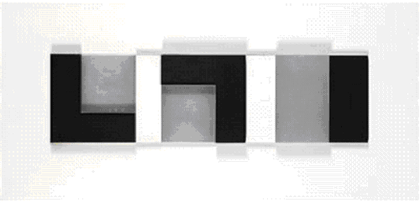
This relief is made of varnished and painted wood, black perspex, and brushed aluminium.
In a statement for a 1968 catalogue the artist John Ernest wrote the following statement.

I like to make things in which the elements are distinct and in which each decision is sure and unambiguous. My elements are squares, triangles, lines and other simple shapes. Their properties of colour and various surface qualities, together with such things as levels of relief, the distance between things, etc., constitute my palette. Mostly I work by combining these elements - either physically or in my mind. I arrange and re-arrange my basic stuff until I have assembled an order that either pleased me or satisfies the pre-conditions of the work.
Two principle interests underlie my work. One is the physical medium of the relief itself and the other is my interest in mathematical structures. They may be fundamentally different, but they are not incompatible. It seems to me that the discreteness, the separability of the parts of the relief provide a physical counterpart to the sets of elements of a mathematical system.
However, the two interests are rarely balanced in a single work. The reliefs that I have in this exhibition show a bias towards the exploitation of physical properties, (the exception is ‘linear relief 1’ which attempts o be witty about bi-lateral reflection). The drawings are more rigorously structured and were originally devised as visual analogues to particular group tables.
Victoria and Albert Museum (1968) p. 2.
The following article illustrates some of his works, both exhibited works and unexhibited sketches to reveal the underlying mathematics.
The first work shown is an unexhibited sketch.

Figure 2: The sum of the first n natural numbers
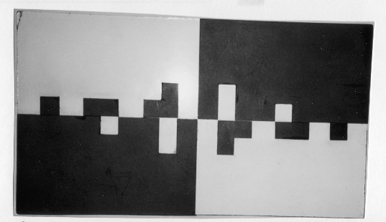
Figure 2 shows a photograph of a small relief sketch made of cardboard on painted hardboard. It illustrates a structural property in the proof of the sum of the first n natural numbers
This simple theorem states
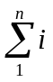 = 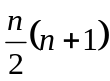
As is well known, the proof involves the following key step, the sum of n pairs of algebraic terms:

1 | 2 | 3 | … | n-2 | n-1 | n
n | n-1 | n-2 | … | 3 | 2 | 1 | +
n+1 | n+1 | n+1 | … | n+1 | n+1 | n+1
The correspondence between this compound algebraic sum and the picture (fig. 2) is clear. Black squares represent units, black grounds (together making up one quadrant) represent n black squares. Just as the upper addend in the sum increases by one unit in each step (moving left to right) – in both the first three and the last three steps – so too the lower addend decreases by one unit in each step, thus maintaining a common sum along the whole sequence (with value n+1).
The overall construction illustrates the beautiful symmetry between the first three and the last three steps. One optional feature is the choice of the L shape to represent 3 units. The L shape figures repeatedly in Ernest’s constructions of 1950s. This choice adds a pleasing complexity to the overall pattern that a simple use of rectangles (e.g., 1x3) would not have done. Furthermore it would lose the height symmetry, if such simple rectangles had been employed – see Fig. 3 below. In the author’s view this is far less pleasing than Fig. 2 above.
Figure 3: Simplified illustration of sum of the first n natural numbers
(For illustrative purposes only – not by John Ernest)
Another work of Ernest’s illustrating mathematical ideas is his Möbius strip sculpture constructed during 1971-1972, with dimensions 7’×7’×14”. The Möbius strip Sculpture was commissioned by the Arts Council for Systems, an exhibition curated by Sir Nicholas Serota at the Whitechapel Gallery London, then touring, 1972-73.
Figure 4: The Möbius strip Sculpture
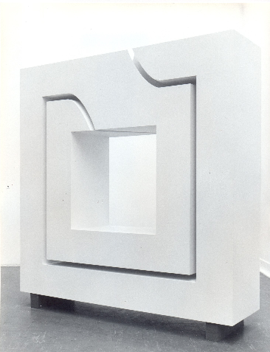

This freestanding sculpture of over 2m in height represents the Möbius strip in an original way. The Möbius strip itself would fit into the missing continuous gap in the work. The half turn is located at the top of the sculpture making the suspended inner segment hang in a surprising way. Only the half twist at the top provides support of the inner segment, with a clear view through the gap for 90% of its length (throughout the sides and bottom, and most of the top).
The work is owned by Tate Britain in London, There is a model of the sculpture of dimensions 14"×14"×4" made of wood (as is the full size construction, although in its recent restoration a metal frame was inserted). A photograph of this model is on the brochure and catalogue (pages 20&21) for the Systems exhibition, as the full size sculpture was not ready in time to be photographed for the catalogue. Photographs of the model were published with the obituary for John Ernest by Alastair Grieve in The Independent of 28 July 1994 and the obituary in The Daily Telegraph of 16 August, 1994

Works based on group theory
John Ernest made a number of works based on group theory, drawing on ways to represent group multiplication tables. His favourites were groups of order 8, which have enough complexity for rich patterns, but not so much that that the details become submerged. There are 5 non-isometric groups of order 8. For lower orders only one (order 4) has 2 different group structures (C₂xC₂, C₄). Not until order 12 is the same level of complexity reached again.

Another possible contributing factor for John Ernest’s fascination with groups of order 8 is his lifelong involvement with chess. Over the years he spent many thousand of hours playing chess, and this involves visualizing the configurations of chess pieces on an 8x8 chessboard.

Fig. 5 shows his Iconic Group Table, the only relief he ever made and exhibited based on group theory. The only other exhibited works based on group theory are represented by Fig. 9 shown below, a painting or drawing.

Figure 5: Iconic Group Table
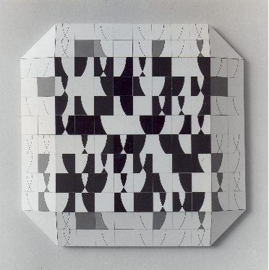

This construction embodies a table for a group of order 8. Around the edge of the 8x8 table the work is bevelled and slopes back towards the wall. On this bevelled border the elements of the table are painted so that they appear to fade away. First losing their strength of colour, and then losing all shading.
There are some ambiguities in identifying the labels for the rows and columns in Figure 3, because of the deliberate loss of details from the elements as they progress across the bevelled surround.
The group illustrated can be rendered as in Table 2.
Table 2: The order 8 group embodied in Iconic Group Table (Figure 5)

 | 1 | 2 | 3 | 4 | 5 | 6 | 7 | 8
7 | 3 | 6 | 1 | 7 | 8 | 2 | 4 | 5
2 | 8 | 4 | 5 | 2 | 3 | 7 | 6 | 1
5 | 6 | 3 | 2 | 5 | 4 | 1 | 8 | 7
4 | 1 | 2 | 3 | 4 | 5 | 6 | 7 | 8
1 | 4 | 8 | 7 | 1 | 6 | 5 | 3 | 2
6 | 5 | 7 | 8 | 6 | 1 | 4 | 2 | 3
8 | 2 | 1 | 6 | 8 | 7 | 3 | 5 | 4
3 | 7 | 5 | 4 | 3 | 2 | 8 | 1 | 6
Once the labels for the rows and columns have been found the table can be regularized so that the identity element (4) comes first and the subsequent elements are labelled in the same order for both columns and rows. This is achieved by permutations of the rows and columns, a permitted operation since it preserves the binary products.
Table 3: A regularisation of table 2 (permutations of rows and columns)

 | 4 | 1 | 2 | 3 | 5 | 6 | 7 | 8
4 | 4 | 1 | 2 | 3 | 5 | 6 | 7 | 8
1 | 1 | 4 | 8 | 7 | 6 | 5 | 3 | 2
2 | 2 | 8 | 4 | 5 | 3 | 7 | 6 | 1
3 | 3 | 7 | 5 | 4 | 2 | 8 | 1 | 6
5 | 5 | 6 | 3 | 2 | 4 | 1 | 8 | 7
6 | 6 | 5 | 7 | 8 | 1 | 4 | 2 | 3
7 | 7 | 3 | 6 | 1 | 8 | 2 | 4 | 5
8 | 8 | 2 | 1 | 6 | 7 | 3 | 5 | 4

Table 3 shows that element 4 is the identity element, and that all other elements are self inverse (of order 2). This makes it the group C₂xC₂xC₂. Inspection shows that the operation in the table is that of symmetric difference, their non-intersecting union. If the elements are seen as subsets of a square highlighted by shading, the combination of any two elements A and B, is their symmetric difference A*B = AΔB, where AΔB = A∪B - A∩B = (A - A∩B)∪(B - A∩B), where X-Y is defined as X∩Y’

This work thus embodies group theory in two ways. First of all it is an 8x8 group operation table (with the labels and elements fading away along the bevelled sides of the square). Secondly, the group operation is not merely formally defined by the group table, but has a meaning in terms of the interaction of the iconic elements themselves. This operation (symmetric difference), and the elements on which it operates, and gives rise to, will have been chosen for artistic reasons, to give a pleasing pattern. The net result is a beautifully executed design of intriguing complexity.
Another iconic group table is shown in Fig. 6.
Figure 6: A further Iconic Group Table

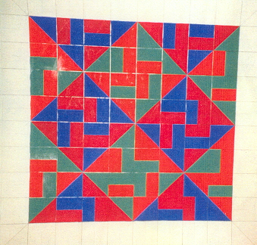

This work on paper is simply a sketch in pencil and watercolours that was never exhibited. Again it is an order 8 group table. An additional decorative feature has been added by using two shades of blue and two of red. This results in the highlighting of a pleasing diamond pattern made by all of the diagonal lines in the elements running continuously, end to end across the table. Half of the elements (32) have a diagonal line, and these combine to make up just 6 larger diagonal lines in the table diagonally bisecting the overall square and its four quadrants.

The pattern exhibited is partly reminiscent of one of Ernest’s better known works, shown in Fig. 5.
Figure 7: Maquette for Mosaic Relief Mural

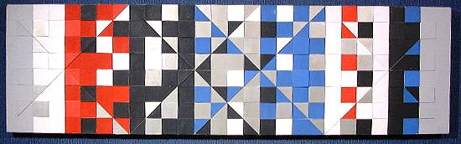
This Maquette for a Mosaic Relief Mural is 16"×55½", made of painted card and wood in white, black, red, blue, silver and grey gouache. Based on this 1961 Maquette, an 8’×28’ Mural Relief was constructed and exhibited at International Union of Architects Congress, South Bank 1961. The Relief was subsequently exhibited at US Embassy, London, but later destroyed because it was so unwieldy and made of elements including asbestos sheeting (overlaid with Formica and brushed metal).
This was John Ernest’s most complex and ambitious mosaic relief, but it did not incorporate any group structure or other mathematical principles, except the use of regular geometric shapes..
The Iconic Group Table shown in Fig. 4 can be represented as follows.
Table 4: The order 8 group embodied in Iconic Group Table (Figure 4)

1 | 2 | 3 | 4 | 5 | 6 | 7 | 8
3 | 1 | 8 | 6 | 7 | 5 | 4 | 2
6 | 4 | 5 | 3 | 2 | 8 | 1 | 7
8 | 3 | 2 | 5 | 4 | 7 | 6 | 1
5 | 6 | 7 | 8 | 1 | 2 | 3 | 4
7 | 5 | 4 | 2 | 3 | 1 | 8 | 6
2 | 8 | 1 | 7 | 6 | 4 | 5 | 3
4 | 7 | 6 | 1 | 8 | 3 | 2 | 5

This can be regularised as follows.
Table 5: A regularisation of table 2 (permutations of rows)

1 | 2 | 3 | 4 | 5 | 6 | 7 | 8
2 | 8 | 1 | 7 | 6 | 4 | 5 | 3
3 | 1 | 8 | 6 | 7 | 5 | 4 | 2
4 | 7 | 6 | 1 | 8 | 3 | 2 | 5
5 | 6 | 7 | 8 | 1 | 2 | 3 | 4
6 | 4 | 5 | 3 | 2 | 8 | 1 | 7
7 | 5 | 4 | 2 | 3 | 1 | 8 | 6
8 | 3 | 2 | 5 | 4 | 7 | 6 | 1

Although there are no labels for this table, 1 looks like a good bet for the identity element.
From this table, based on this assumption, the properties of the elements can be inferred.
Table 6: Properties of the elements

Element no | inverse | order
1 | identity | 0
2 | 3 | 4
3 | 2 | 4
4 | 1 | 2
5 | 5 | 2
6 | 7 | 4
7 | 6 | 4
8 | 8 | 2

With elements of these orders the group can be identified as C₂xC₄.

Another sketch by John Ernest is shown in Fig. 8.

Figure 8: A further Iconic Group Table

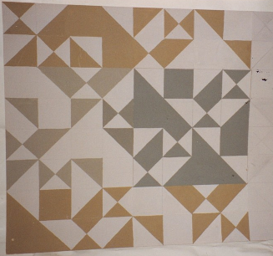

This appears to be another order 8 iconic group table, somewhat similar to that in figure 3, because the elements could be derived from each other by a symmetric difference operation. The different shades of colour are purely decorative, but give a pleasing look to the picture. The different elements combine with each other to give a complex series of adjacent shapes. The author has not attempted to identify the group involved (assuming there is an underlying group structure)

The elements used here are the same as in Fig. 9 below, further suggesting that the operation is that of symmetric difference, as it is to be in the following figure.

Figure 9: An Iconic Group Table with Labels
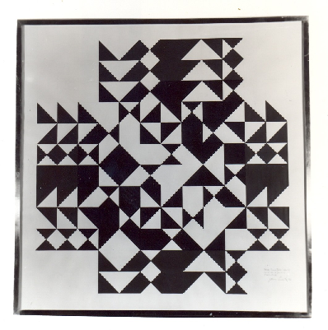
This painting (fig. 9) is the only one of John Ernest’s iconic group tables that is in a public collection of which the author has knowledge (it may be one of a set of 4 such works). It was commissioned from the artist in 1968 by the Victoria and Albert museum, for an exhibition. Four Artists Reliefs, Constructions and Drawings, Victoria and Albert Museum, 1968. This show also toured the UK in 1971-72 as a V&A loan exhibition.

Close scrutiny suggests that this is another group of order 8. The top, bottom, leftmost and rightmost two rows and two columns are labels (repeated). The table has been turned into a cross shape by the addition of these label rows and columns. Since the first element in the table, the identity element, is represented by a blank square, the third row from top and third column from left are in fact the first row and column of the table. The identity element runs down the leading diagonal of the table. This indicates that all elements are self inverse, thus identifying the group as C₂xC₂xC₂.

The group present in Fig. 9 can be rendered as is shown in Fig. 10.
Figure 10: The group table in the centre of Fig. 9

1 | 2 | 3 | 4 | 5 | 6 | 7 | 8
2 | 1 | 4 | 3 | 7 | 8 | 5 | 6
3 | 4 | 1 | 2 | 6 | 5 | 8 | 7
4 | 3 | 2 | 1 | 8 | 7 | 6 | 5
5 | 7 | 6 | 8 | 1 | 3 | 2 | 4
6 | 8 | 5 | 7 | 3 | 1 | 4 | 2
7 | 5 | 8 | 6 | 2 | 4 | 1 | 3
8 | 6 | 7 | 5 | 4 | 2 | 3 | 1

The only photographs available are in black and white but the author has a memory of it being bi-coloured in both black and red, and slightly different hues are suggested by the photograph, and the picture in the catalogue for the exhibition. The operation appears once again to be that of symmetric difference.

The combination of the adjacent elements in the table and its surrounds gives rise to a variety of complex and unexpected shapes. Treating the drawing as monochrome, this arises as adjacent black shapes merge into larger black shapes, and this happens equally with the white shapes. Different patterns would emerge if the colouring were revealed.

Conclusion
John Ernest’s source of inspiration in mathematical concepts and theories has been illustrated here, although there are many more examples in his work. He was also fascinated by the golden section, and various topological and geometrical objects and results including the Klein bottle, and the Desargues configuration. The examples shown illustrate both this (mathematical) source of inspiration, but also his belief that aesthetic considerations must always take precedence over mathematical ones, to avoid the danger of the artistic process becoming mechanical. Many artists have been inspired by mathematics, but few have delved into its deeper structures as a source of inspiration for their art as has John Ernest.

References

Grieve, Alastair (2005) Constructed Abstract Art in England After the Second World War: A Neglected Avant Garde, Yale University Press.

Reichardt, Jasia (1964) Some notes about the work of John Ernest, John Ernest Constructions 1955-64 (Catalogue for one man show) ICA, London: Institute of Contemporary Arts, p. 1.
Victoria and Albert Museum (1968) Four Artists Reliefs, Constructions and Drawings, London: Victoria and Albert Museum.

The artist John Ernest is the author’s father.

