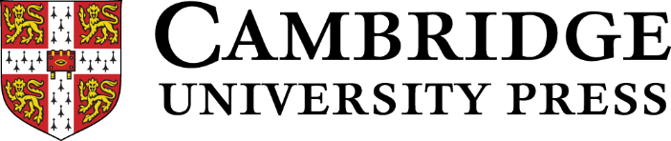

BAAL / CAMBRIDGE UNIVERSITY PRESS SEMINAR 2021-22:

Going Meta: Bringing together an understanding of metadiscourse with students’ metalinguistic understanding.

Seminar Focus Questions
- What do we know from research about metadiscourse in writing?
- What do we know from research about the metalinguistic understanding of writing?
- What are the possible connections and disconnections between the two?

9.00 Welcome and Introductions

9.05 Seminar Series Welcome on behalf of BAAL
Dr Tae Hee Choi, Education University of Hong Kong.

9.15 Overview of the ‘Writing the Future’ study: the springboard for this seminar series
Assistant Professor Abdelhamid Ahmed, University of Qatar.

9.30 The Corpus Study of Metadiscourse in ‘Writing the Future’
Dr Esmaeel Abdollazadeh, University of Exeter.

9.45 The purpose of the seminar series
Professor Debra Myhill, University of Exeter

10.00 Participant Presentations

The role of teacher-guided talk in facilitating metalinguistic understanding.
Annabel Watson, University of Exeter

The sociopragmatic dimension of language use and evaluations of interactional behaviour. A cross-cultural investigation of Italian and British-English speakers.
Valentina Bartali, University of Warwick

Metalanguage and metadiscourse in negotiating new understanding.
Anna Mauranen, University of Helsinki

10.45 Break

11.15 Participant Presentations

The linguistic/metalinguistic distinction in writing
Joana Batalha, Linguistics Research Centre of NOVA University Lisbon

Understanding Decision-Making in Annotating Metadiscourse in Learner English Essays
Lee McCallum, Coventry University

Stance and Judgment: What We Know about Successful Student Writing in the Disciplines
Zak Lancaster, Wake Forest University

12.00 Plenary discussion: ‘Mapping the territory’ of research in metadiscourse and metalinguistic understanding for writing - connections and disconnections.

12.30 Next Steps and Close

