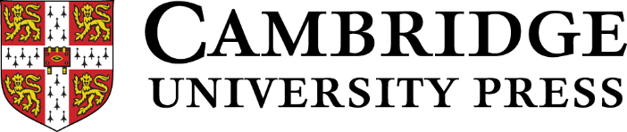

BAAL / CAMBRIDGE UNIVERSITY PRESS SEMINAR 2021-22:

Going Meta: Bringing together an understanding of metadiscourse with students’ metalinguistic understanding.

Seminar Focus Questions:
- What might be the driving questions for a Special Issue?
- What might the Call for Papers briefing cover?
- What journal is the most appropriate for this Special Issue?
- What are the next steps to see this through to completion?

9.00 Welcome and Introduction

9.15 Where we are? An overview of discussions and reflections from the seminars this far.

9.30 Breakout Groups: to discuss ‘What might be the driving questions for a Special Issue?’

10.00 Group Feedback

10.30 Break

11.00 Breakout Groups: to discuss the Call for Papers and possible journals to approach.

11.30 Group Feedback

12.00 Plenary Discussion on next steps

12.30 Close

