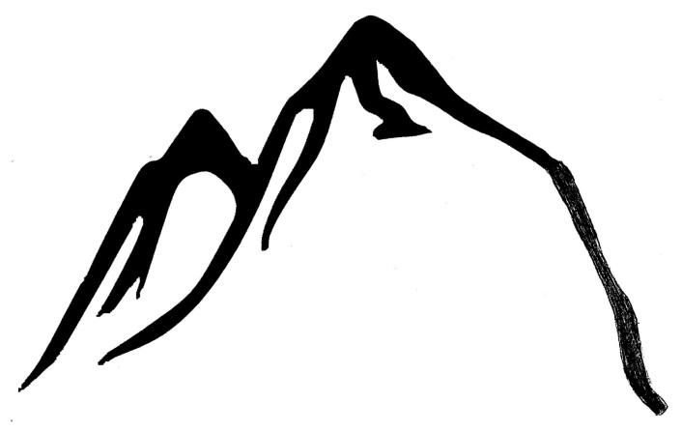

OPENING

PROBLEM

CLIMAX

RESOLUTION

ENDING

