PAIR2004 Group research project:

Sovereign Housing Association: Needs and Expectations of Younger Tenants

Student ID Numbers:
24883166, 24693731,
24256542, 24590665, 24858587,
23409444, 24808555, 23520035,
25104365, 24974498

Word count: 5,748

Executive Summary
Across the South and South-West of England, over 34,000 properties are provided by Sovereign housing and tenancy options include social renting, private renting and shared ownership. This paper’s main focus is on the social housing provision and its tenants. A team of researchers from the University of Southampton were tasked to explore and report on three key questions that Sovereign have outlined to be important and relevant to their business. First, whether or not Sovereign’s tenants are shifting to a younger demographic. Secondly, whether or not their needs and expectations are different compared to older tenants. Thirdly, if these needs and expectations are different, then what are these needs and expectations? "Young" tenants have been defined by the age bracket 16-25. Our results showed that:
- Contrary to the notion that the demographic may be getting younger, the demographic of people in social housing is increasing – the number of ‘young’ people is decreasing.

- The lack of entrants to social housing at a young age is partly offset by the increasing number of people prolonging residence with their parents/family.

- The younger people that are Sovereign social housing tenants have similar needs to the older tenants. One main discrepancy between needs is that younger people are less experienced and knowledgeable as to how to plan and manage financial matters. Older people tend to have little trouble with this.

- What was crucially different with younger tenants as opposed to the older ones is the difference in expectations. Entrants to social housing that fit the "young" age bracket tend to have varying and misinformed expectations as to what they're entitled to, what is within Sovereign’s jurisdiction to provide, and what they, as tenants, are permitted to do within their contract terms.

- The process and channels, in which tenants can approach Sovereign with grievances, queries, or other problems, may provide Sovereign’s staff with a skewed perception about the demographic. Research found that younger people are more likely to approach Sovereign with their concerns than the much older tenants. This suggests that the "young" demographic is more vocal about their problems, but do not actually make up a bigger part of the demographic.

- Major differences in the expectations of 16-25 year old tenants stemmed from a lack of pre-social housing education as to what their is available. Many expect the quality to be higher than it actually is, and do not realise a lot of the difficulties they would face living alone in social housing until they actually move in. However, this does not seem to be the case with all tenants as there was some evidence to suggest what they received was what they expected.

- Some young tenants are not as informed as others, for instance many did not know they must leave the house in the same condition as they found it when moving out. Also, a lot of younger tenants expect items that aren't provided by Sovereign in all cases such as TVs, carpets, and other non-essential items.

- We propose some ideas as to how Sovereign can improve their services to ensure higher quality and tailored services for these younger and more vulnerable residents. These suggestions will be outlined in the "policy recommendations" section of the paper.

- We conclude that Sovereign should not focus on a major structural shift of resources and effort to accommodate the tenants within the "young” bracket. The majority of the demographic are still older tenants, and Sovereign should use their experience and knowledge in that area to continue efforts to provide good quality service to them.

Rationale:

Sovereign Housing is a large scale housing provider that owns and manages approximately 34,000 homes in the South and South West of the UK. Their mission is “creating homes, shaping communities, changing lives”. They provide homes to all ages, backgrounds and economic statuses, but tenants must be able to pay their rent. They are regulated by the Homes & Communities Agency, who provides Sovereign with “about 20% of the cost of building new homes, with the remainder secured from financial institutions”.
The current government’s ideological direction has manifested itself in large cutbacks to public spending budgets. Consequently, there has been a significant reduction in the subsidy that housing associations receive from the government. This has created a need for housing associations, like Sovereign, to use their resources more efficiently which can be done if spending is fine tuned. In the interest of improving their services and spending their budget more efficiently, Sovereign were keen to better understand the demographic of their tenants. They believe that “the demographic of the people we are now housing is gradually lowering the overall age of our residents”, and given that younger people tend to be less satisfied with the services Sovereign provide, there may be room for improvement and increased suitability of their services to younger tenants. Also, if our research indicated that a demographic shift in Sovereign’s tenants to younger households had indeed occurred, then Sovereign could reduce the number of homes that are developed to accommodate the elderly. To understand the situation better, a “sound evidence base” is required: we are to provide, or at least help in providing, this evidence base. Research on social housing tenants is very relevant as it is required if housing associations are to reduce spending without compromising on the quality of service they provide.

Three questions were tasked to us in the policy brief we received:
- “Is there a shift in the demographic of our tenants to younger households?
- Are we right to believe that the needs and expectations of our younger tenants are different?
- If so, what are their needs and expectations?”
The first question is fairly straightforward and requires data analysis, the methods for which will be discussed in the methodology section. We agreed with our principal point of contact with Sovereign – Chris Smith – that our research on this point would be broadened to all social housing tenants in the UK, as opposed to just Sovereign’s residents, as it was felt that the demographics in social housing would be similar in other housing associations. The answer to this question will provide Sovereign with sound evidence as to the ages of tenants in social housing, in recent years, currently, and predicted for the future. From this, it will be clear as to whether the belief regarding “lowering the overall age of” their tenants is correct or not.
The second and third questions require more qualitative analysis, the methods for which will be discussed in the methodology section. The results of these questions will need to be considered by Sovereign’s staff in terms of what they currently provide and do for young people, as well as their beliefs about what young actually people want and expect whilst in social housing.
Evidence of this nature already exists in part. Centrepoint’s ‘Is Housing Working for Young People?’ report looks at where young people are living and in what proportions, i.e. private renting, social renting or owning in some capacity. It also looks at young people on Housing Benefit and how it works in practice: we are adding to this body of evidence by finding out what kind of things young people expect in social housing, which we expect to include comments on the benefits system. The personal experiences of many voluntary Sovereign housing tenants will be included in our report, but in a more detailed way than the quotes occasionally dropped in the Centrepoint report.
We anticipate at least one common issue in social housing being made clear to us through our primary research, which will not only shape our key policy recommendations but will also add to the recommendations Centrepoint makes in their ‘What needs to change?’ section; the recommendations they make, we believe, require expanding and further research, such as the idea of housing strategies.
The Joseph Rowntree Foundation report entitled ‘Housing Solutions and Options for Young People in 2020’ provides much useful analysis for the future of housing for young people. Whilst ‘young people’ are defined as being 18-30 in this report, the data and graphs are still useful in looking at trends in the tenure of different types of housing. We will compare the data provided in this report with data from several government sources (English Housing Surveys, CORE data and Census data) in order to establish trends in social housing tenure. The policy recommendations made in the JRF report will also be compared to our findings in order to propose more effective policy recommendations.

Methodology:

For this project we used a variety of research methods to gain an overall perspective of the needs and expectations of younger tenants in social housing as well as the demographic of social housing tenants.
In order to establish the needs and expectations of young people in social housing, we conducted primary research in the form of interviews of housing officers from Sovereign, in order to get their perspective of the topic. We opted for semi-structured face to face interviews to probe them about their understanding of the needs and expectations of younger tenants and let the housing officers discuss various views they have come across in their work. Halperin and Heath (2012, p. 254) believe that this type of technique is best for an in depth exploration of points as it leads to a long and detailed discussion of issues. After interviewing the housing officers we were able to transcribe the interviews and pick out the opinions and issues relevant to our research. Through doing this we gained up-to-date, primary data on perceived tenants needs and expectations in Sovereign Housing (through the housing officers) of tenants of different ages.
A key consideration we had to take into account when interviewing is the likelihood of bias in our findings. Halperin and Heath (2012, p. 259) suggest that by conducting semi-structured interviews there is some risk in the interviewees recalling the information accurately as well as giving information that the interviewer wants. However, whilst these disadvantages do exist, Marsh and Stoker (1995, p. 152) suggest that interviewing is still the most appropriate technique to use when trying to understand people’s views and opinions. As a result, by conducting interviews with housing officers we were able to gain a more in depth understanding of young people’s lives living in Sovereign Housing, making our findings and recommendations as accurate as possible.
Our second form of primary research involved conducting a focus group with Sovereign housing tenants and asking them what their individual needs and expectations are. This focus group built on our previous interviews with the housing officers and enabled us to see exactly what young tenants in Sovereign Housing want. Again we opted for a semi-structured approach as we could have an in-depth discussion amongst tenants and get first hand views on what young people expect in social housing.
Burnham (2008, p. 213) suggest that by conducting these discussions the investigation is open to new and unexpected information that would not be possible with face to face interviews. By letting the tenants discuss their issues about Sovereign Housing in a structured way we could analyse their expectations for social housing in general. As a result, we could also find out what the younger tenant’s needs are, and if these needs differ from the other tenants. However, the limited number of tenants that participated in the focus groups limits the representative ability of our research; further research with different tenants would aid in establishing the validity of our research.
By interpreting and analysing the information gained through interviewing the housing officers and conducting the focus groups with young tenants, we could accurately gauge whether the needs and expectations of young people in social housing do indeed differ from the general needs of tenants.
In order to establish any trends in the demographics of social housing tenants, we performed secondary data analysis. We used the 2001 and 2011 UK Census to look at certain demographic trends, including changes in age and ethnicity in England over the past ten years, and information about the size of social housing stock and the number of people living in social housing. The census is primary data, and as such should be free from bias or analytical interference. As a source (government data out of the Office for National Statistics) it is reliable and gives reasonably comprehensive and accurate data.
We also looked at other government research, including from the English Housing Survey annual reports and its predecessor, the Survey of English Housing. Data we looked at from these reports includes economic statistics, such as the average weekly rent for social housing, the proportion of social renters that received housing benefit and information regarding the economic activity of those in social housing. As these are primary data sets from a reliable source it should be accurate.
The Centrepoint report, “Is Housing Working for Young People”, primarily takes its findings from the information in the English Housing Survey and so shows information including changes in the number of people in social housing and statistics regarding rents. Therefore, as it uses core data that can be checked elsewhere, it is easy to ensure that these findings are reliable. The Rowntree report, “Housing Options and Solutions for Young People in 2020”, also gives information on the types of people in social housing, and how this may change in the future. As this is a predictive report, we must not take these findings as ‘fact’. Halperin and Heath suggest the usefulness of looking at these types of data sources, as they are good at “reducing bias” and also useful in studying “larger populations…than would be possible through either interviews or direct observation”(2012, p. 318-9).

Findings (demographics):

Below is a presentation of existing evidence and data from a variety of reports that we systematically reviewed, regarding the historical, current and predicted state of social housing tenants in the UK. We then make a series of conclusions based on this evidence. Corroborating data in this way adds to the validity of the data and decreases the likelihood of our research being wrong. We also draw on a series of different data sets, as the reports are from different organisations, furthering increasing the accuracy of our conclusions. The information presented, including graphs and tales where relevant, has been selected by its relevance to answering the question regarding change in the demographic of social housing tenants laid out in the policy brief.

Social Housing Lettings & Sales in England, 2011/12: Continuous Recording (CORE)
In 2011/12, 80% of social housing providers (659) were Private Registered Providers, supplying 72% of the social lettings recorded.

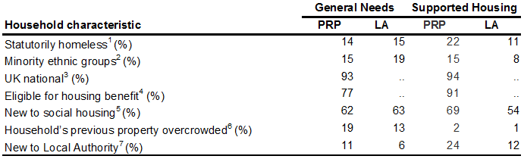
Table 1: Key household characteristics of social lettings, 2011/12 (p. 8)

This table shows household characteristics for ‘general needs’ i.e. standard needs social housing, and ‘supported housing’ i.e. special facilities are required, such as for disabled tenants. The use of this table is largely limited to the eligibility for housing benefit statistic.

Rowntree report: Housing Options and Solutions for Young People in 2020
The independence of young people in all housing sectors is going to drop in the coming years; many will live move in - or live longer with - their parents. The total number of young people living in their own social rented tenancies in 2020 is predicted to decrease by approximately 360,000 to 780,000, compared to 2008. The number of young people living with parents in social rented accommodation is predicted to increase by approximately 170,000 to 870,000.

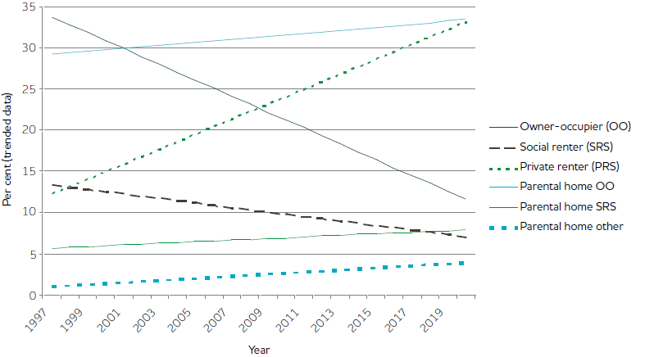
Graph 1: Trend-based tenure change and projections for young people aged 18-30 between 1997 and 2020 (p. 17)

This graph shows the recent and predicted trends of tenure in the different types of housing for young people. It demonstrates a downwards trend in social housing tenancy, and also which types of housing the rest of the ‘young people’ demographic live in.

English Housing Survey Report 2011-12
The number of social housing tenants has been on the decrease since the 1980s.
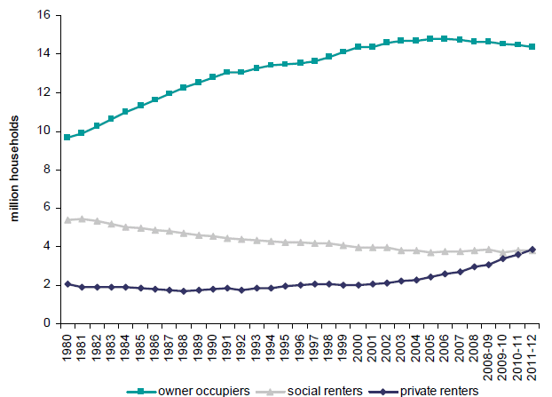
Graph 2: Trends in tenure 1980 – 2011/12 (p. 10)
The graph above shows the long term trends in tenure (for all ages, not specifically young people) of the three main types of housing. Along with Graph 1, it shows a declining trend in social housing tenancy.

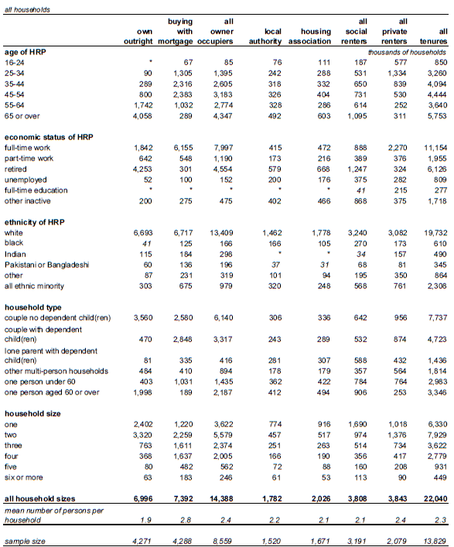

Table 2: Demographic and economic characteristics, thousands of households, 2011-12 (p. 11)

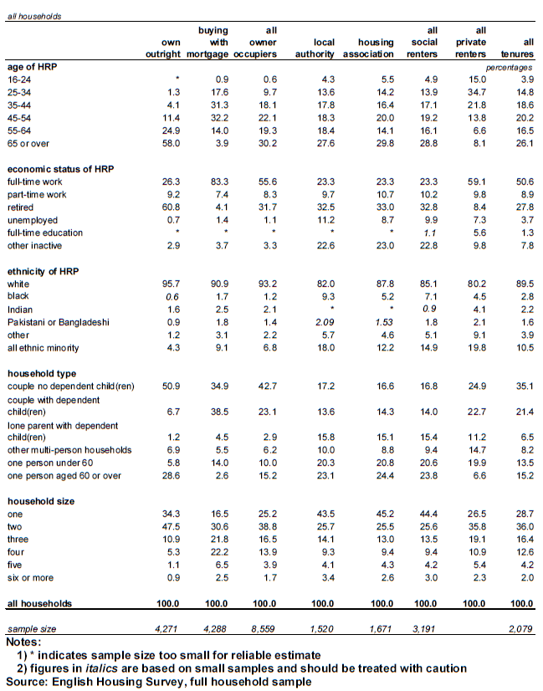
Table 3: Demographic and economic characteristics, percentages, 2011-12 (p. 48)
(Household reference person = HRP)
Tables 2 and 3 provide comprehensive data on the demographics of housing tenants. It is useful for considering the current demographic of housing tenants, but it only has data for last year: on its own it cannot be used for demonstrate trends, hence why other evidence is crucial.
In 2011-12, 7.7 million households were renting their homes. There was an even split between the social rented sector and the private rented sector.
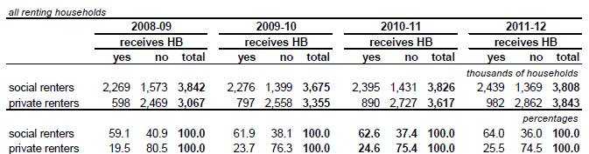
Table 4: Receipt of Housing Benefit 2008/09 to 2011/12 (p. 17)

Table 4 displays data about those receiving Housing Benefit over the last few years, demonstrating the trend that those in social housing are increasingly receiving Housing Benefit.

Centrepoint policy briefing: Is Housing Working for Young People?
Since 1981, the number of social tenancies rented by young people has fallen by 90,000.
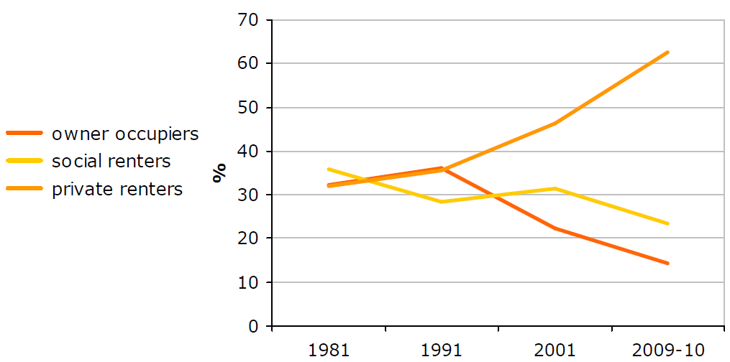
Graph 3: The changing tenure of householders aged 16-24 (p. 2)
Graph 3 shows the changing tenure of householders aged 16-24, which, along with other graphs, demonstrates the decreasing tenure of young people in social housing.

Fifteen years of the Survey of English Housing, 1993/94 – 2007/08 (Known as ‘English Housing Survey’ post-2008)
There has been a slight but steady decrease in the size of the social rented sector, from 23% of households in 1993/94 to 19% in 2007/08.
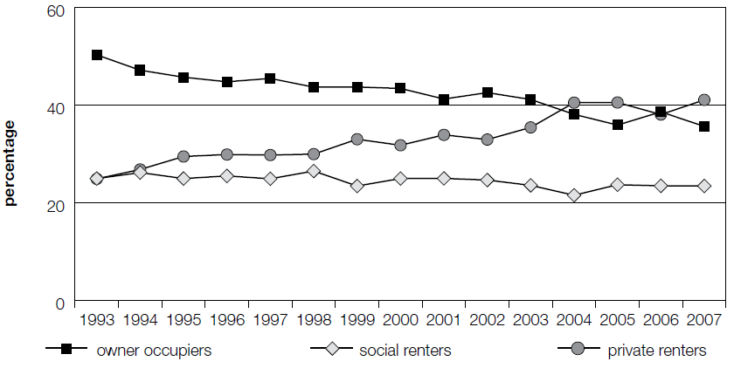Graph 4: Tenure of households age under 30, England only (p. 8)

Graph 4 shows the tenure of households for under 30 year olds in England. It shows a slight decrease in the tenure of young people in social housing; this is different to the other data, but the different age gap probably accounts for this.

UK National Census (2001 and 2011): England data
- The number of social rented households has fallen between 2001 and 2011, from 3,940,728 to 3,903,550 (19.26% to 17.7%).
- The total number of social rented residents has fallen from 8,648,718 in 2001 to 8,570,417 in 2011.

Conclusions about age:
Young people currently account for 5% of the share of social housing. The number of young people living in social housing has fallen in recent years and the number of social housing tenants has been decreasing since the 1980s.
The number of young people in the country grew between 1981 and 2009/10, but the number of young people in social housing has fallen by a third, to under 195,000: the number of young people in social housing is at its lowest level ever. See tables 2 and 3, and graphs 1, 3 and 4.

Conclusions about ethnicity:
Comparing the figures from the UK National census’ to the percentages of households in housing associations in the English Housing Survey Report 2011/12 (see Table 3), assuming that the HRP’s ethnicity is representative of the whole household, we found:
There is a higher than proportionate number of ‘white households’ in housing association properties; there is a lower than proportionate number of ‘black households’; there is a higher than proportionate number of ‘Pakistani or Bangladeshi households’ (almost double the percentage). The biggest change in percentage of the population is the Black ethnic group, followed by Pakistani and Bangladeshi, followed by Indian.

Conclusions about economic status:
The economic activity of social renters has seen little change between 1993 and 2007 (data for England only). The percentage of people working full time in social housing is 23.3%, with an additional 10% working on a part time basis. 10% of tenants are unemployed but a further 22% are registered as other inactive (not seeking work). This shows that housing associations need to be sympathetic and flexible to the needs of underemployed or unemployed tenants as they form a large proportion of their client base. In addition, a significant proportion of the other inactive residents may require additional support as this classification includes all tenants with disabilities, which impair their ability to work. See tables 2 and 3. In 2011/12, 64% of those in social housing received Housing Benefit, compared to 26% in the private sector. See tables 1 and 4.

Conclusion about proportions of types of tenure over time:
The changing tenure of households aged 16 – 24 demonstrates that there has been an overall downward trend with regards to the level of young people in social housing. See graphs 1, 2, 3 and 4.

Findings (needs and expectations):
After interviewing three different Housing Officers from Sovereign Housing, we gained a good understanding of the needs and expectations of younger tenants from the Housing Officers' input. Furthermore, we conducted a small focus group with tenants, also from Sovereign housing, who provided significant insight into the needs and expectations of younger tenants. In this section we split up the findings relevant to each of the three questions covered in this project. We will refer to the Housing Officers as HO 1, HO 2 and HO 3.
The first topic we covered in the interviews is that of demographics and if there had been any noticeable change in the demographic. The responses from all three Housing Officers were fairly inconclusive and on the main part suggested that there had been no noticeable changing demographic. However the findings here suggested that demographic was dependent upon location. With HO 3 explicitly suggesting that the demographic was different in different areas, with this Housing Officer's area being mainly occupied by younger tenants. HO 2 also suggests that the demographic is different in different areas. HO 2 postulated the idea that there was an increase in younger couples with children appearing in the rural areas of Sovereign Housing. Our findings on demographics from the interviews suggest that there is no definitive change in demographic towards younger tenants, as backed up by our secondary research.
The findings, in relation to how the needs and expectations of younger tenants differ from those of older tenants, demonstrates that young people are more demanding yet less aware of what is on offer. HO 2, and HO 3 both suggest that younger tenants are more demanding than older tenants and HO 2 advocates that younger tenants expect more ’hand-holding’ than older tenants and expect more physical and financial assistance, such as more goods in the kitchen. These expectations, suggested by HO 2 and HO 3 are in conflict with the responses from HO 1, who suggested that younger tenants are less likely to come in asking for help as they are shy or just don't want to seek help. This seemed to be supported by the focus group with participants feeling they could not ask for help as they felt a stigma is attached to asking for help. The further difference between young and old tenants is that of financial planning and anti-social behaviour: this will be covered in the next section. We can summarise that the needs and expectations of younger tenants do differ from that of older tenants, with younger tenants demanding more physical and financial aid, and also more ‘hand-holding’.
The area most significantly covered topic in the three interviews and focus groups was that of the needs and expectations of younger tenants. These responses mainly covered that of needs, from the focus group participants and the Housing Officers' view on what the biggest problems or areas of concern. The most significant of these included problems with financial planning, relationship breakdown, and anti-social behaviour. With HO 1 and HO 3 suggesting that financial planning was the biggest problem, whilst HO 2 believed relationship breakdown and anti-social behaviour to be the biggest problem. However, all three Housing officers believed these issues to be significant. The needs relating to financial planning can be seen as most significant from the findings. HO 1 emphasised problems with money management, whilst HO3 highlighted not knowing where to go with problems, linked to the Housing Officer's belief in lack of education and information friendly to younger tenants. In terms of problems with anti-social behaviour, from the Housing Officers' point of view; these are linked with a lack of education (HO 1), lack of previous independent living (HO 1 & 2), a social barrier and the younger tenants being rebellious with no structure (HO 2). From these findings, the most significant problems constitute financial planning, money management, anti-social behaviour and relationship breakdown.
Whilst the Housing Officers brought up expected issues, the focus group raised an issue which was surprising. The focus group felt that the needs of younger people were not being addressed to the same degree as the older tenants. The participants felt that the younger tenants were being ‘contained’, citing an example of a tenant they knew who had been placed in temporary accommodation for a couple of years and that being placed into temporary accommodation was seen as “cattle holding”.
The focus group provided a positive response in regards to the expectations of social housing. The participants expected social housing organisations to: cover repairs and maintenance, help with anti-social behaviour issues, and offer help and advice where needed. Participants built on this by explaining they felt that Sovereign did these functions very well, particularly praising Sovereign’s approach to anti-social behaviour problems. On the other hand, participants explained there were communication issues with the maintenance team, such as appointments not being kept and issues in correspondence, such as wrongly addressed letters.
Another need raised by the focus group was in regards to information provided by Sovereign. The participants of the group felt that the delivery of some information was very good, such as the website and the monitors in the Sovereign buildings, but other methods were not as effective. The contributors felt that the newsletter magazine was overwhelmingly packed with too much information and that some of the content did not apply to them, such as the information regarding Sovereign in other locations. Furthermore, the participants felt there was a lack of information provided around local issues which affected them, such as panels by Sovereign that tenants can get involved in and make their voice heard. Lastly, the group also believed the information provided to tenants when moving could be better suited. The participants felt that an information pack tailored towards younger people containing useful information, such as contacts and services ideal for them, would make the transition into social housing easier.
Our research also covered what is already done in order to help tenants with their needs. Most significantly this included handing out information, and using outsourced services such as the citizens’ advice bureau (HO 1 & 2) to help with financial planning. This issue was reinforced by the view of the focus group, but felt that a direct service with Sovereign would be better as the bureau, they felt, was not as flexible. Aid in the form of information to outsourced services also featured first point for childcare services (HO 2). All three housing officers suggest information is handed out to tenants regarding advice and the outsourced services.

Policy Recommendations
From our research we have come up with a number of policy recommendations for Sovereign Housing’s consideration. This draws upon the findings outlined above from the analysis of demographic data, from the interviews with some of Sovereign’s Housing Officers and a focus group with some of their tenants.
We firstly recommend that Sovereign recognise that the number of young people in social housing across the country is actually falling and that this is likely to be the case with their tenants as well. Therefore whilst the majority of the following recommendations are focused on young tenants, we stress that Sovereign should bear in mind that young people are a decreasing minority in social housing. By this we mean that Sovereign should not change their services drastically and risk not meeting the needs and expectations of older tenants. When speaking to the Housing Officers, the impression was that whilst younger tenants are the minority, they tend to be a ‘louder’ group than older tenants; younger tenants appear to be approaching Housing Officers more often and with a wider range of issues than tenants in other age groups. It would likely be worthwhile making this clear to the company’s frontline staff, especially the Housing Officers themselves.
Due to the lack of data specific to Sovereign housing the research team had difficulty when trying to answer the demographic research question. As stated earlier in the report, general national data was used from a number of sources. We understand that the lack of demographic data on Sovereign’s tenants is at least partly due to the company merging with a number of other Social housing organisations over the years. Because of this, it might be worth Sovereign considering whether it would be in its interest to improve their tenant data, which could mean future research is better tailored specifically to Sovereign Housing.
Our second major recommendation is wide-spread financial planning service, which stems from the interviews with the three Housing officers and the focus group. The officers suggested that some form of pre-emptive education for tenants prior to moving into social housing would ease the transition into independent living. This would be most helpful for young people, who are most likely to have not experienced independent living before. The focus group participants felt that a direct service, like a group workshop, for tenants would be incredibly helpful, especially with impending government reform which will see housing benefit paid directly to the individual instead of directly into the housing authority. It is our understanding that Sovereign currently conduct workshops in financial planning in some areas and it may be useful for the company to expand these workshops, perhaps making them compulsory for all young tenants. The focus group participants felt that if they were invited to such a session they would be more likely to partake in the exercise; this could, as a result, remove the barrier between the tenant and Sovereign staff as this may remove any stigma about asking for help. Sovereign should increase its ties with schools and colleges in areas where it has a large amount of housing stock. This would increase the knowledge of social housing and what to expect amongst potential future tenants and would also stress the importance of good financial planning.
Thirdly, we recommend that Sovereign consider reforming the information/welcome packs given to tenants when they move into social housing. An information pack aimed specifically at young people could help to avoid a number of common issues at the beginning of a tenancy. This pack would need to contain vital information, such as financial planning, rent deadlines, terms of tenancy agreements and things not to do, much of which is perhaps already known by some older tenants. It is worth consulting younger tenants, who are currently in social housing, when designing this pack as it would be useful to get their views on the current literature offered by Sovereign.
One of the recommendations which came out of the focus group was in regards to distribution and content of information provided by Sovereign housing. The content on the website and present in the Sovereign buildings in the local areas are very helpful and should be considered successful and as a result we suggest the continued maintenance of these methods to insure the excellent standards set. We also suggest the reformatting of the magazine distributed to tenants. Tenants felt that it was overloaded with information which did not affect them, such as Sovereign in other areas, and as a result did not read it at all. Therefore, we suggest a more locally tailored publication featuring local and community news which affect the tenant. It should also feature more about the local panels which tenants could take a seat on. It is also fundamental that the new publication keeps the informed with issues which affect them a lot, such as welfare reform. However, tenants would also like if any local or community events could be communicated more verbally as there already exists a lot of correspondence and paper work.
Another reform to emerge from the focus group was in regards to fine-tuning certain services. Some of the participants felt that more needed to be done in regards to child care. The participants felt Sovereign needed to be more transparent on who qualifies for childcare provision and who does not and as a result if they did not qualify Sovereign should signpost alternatives for tenant. The participants also felt having some encouragement or assistance to access health services would be appreciated, especially those who may live by themselves. Without some backing tenants felt a tendency to dodge the use of health services as there is no one to encourage them to go. The focus group was also believed that there needs to be a garden maintenance service, primarily for those who are unable to attend to their gardens. This recommendation is likely to benefit the wider tenants of Sovereign housing as those who are unable to attend to their garden are unlikely to be exclusive to young tenants. The last alteration from the focus group included the transparency of the allocation of points for houses system. The participants raised this issue as they felt at the system was arbitrary and they were unable to understand how some tenants were housed quicker when the individuals needs were less pressing.
One of the most significant recommendations drawn from the focus groups was the need for stability of Housing Officers. The participants explained that they had experienced a constant change in who was their Housing Officer and as a result felt it was difficult to build a relationship with Sovereign and as a result had problems with it services. Whilst we understand individuals within Sovereign are being reshuffled during this restructuring period, it is important to consider the effects of not having a consistent Housing Officer available for the tenants.
Our final recommendation is to conduct further research in order to corroborate the research undertaken in this report, perhaps with the use of more focus groups of young tenants. Although we managed to conduct one focus group, the exercise of multiple groups was something we had wished to conduct ourselves, however we were unable to due to logistical issues. We feel it would be worthwhile research for Sovereign to undertake to confirm our findings.

Bibliography:
Burnham P. (2008) Research Methods in Politics, 2nd ed. Basingstoke: Palgrave Macmillan.

Centrepoint (2012) Is housing working for young people? [Online] Available from: www.centrepoint.org.uk/media/164283/is_housing_working_for_young_people_v3.pdf [Accessed 10/3/2013]

Department for Communities and Local Government (2009) Fifteen years of the Survey of English Housing: 1993-94 to 2007-08 [Online] Available from: webarchive.nationalarchives.gov.uk/20120919132719/http://www.communities.gov.uk/documents/statistics/pdf/1346239.pdf [Accessed 11/3/2013]

Department for Communities and Local Government (2012) Social Housing Lettings & Sales in England, 2011/2012: Continous Recording (CORE) Data,[Online] Available from: www.gov.uk/government/uploads/system/uploads/attachment_data/file/9361/2219850.doc [Accessed: 12/3/2013]

Department for Communities and Local Government (2013) English Housing Survey: Headline Report, [Online] Available from: www.gov.uk/government/uploads/system/uploads/attachment_data/file/88370/EHS_Headline_Report_2011-2012.pdf [Accessed:12/3/2013]

Halperin S. and Heath O. (2012) Political Research: Methods and Practical Skills. Oxford: Oxford University Press.

Marsh D. and Stoker G. eds. (1995) Theory and Methods in Political Science. London: Macmillan.

Office for National Statistics (2001) Census: Key Statistics - Local Authorities KS06 Ethnic Group (England and Wales) [Online] Available from: www.ons.gov.uk/ons/rel/census/census-2001-key-statistics/local-authorities-in-england-and-wales/local-authorities-ks06--ethnic-group.xls [Accessed 4/3/2013]

Office for National Statistics (2011) Census: KS201EW Ethnic group, local authorities in England and Wales, [Online] Available from: www.ons.gov.uk/ons/rel/census/2011-census/key-statistics-for-local-authorities-in-england-and-wales/rft-table-ks201ew.xls [Accessed 5/3/2012]

