PAIR 2004- HACAN Project

“With respect to the balance of social costs and private benefits, would it be plausible to assume those in support of Heathrow expansion are acting with a vested interest?”

Contents Page

- Executive Summary page 1
- Rationale page 2
2.1) Literature Review page 2
2.11) Cost Benefit Analysis page 3
2.12) Social Costs of Heathrow expansion page 3
2.13) Economic Benefits page 4
2.14) Tradable Permits page 4
3) Methodology page 4
3.1) Who was chosen page 4
3.2) Internet research page 5
3.3) Surveys page 5
3.31) Internet page 5
3.32) Telephone page 5
3.4) Matrix Method page 6
4) Findings page 11
4.1) Table of responses page 11
4.2) Data Interpretation page 16
5) Advice to Stakeholders: page 18
5.1) Anti-aviation/ Environmentalists page 18
5.2) Industry page 18
5.3) Lobbyists page 19
5.4) Government page 19
6) Methodological Constraints page 20
7) Future Research page 20
8) Bibliography page 22
9) Appendix page 23

“With respect to the balance of social costs and private benefits, would it be plausible to assume those in support of Heathrow expansion are acting with a vested interest?”

1) EXECUTIVE SUMMARY
Over the past decade the expansion of Heathrow airport into a larger central Hub for the aviation industry within the UK has been proposed and then disregarded, and then proposed once again. The expansion is set to take the form of a third runway, and as a consequence a sixth terminal, which would thereby increase the volume and frequency of flights leaving Heathrow. In 2012 a group of 63 companies signed a letter to the Daily Telegraph issuing a statement of support towards the expansion; claiming that the expansion would help boost the economy by increasing the UK’s connectivity in global markets, creating jobs and stimulating the economy and by improving the competitiveness of the UK markets. These benefits may appear to provide enough justification for the expansion to take place but pressure groups, such as HACAN and Friends of the Earth, campaign against these claiming the benefits are exaggerated and the environmental costs are not accounted for. In order to assess if the economic benefits identified are merely a mask for the vested interests of the firms who will experience the majority of the advantages, but not the external costs. A cost-benefit analysis would be needed to conclude accurately if the social benefits are greater than the social costs, incorporating all of the externalities, in order to deem if the firms are proposing a policy that is beneficial for the majority or just their private interests.

Following a range of desk-based, Internet research regarding the firms involved in support of Heathrow a survey was issued online, and then to compensate an extremely low response rate it was then completed as a telephone survey also. However, results were unsatisfactory due to a poor level of response and the appearance of a general sense of apathy towards the project as a whole. Researchers found emails were ignored, phone calls disconnected and company policies used to prevent individuals answering questions regarding the expansion. A network map was also created using a matrix method in order to assess the links between the organizations supporting the expansion as an attempt to deem if their corporate relationships could have led to this group of pro-expansion firms forming.

Whilst results from the survey could not be assessed as discrete data that could easily be inputted into graphs and tables for analysis, the lack of response provided an interesting finding in itself. The reluctance to provide statements regarding the expansion, or in some cases the general lack of knowledge on the original letter, enables the assumption to be made that perhaps these organizations simply no longer hold such a strong interest in the matter as they previously did. The network map provided evidence for strong links between the majority of the organizations, this demonstrated another economic basis for their support of the expansion. As a result of these links it becomes plausible to assume that the firms who originally signed the letter may have done so with vested interests at the forefront of their decision-making process, as their links to firms within the aviation industry means their own firm will benefit from an increase in business should the expansion take place. The firms do not face the negative externalities created by increased aviation, such as the noise and air pollution in the surrounding area, as much as the individuals within the community, which means these will not have been accounted for within a cost-benefit analysis of each firm before they voiced their support.

The most effective way to prove that these assumptions are indeed correct would be through the creation of a much more accurate cost-benefit analysis model, with quantifiable figures. Through this an optimum for at which point the whole of the UK should consume the good, in this case flights within the aviation industry can be found. This can then be obtained through the creation of a tradable permit system regarding flights and the aviation industry. In this way the negative externalities associated with air travel can be internalized to make them the responsibility of the market, and no longer just a problem faced by individuals.

2) Rationale

Research Question:
“With respect to the balance of social costs and private benefits, would it be plausible to assume those in support of Heathrow expansion are acting with a vested interest?”

“In support of Heathrow expansion” refers to the 62 companies who signed a letter sent to the Daily Telegraph in 2012

Conditions for assumption: if social cost is greater than the private benefit the organization is acting with a vested interest to support it.

When an individual or organization makes a decision to support or oppose a policy proposal the process to make this choice comes through a cost-benefit analysis; be this a conscious or sub-conscious procedure. Costs and benefits come in two different forms; either social, and effecting the whole of society, or private and specific to the individual. Therefore as noted by Smit et al (2013) “a social cost benefit analysis (SCBA) is the most appropriate way to evaluate airport investment plans.” By utilizing a research question that involves cost-benefit analysis there is a quantifiable way to assess if the decision to support the expansion of Heathrow is because the organization is acting in a self-interested manner or if in fact their decision is the optimal for society.

Climate Change and the effect of polluting activities, such as aviation, is an extremely topical issue. As globalization has increased causing an increase in demand for aviation but many climate change campaigners fear that the cost of this is too high, as people increase their emissions at the expense of the environment. As a result of this the expansion of Heathrow and debate surrounding creating a more competitive central hub airport in the UK has become a crucial, vote-influencing election debate. In the 2010 national election every party agreed in their manifesto that they would not build a third runway at Heathrow; and yet the issue arises again and again.

2.1) Literature Review

2.11) Cost-Benefit Analysis

Cost-Benefit Analysis is a method of assessment used to calculate if the social costs of a policy are greater than the private benefits to the individuals who are in support of the proposal. This allows an assessment to be made if the supporters are acting with self-interested motivations, or if in fact they are in favour of a change, which is beneficial to the majority of society.

The Economics of Airport Expansion report (Smit et al, 2013, p9) identifies that:
A CBA typically comprises of four steps:
1. The project and the baseline scenarios are defined. If project alternatives exist, all relevant alternatives are defined.
2. The effects of the project are identified.
3. Each effect is quantified.
4. Where possible, effects are monetised.

The government Department for Transport (2005) identifies five objectives for any transport policy; Minimal Environmental Damage, High Safety precautions, Economic Efficiency, Increased Accessibility and Integration. These are carefully designed to reduce the costs of any transport policy, such as the ones in the case of Heathrow expansion, and to increase both the social and private benefits.

2.12) Social Cost of Heathrow Expansion

The main social cost of expansion to Heathrow, through the form of a third runway, is evidently the environmental impact of increased aviation. HACAN, a campaign group aiming to minimize noise pollution in the area surrounding Heathrow, claim that if the expansion were to go ahead there would be one million people disturbed by the noise, 700 homes destroyed and it would lead to Heathrow being the biggest CO₂ emitter in the UK (HACAN, 2006). There is much dispute over if the government plan for the expansion is accurate, with Friends of the Earth identifying five main flaws; primarily their report states that the cost-benefit analysis completed by the policy designers does not provide relevant weight to the costs and benefits by undervaluing the environmental impact (Friends of the Earth, 2008, p3).

The Economist ran an online reader’s opinion group; asking for individuals to write in with their beliefs on if Heathrow expansion through the building of a third runway would be beneficial. Much of the opinions collected by this project claimed that it would be more convenient to split the increase in flight availability across regional airports as opposed to creating one central hub. Whilst MP Caroline Spelman claimed in The Economist (2013) it was most important to reduce our emissions especially around Heathrow where the UK is already in violation of EU air quality directives; this shows that this group of people have deemed the social costs of the third runway to far outweigh the benefits and are looking for other alternatives to improving transport links.

2.13) Economic Benefits

Those in support of the expansion of Heathrow are individuals and organizations that see the economic benefits of the third runway to be high enough to justify the social costs previously identified. Supporters of Heathrow expansion claim that the UK needs to become more globally competitive, and for this to occur a strong hub airport is needed to improve trade links and add to the ease of Multinational Corporations in using the UK as headquarters. Furthermore any fiscal stimulus in the economy, such as the construction of a runway or an influx of passengers in an area, will create more employment in the local area, which will improve the economy of the UK as a whole.

However, the strength of these economic arguments is questionable with recent reports stating, “claims about the economic benefits of connectivity are not founded on solid evidence.” (Smit et al, p44). Upon investigating the link between connectivity and economic growth, through trade, “empirical evidence suggests there is a weak correlation, mostly for less developed economies, but there is no evidence of causation.” (Smit et al, p6) If this is true then the extent to which the benefits of an expanded Heathrow may have upon the British economy could be seen to be greatly exaggerated.

2.14) Tradable Permits

Tradable permits are one popular solution to solving market failure where there is a high level of negative externalities. A tradable permit creates “a transferable right to emit a substance that can create pollution” (Ellerman, 2005) which means the allocation of permits accompanied by a bartering system will enable the problems of over-consumption to be internalized. This means the problems associated with noise pollution and CO₂ emissions is accounted into the decision of the airport to provide more flights, or to build a third runway.

3) Methods

3.1) Who was chosen

The sampling frame that we chose were the companies and organisations drawn from the ‘Heathrow in crises’ letter in the Daily Telegraph. From here there were a total of 62 names of signatories who supported the expansion of Heathrow, in the form of a third runway. This was the easiest way to highlight a broad group, interested in expansion and from this to try and identify motives of those involved.

3.2) Internet Research:

All the signatories and their associated organisations were then researched to gain a general insight into their background and trying to determine possible motives for signing the letter. This was incredibly helpful as there was a lot of information that was readily available, very quickly a benefit as noted by Jackson (2007). However, a draw back of using such a method to try and extract data is that not everyone provides the same level of data, so some of the organisations had to be emailed in order to try and gain the basic level of data. From here the data was put into an Excel spreadsheet, it also formed the base for the Matrix that was used to cross reference links between organisations and companies. The best way to go forward to advance the limited information we had was to conduct an online survey to gain a deeper insight into the realities of the situation.

3.3) Surveys:

3.31) Online

With the low research budget available to us, the best way of trying to gather all the data we required was to email those who signed the ‘Heathrow in Crises’ letter. In addition, given the time constraints of trying to collate the data and then be able to construct any analysis, the swiftness of the online survey made it the most applicable form of data collection for our research project.

However, this in itself was problematic owing to the low response rate of an online survey as highlighted by Aldridge and Levine (2001). The drawback of using such a method, which we have accounted for, is the lack of trust of handing over information online. Without knowing whom you are giving the information to, or the purpose of the information, it is hard to attract people to actually fill in the survey.

As a result of the response rate being zero, we had to adapt the online survey to use for a phone survey. This gave us a chance to speak to those contacts that had signed the initial letter in support of the expansion of Heathrow.

3.32) Telephone

The benefits of having a relatively large research group was that because phone surveys are labour and time intensive, they could be catered for in a short period of time. In addition, as there is direct contact between interviewer and interviewee it allowed us to gain some responses. Owing to the wide geographic range of the companies that signed the letter, the telephone interview was a practical alternative to the Internet survey.

On the other hand though, the telephone survey did have some major drawbacks. For example, a number of the companies that signed the letter were in fact large multinational companies. They were very difficult to permeate and to try and get a contact because no one within the organisation wanted to conduct a phone survey. Furthermore, as the survey was quite a long one, with some more challenging questions, it was not really applicable for a telephone survey.

3.4) Matrix Method

As part of our report, we decided to create a matrix map showing whether there are any links between any of the companies who have supported Heathrow expansion.

Using Excel, we created a 62 by 62 spreadsheet, an example of which is shown below. We then used the Internet to conduct research into whether there were any links between the organisations in question. When we found links between the companies and groups, we entered a 1 in the cell, and where no links were found, a 0 was entered.

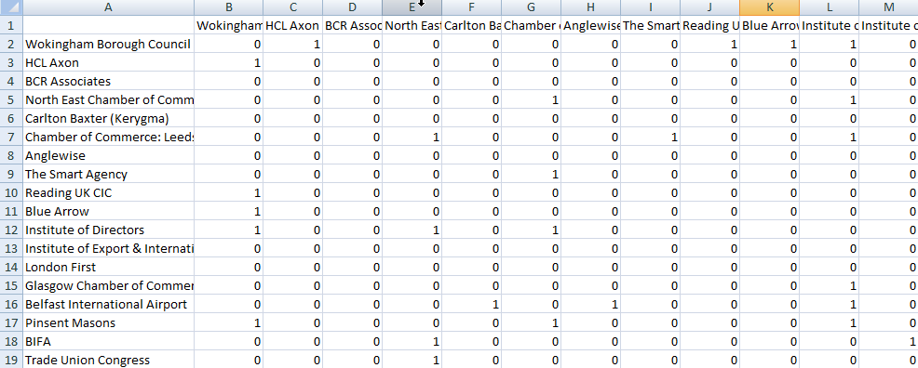
A “1” was entered in this cell, which indicates a link between Chamber of Commerce: Leeds, York and North Yorkshire and The Smart Agency
We entered a “0” in all cells diagonally through the spreadsheet since companies cannot have links with itself

In order to build the matrix, we used NetDraw, a windows program for drawing and visualizing social network data (Borgatti, 2002). The screenshots below show the steps taken to create the matrix on NetDraw.



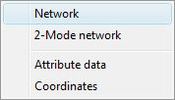

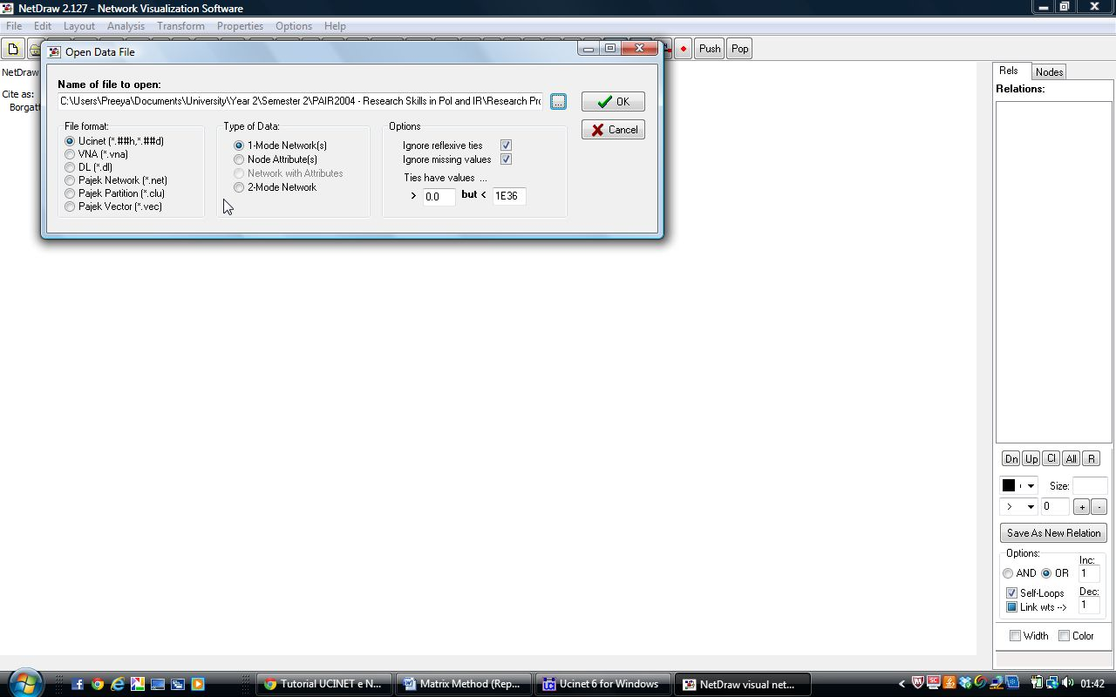
We opened the Excel Spreadsheet in NetDraw
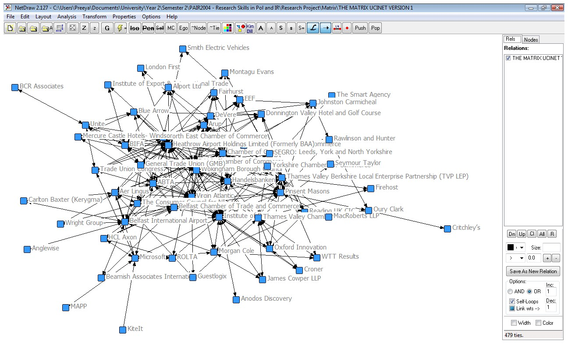

As shown above, NetDraw automatically created a matrix once the spreadsheet was open in the program. However, at a glance, this was visually not very effective as it was not easy to see the names of the companies or whether the links were concentrated.

In order to improve the visualisation and analysis of the matrix, we grouped the companies by industry, created a colour coding system and moved the nodes to form a circular shape.

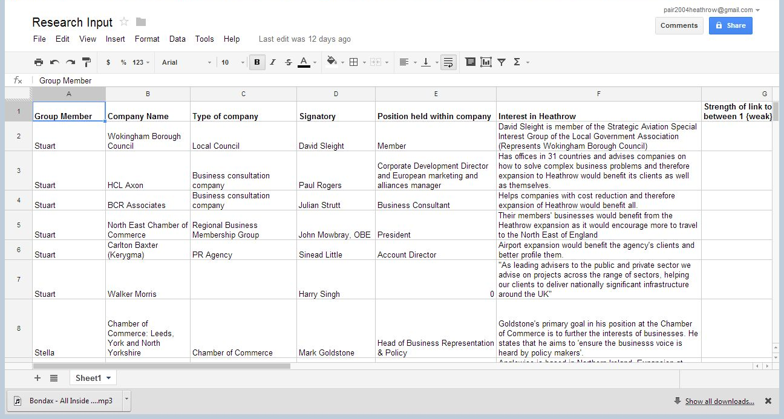
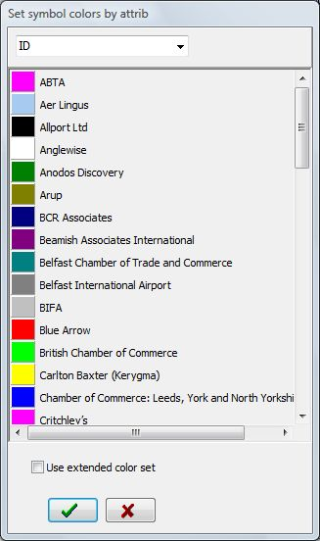
Colour Key
Chambers of Commerce
Consultancy
Engineering
Aviation/Airports
Accountants
Law
IT
PR
HR
Finance and Banking
Travel Industry
Hoteliers
Recruitment
Freight
Trade Unions
Others
The Research Input spreadsheet which was completed by all members of the group showed details about the type of the company, as highlighted below. We used this information to split the companies into 16 different industries and allocated a colour to each.


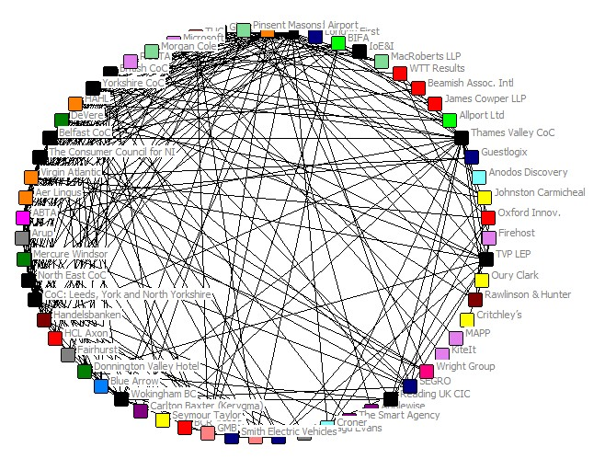

We found that when the matrix was presented in a circular form, it was easier to see the industries and companies with which firms had the greatest number of links.

4) FINDINGS

The Internet research that was initially completed as an introduction to the companies who had signed the previously mentioned letter enabled the creation of the following table; which allows a clearer representation of the data for comparison of the firms and to recognize common links.

Primarily the types of industries in support of the expansion could be identified and split into 7 main categories:

-Consultancy Firms
-Aviation and Transport
-Manufacturing
-Construction
-Commercial
-Law
-Retail

We also used this opportunity to identify any observable links between the organizations and the Heathrow expansion as the first step into identifying a vested interest:

4.1) Table of responses

FIRM | INTERNET SURVEY RESPONSE | PHONE SURVEY RESPONSE (Y/N/reason given?) | TYPE OF INDUSTRY | Suggested Link to Heathrow Expansion
David Sleight, Wokingham Borough Council | No | Yes | Borough Council | David Sleight is member of the Strategic Aviation Special Interest Group of the Local Government Association
Sinead Little, Carlton Baxter (Kerygma) | No | No, Couldn’t get in touch with them. | PR Agency | Link not easily identifiable
Harry Singh, Walker Morris | No | No, Couldn’t get in touch with them. | Law Firm | Link not easily identifiable
John Mowbray, North East Chamber of Commerce | No | No, Couldn’t get in touch with them. | Regional Business Organization | Chamber of commerce must represent the collective views of the firms within it
Paul Rogers, HCL Axon | No | No, not company policy to respond. | Business consultancy | Global corporation, offices in 31 countries so reliance upon travel
Julian Strutt, BCR Associates | No | No, not company policy to respond. | Cost reduction companies | Link not easily identifiable
Phil Dilley  Arup | No | No, Couldn’t get in touch with them | Engineering Company | Link not easily identifiable
Mark Nodder  Wright Group | No | Refused to do survey | Coach Company | Link not easily identifiable
Mark Tanzer  ABTA | No | No, they asked for another email; didn’t respond to email | Travel Association | Represents several travel businesses who would benefit
Steve Lamb  TVC | Yes | n/a | Business Lobby | Claims it will aid economic growth
Steve Ridgway  Virgin Atlantic UK | No | No, they asked for a letter; haven’t replied | Airline | Opportunity to increase flights and generate greater revenue
John Longworth  British Chamber of Commerce | No | No, asked for another email; didn’t respond to email | National Body of Chambers of Commerce | Chamber of commerce must represent the collective views of the firms within it
Chris Parker  Microsoft | No | No, asked to email; didn’t respond to email | Computer Company | Link not easily identifiable
Graeme Matthews  DeVere | No | No, couldn’t get a response | Hotels | Situated near Heathrow, greater flights in and out of Heathrow would create more business
David Richardson  Croner | No | No, couldn’t get in touch with them | Human Resources Consultancy company | Link not easily identifiable
Giles Withey  ROLTA | No | No, not company policy to respond | Business Intelligence and Engineering Company | Link not easily identifiable
Lesley Batchelor, Institute of Export & International Trade | No | No, couldn’t get in touch with them. | Professional membership body | Increased capacity at Heathrow would create easier trade
Baroness Valentine, London First | No | No, said they’d put call through and never did. | Non-profit organization | Would encourage tourism and business into London
Stuart Patrick, Glasgow Chamber of Commerce | No | No, couldn’t get in touch with them. | Chamber of Commerce | Chamber of commerce must represent the collective views of the firms within it
Uel Hoey, Belfast International Airport | No | No, couldn’t find the right number. | Airport | Opportunity to increase flights due to connections with Heathrow
Jonathan Riley, Pinsent Masons | No | No, couldn’t get in touch with them. | Law firm | Link not easily identifiable
Alph Forest, BIFA | No | No, No, couldn’t get in touch with them. | Trade association | Link not easily identifiable
Katrena Drake  Firehost | No | No, overseas call didn't connect. | Data protection company | Link not easily identifiable
Paul Briggs  Thames Valley Chamber of Commerce | No | No, said he would reply to e-mail. Never did. | Business network | Chamber of commerce must represent the collective views of the firms within it
Gerry Beamish  Beamish Associates International | No | No. Never connected. | Business consultation company. | Link not easily identifiable
Neil Kennedy  MacRoberts LLP | No | No. Didn't agree to answer questions. | Legal | Link not easily identifiable
Andy Cowle  James Cowper LLP | No | No. Didn't agree to answer or connect for questions. | Business consultation | Link not easily identifiable
Brendan Barber  Trade Union Congress | No. | No, was not available to answer. | Labour organization | Opportunity for job creation
Philip Walker  WTT Results | No | No phone contact. | Business consultation | Link not easily identifiable
Colin Matthews  Heathrow Airport Holdings Limited (Formerly BAA) | No | No telephone number for this individual. | Aviation Company | Direct link to aviation industry, would create more business
Matt Jenkin,  Morgan Cole | No | Failed to return telephone call. | Law firm | Link not easily identifiable
Robert Desmond,  Wilson Group | No | Could not locate individual | Housing developer. | Link not easily identifiable
Steven Leigh,  Yorkshire Chamber of Commerce. | No | Could not get through to individual. | Local Authority organisation | Chamber of commerce must represent the collective views of the firms within it
Geoff E. Allison,  Smith electric Vehicles | No | Large international company and individual was not available *on leave* | Transportation company. | Link not easily identifiable
Mark Goldstone, Chamber of Commerce: Leeds, York and North Yorkshire | No | Unable to be connected to correct individual | Chamber of Commerce | Chamber of commerce must represent the collective views of the firms within it
Ray Hayden, Anglewise | No | Unable to contact individual | PR agency | Link not easily identifiable
Nigel Charlesworth, The Smart Agency | No | Phone call never returned | PR/Marketing firm | Link not easily identifiable
Tim Smith, Reading UK CIC | No | Phone not answered | Local Economic Development Company | Heathrow is the closest airport to Reading; would cause local development
Carl Dodd, Blue Arrow | No | No one willing to answer questions | Recruitment Agency | Link not easily identifiable
Simon Walker, Institute of Directors | No | Unable to reach individual | Business Consultancy Firm | Link not easily identifiable
EEF | No | No individuals were willing to answer questions | Manufacturers Organization | Link not easily identifiable
Jim Shannon | No | Not available for survey | MP DUP Spokesman on Health and Transport | Link not easily identifiable
Jack McLaren, Johnston Carmichael | No | Could not contact individual | Chartered Accountant | Link not easily identifiable
Richard Shearing, Anodos Discovery | No | Difficulty in being transferred to anyone to answer questions | Human Resources firm | Link not easily identifiable
Trevor Hullat, Allport Ltd | No | Unable to locate individual | Cargo Service | Hold offices at Heathrow Freight Centre
Jo Willet, Oxford Innovation | No | No one willing to answer survey | Business Consultancy Firm | Link not easily identifiable
Richard Cushing, GuestLogix | No | Individual could not be contacted | Onboard Retailer | Link not easily identifiable; although Richard Cushings did previously work for BA
John Izett, Montagu Evans | No | Unable to be connected to someone to answer | Structural and Civil Engineers | Link not easily identifiable
Mike Pearson, Aerosport | No | Unable to find contact details | Aerial Photography firm | Link not easily identifiable
Andrea Hunter, Aer Lingus | No | Could not be connected to anyone able to answer the survey | Low Cost Airline | Opportunity to increase flights and generate greater revenue
Chris Sheerin, KiteIt | No | Could not be contacted | IT company | Link not easily identifiable
Neil Impiazzi, SEGRO | No | Unable to reach individual | Industrial Property Developer | Part of an Airport Partnership; manages a £1 billion portfolio at Heathrow
Lawrence King, Critchley’s | No | No one available for survey | Accountants | Link not easily identifiable
Kulwarn Nagra, Rawlinson & Hunter | No | Unable to be contacted | Business Consultancy firm | Link not easily identifiable
Mick Rik, Gerneal Trade Union | No | No one available who was able to answer the survey | Trade Union | Expansion would create more jobs; main priority of TU
Jo Wright, Oury Clark | No | Unable to contact the individual | Accountants | Link not easily identifiable
Peter Rose, MAPP | No | Unable to be connected to an individual | IT and Recruitment firm | Link not easily identifiable
Anthony Cox, Donnington Valley Hotel and Golf Course | No | No one willing to answer survey | Hotel | Increase in flights will mean more custom for the hotel
David Hayden, Mercure Castle Hotels-Windsor | No | Unable to be connected | Hotel | Opportunity to benefit from tourism and business trips
Peter War, Fairhurst | No | Unable to reach individual | Engineers | Link not easily identifiable
Andrew Murray, Consumer Council for NI | No | Individual was not contactable | Representing NI consumers | Will add to ease of transport in and out of NI
Ann McGregor, Belfast Chamber of Trade and Commerce | No | Individual could not be contacted | Chamber of Commerce | Chamber of commerce must represent the collective views of the firms within it
Len McClusky, Unite | No | Individual not contactable | Trade Union | Expansion would create more jobs

4.2) Data Interpretation

The distribution of the survey we designed was not as successful as we had hoped, after emailing it to our selected companies the only response we received was a belated email response and then after adopting the telephone survey method, one individual completed the survey this way. However this lack of response can also be deemed to be a significant finding in our research process. Many of the organizations that were emailed or called were very dismissive of the researchers; keen to keep connecting the call to different departments, which were not able to answer the questions, and in some cases provided the wrong details for email addresses to utilize instead. This demonstrated a general sense of apathy towards the issue, with many individuals spoken to on the phone being unsure of the letter being signed in the first place.

The telephone survey with David Sleight of Wokingham Borough Council returned some important feedback. Primarily there was a lack of knowledge when signing the original letter and a shift in opinion too. Mr. Sleight was not aware that his name would be printed alongside the signature on the letter as he believed he was merely signing it as part of Wokingham Borough Council; this demonstrates an error on the part of the organization originally campaigning for signatures and signifies that if Mr. Sleight was not given an accurate and clear description of the item he was signing then perhaps the other signatories were not either. Furthermore Sleight indicated that Wokingham Borough Council’s stance on the matter was now undecided, claiming there was a need for greater information to be available before his organization would be willing to comment further. With this in mind it would be a plausible assumption that perhaps the surveying method was not the sole reason for a lack of response; organizations may feel their opinion is shifting or did not see the significance of signing the original letter.

As this research was completed we also used our findings regarding the location of each firm to construct a map to indicate if proximity to Heathrow was a key determinant of the support or if the firms held any other locations in common. Figures 1 and 2 shows the location of firms with respect to Heathrow; whilst there are some expected trends such as the way many firms close to the airport support the expansion as it will enable them better transport links or more business with increased visitors to Heathrow, some of the results were less predictable. For example, there is a large volume of support for the expansion in Ireland as much of the business and trade that the Irish economy relies upon enters the UK via Heathrow first before transferring to the main Irish airports. It is clear in these cases there is a vested interest, as the firms believe their own business will benefit from the expansion.

Furthermore, by using the matrix method to create the following network map, the links between each company were also identified as such:

This map shows that there are a vast number of links between each company that signed the letter this demonstrates that even if it is not directly clear how an individual firm is linked to the aviation industry their close relationship with the other organizations with direct links will mean they also hold an indirect interest in aviation. For example, we found that the largest Chamber of Commerce in the Yorkshire region has hired the public relations and marketing firm, The Smart Agency, to provide support as it positions itself as a key player in providing advice and services to businesses in the region.

At present we are unable to pinpoint a level of optimum consumption of air travel with the current information we hold. An assessment would have to quantify the costs of pollution (noise and CO₂), the loss of flights from regional airports and the loss of land against the benefits of becoming more globally competitive, economic growth opportunities and an increase in jobs.

However, regardless of if it is possible to place exact numbers on the measurement or not, when such a strong relationship is seen between all the firms in support of Heathrow expansion it is clear that there is a large benefit to these firms from the expansion. These firms will not directly be facing the consequences and the costs of the expansion and any they do face will be cancelled out by the positive benefits, showing that this decision is one of vested interests.

5) Advice for Stakeholders:

5.1) Anti-Aviation and Environmental Campaigners:

Those who are campaigning against the expansion of Heathrow (or aviation at all for that matter) and assessing whether there are firms acting with vested interests have to understand the issue in a broader context. As in the case of the Heathrow in Crisis letter, there were a wide range of industries, groups and organisations that supported the expansion.

A vested interest is also quite a narrow assumption. There may be those living within a 30-50 mile radius of Heathrow, who would happily support the expansion if it means they are going to be able to benefit directly from a broader range of flight destinations, or because they perceive there will be an economic benefit to the communities they live in. However, a vested interest may be a more direct involvement with the project. For example, construction firms getting contracts to develop a sixth terminal; law firms who represent local interests and so continuing the debate, continues work for them; companies such as British Airways who would be able to purchase more air slots, so would be able to expand their own company.

Those opposed to Heathrow have to determine what their real cause for concern is. For the campaign against Heathrow to be a purely NIMBY (not in my back yard) one, it opens the potential for expansion of other London airports such as Gatwick, Stansted, or the proposed Thames Estuary airport (Boris Island). Therefore it means that the economic grounds on which the debate is being structured is not necessarily wrong, it is just that those people do not want to be directly affected. At this point the aims of an environmentalist and a NIMBY campaigner become vastly different.

A move to have a ready-made policy for campaigning against aviation would be the most advisable option. The proposition of a permit system for UK aviation would be certainly worth considering. Having a select number of flights available it would mean that the permits could be allocated to those areas in which they are most needed. Therefore, if Heathrow has such a large area of demand that it requires a third runway, this might lead to a level of local environmental degradation, but certainly would not have a real terms increase in climate change, as there would be fewer flights from other regional airports.

5.2) Industry:

It is very easy for those in industry to support a project, which in the short term will provide immediate economic benefits. By supporting the expansion of Heathrow airport however, those involved may not have assessed the unintended consequences which may occur, for example the survey response alluding to one member not even knowing his name would appear as a signatory on the Heathrow in Crisis letter.

As a group it is unsurprising that they would only consider the benefits to themselves and not factor in the social costs that do exist for local residents and those directly affected by Heathrow. If during a period of economic difficulty the UK wanted to implement the building of infrastructure then it could be done, but it might come at the cost of business and industry in other parts of the country. If there was the implementation of a tradable permits scheme then it is possible that the third runway could be built if it had a greater demand for flights than say Manchester, Birmingham and other smaller airports.

Furthermore, it is also possible that a business organisation could be acting with a vested interest, whilst also be lobbying for the prosperity of the UK economy as a whole. Any expansion seen within the economy is inevitably the result of at least one industry experiencing the initial growth to cause this trickledown effect into the economy as a whole. Therefore, even if an industry is supporting a policy that will specifically boost their own revenue it may also be beneficial for the economy as a whole, dependent on the external costs. Industry has just got to be very clear about the links that it has in order to allow for the public and government to make a reasoned conclusion as to what is strictly a vested interest and what is a dual interest.

5.3) Lobby Groups:

For lobbyists they need to draw a far different conclusion. Firstly, purely from a selfish perspective they need to identify those who are going to have a vested interest as a result of expansion, be that for or against.

Secondly, there needs to be a real consciousness about when the issue of Heathrow expansion is a topical one. Having come and gone, now appearing to return as a potential transport policy, they need to time their lobbying activities for when the campaigns are at there greatest. For example, it is almost guaranteed that airport expansion will not be a real possibility during this current Parliament, as all three major parties agreed in their manifestos not to support the policy. However, now would be a good time to start laying the foundations of a campaign as preparation for after the 2015 general election where a decision is likely to be made, meaning that the lobbying can target appropriate individuals effectively.

5.4) Government:

The role of government is one that really is not clear. Ideally they would be an arbiter over the issue, deciding whether the case by business or the case of environmentalists was stronger, and then reaching a judgment. However, this is dependent on assuming that those in power do not have a vested interest as well. Many of the constituencies around the Heathrow area, likely to be directly affected, are currently Conservative Party held seats. However the Conservative Party is traditionally a supporter of business and industry, thus they would be inclined to support the expansion. If however, their constituents are against expansion, it creates a clear conflict of interests for those in power.

In addition, just because the UK economy is struggling at the moment, it does not mean that it should try and re-energise the economy with a relatively short-term (in comparison to the potentially irreversible environmental damage) capital infrastructure development. Moreover, when it comes to financing major infrastructure programmes it is long assumed that the state has to play a significant role in building such developments. This does not take into account the current government reducing public spending and debt, thereby not wanting to be the financier of Heathrow expansion. If as a result, the finance is raised through private means then this does raise serious questions about the neutrality of government as an arbiter.

The government’s need to conduct a cost-benefit analysis is therefore essential. The major stipulation being, it has to include factors that both environmentalists, as well as business can agree upon. Furthermore, it can have a vitally important role in setting up the tradable permit scheme. It can do so, by setting the number of permits, regulating and enforcing the permits. If the data suggests that the permits would be located around the Heathrow area, it can at this point grant permission for the expansion of Heathrow. However, if it cannot prove that there are clear economic benefits, which outweigh the costs, then there should be no expansion of Heathrow.

6) Methodological Constraints:

The main constraint that we encountered throughout the project was a lack of finance. This is because it was the single largest determinant of the type of research that was conducted. If there had been more finance available we would have attempted to conduct face-to-face interviews with as many of the signatories as possible. In addition, this data would have been enriched through the conducting of a focus group to really determine whether those that supported the expansion of Heathrow were doing it for purely vested interests. The quality of data would have been far greater, as it would have taken it from being largely Internet, secondary based data, to primary data that could have been taken for use in other research.

Surveys are a fantastically useful tool in gaining primary research. However, there needs to be an incentive for those who take part in them, or more often than not, they simply will not.

7) Recommendations for future research:

The initial proposal for how we would suggest research could be continued must be a process of tackling the methodological constraints that we have faced. Primarily we would suggest that a high response rate to the survey would be extremely beneficial. To do this we would propose that a focus group and face-to-face interviews were conducted in order to gain a better understanding of the motives for each organization in supporting the expansion of Heathrow. This would also enable researched to assess if the opinions remain relevant, or if in fact interest has been lost in the campaign as noted in recent statements from John Stewart (Millward, 2012).

Furthermore in order to offer a more quantitative analysis of the matter we would also recommend that research into monetizing the costs and benefits of the expansion could be completed which would enable a conclusion to be reached formulaically. It is difficult to form a judgment with first adding a weighted measure to each cost and benefit, it is clear that the cost of noise pollution cannot have a precise value to it but it must be weighted to represent the vast number of people it affects.

Word Count: 5100
Bibliography

- Aldridge, A and Levine, K. (2001) Surveying the Social World. Open University Press: Buckingham. P85

- Borgatti, S.P. (2002). NetDraw Software for Network Visualization. Analytic Technologies: Lexington, KY

- Daily Telegraph (2012) Heathrow in Crisis: letter in full [online], March 3. Available at: http://www.telegraph.co.uk/finance/newsbysector/transport/9120943/Heathrow-in-crisis-letter-in-full.html [accessed 12/05/13]

- Department for Transport (2005) Introduction to Transport Analysis TAG Unit 1.1[pdf] Available at: http://www.dft.gov.uk/webtag/documents/overview/pdf/unit1.1.pdf) [accessed 12/04/13]

- Ellerman, A.D. (2005). A Note on Tradable Permits, Environmental & Resource Economics. 31: 123-131. P124

- Friends of the Earth (2008 ) Heathrow Expansion-its true costs [pdf] Available at: http://www.foe.co.uk/resource/briefings/heathrow_expansion.pdf [accessed 12/05/13] page 3

- HACAN (2006) Heathrow Third Runway [online] Available at: http://www.hacan.org.uk/the_campaign/runway_3.php [accessed 12/04/13]

- Jackson, K. (2007) Political Parties, the Internet and the 2005 General Election: third time lucky? Internet Research. Vol 17 (3). Web. Available at: https://blackboard.soton.ac.uk/@@/32C97A3825FECB2E5D556852FAD2E910/courses/1/PAIR2004-28036-12-13/content/_1889182_1/PoliticalParties_Internet.pdf [accessed 18/04/13] page 249-271

- Millward, D. (2012) Willie Walsh rules out third runway at Heathrow. Daily Telegraph. [online] 2 December. Available at: http://www.telegraph.co.uk/news/aviation/9717087/Willie-Walsh-rules-out-third-runway-at-Heathrow.html (accessed 19/04/13)

- Smit, M, Koopman, M and Faber, J. DELFT (2013) The Economics of Airport Expansion [pdf] Available at: http://assets.wwf.org.uk/downloads/economics_of_airport_expansion_march_2013.pdf [accessed 12/05/13] page 5,6,9,44

- The Economist (2013) Our Solution to Expanding Heathrow Readers Respond [online] Available at: http://www.economist.com/blogs/gulliver/2013/04/our-solution-expanding-heathrow [accessed 12/05/13]

Appendix
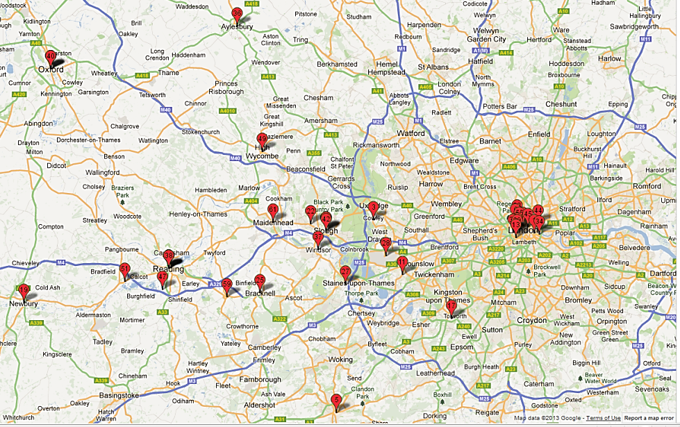
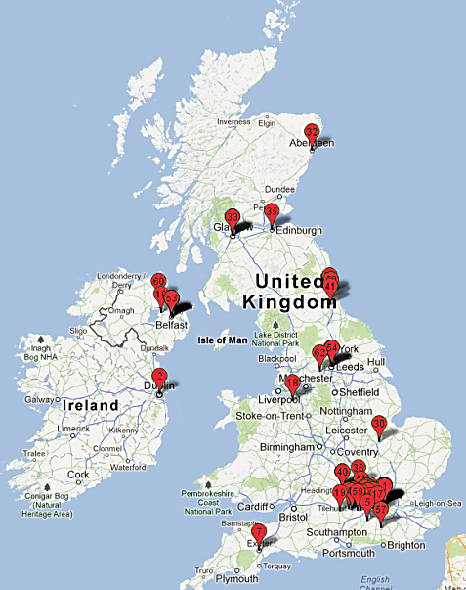
Figure 1- Location of the company headquarters across the UK. With a high concentration in the London area, but also spread around the UK
Figure 2- High concentration of the signatories located around the London area, and very near Heathrow

