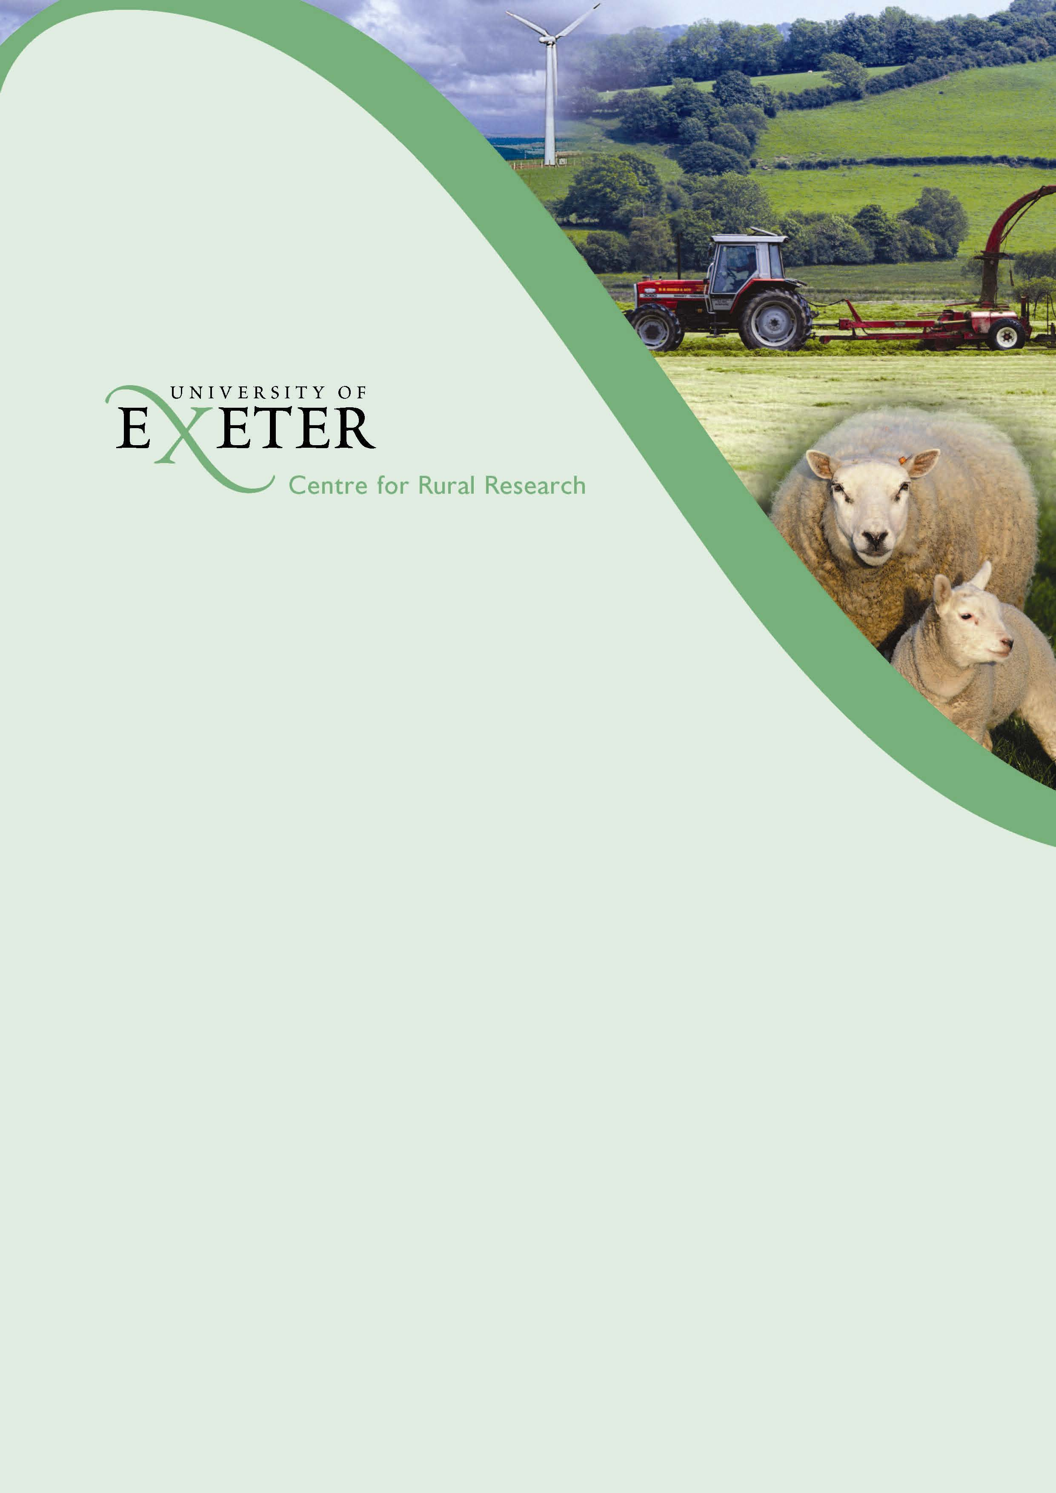

A Review of Devon’s Food Economy

Matt Lobley, Jo Trail Thomson and Donald Barr

CRPR Research Paper No 34



**A Review of Devon’s Food Economy**

Matt Lobley, Jo Trail Thompson and Donald Barr

June 2012

For further information, please contact Dr Matt Lobley, Centre for Rural Policy Research, Department of Politics, University of Exeter, Rennes Drive, Exeter, EX4 4RJ.

Tel: 01392 724539 E-Mail: [mlobley@exeter.ac.uk](mailto:mlobley@exeter.ac.uk)

This report can be downloaded from the CRPR website at:

<http://www.centres.ex.ac.uk/crpr/publications>

**CRPR Research Report No. 34**

**ISBN 978-1-905892-15-0**

**Price: £15**

The views expressed in this report are those of the authors and are not necessarily shared by other members of the University, by the University as a whole, or by the funders.

**Copyright © 2012, Centre For Rural Policy Research, University of Exeter**

**ACKNOWLEDGEMENTS**

We are grateful to the large number of individuals and businesses that participated in the research on which this report is based. Thanks to Allan Butler for managing the online survey. Various Defra staff were particularly helpful in supplying data and answering our queries. We are grateful to Devon County Council for funding the Sustainable Rural Futures Research Programme at the University of Exeter which funded this research.  Thanks to Marilyn Stephen for proofreading and formatting the final report.

**CONTENTS**

**Page**

**Summary 1**

1. **Background, Methodology and Approach 5**
2. **An Overview of Devon’s Agri-food Industry 7**
3. **The Economic Value of Devon’s Food Economy:**

**GVA and Employment 17**

1. **Primary Sector Analysis 29**
2. **Processed and Manufactured Foods 47**
3. **Conclusions 51**

**Appendices**

**Appendix A Summary Results of the Online Survey of**

**Food Producers in Devon 55**

**Appendix B Detailed Data on Employment in Devon’s**

**Agri-food Industries 67**

**Appendix C Further Analysis of Agricultural GVA 73**

**Appendix D Notes for Supply and Use Tables Calculations**

**Relating to the Primary Sector Analysis 77**

## SUMMARY

**Introduction**

This is our first review of Devon’s food economy. It seeks to establish a current and accurate picture of the sector, providing an overview of trends, market developments, impact of the recession[1] and business support needs. Given current policy reform and changes in the global economy it is a critical time to review the sector. Cornwall has benefited from such intelligence for close to a decade and now, thanks to funding from Devon County Council, we are able to present the first comprehensive review of Devon’s food economy.

Researching the agri-food sector beyond the farmgate can be challenging. Extensive data is frequently unavailable. We have made considerable use of Defra data and have been supplied with data from other sources. A number of the figures quoted in this report have been derived from estimates and calculations and the necessary caveats are detailed in the accompanying text, tables and appendices. We have also collected a range of data directly from businesses in the agri-food sector via an online survey of 108 food and farming businesses. In addition we conducted a number of semi-structured interviews with key informants (many of whom are producers, processors and retailers) in order to provide additional depth to the online survey and to gain the insight of key observers of, and participants in, Devon’s food economy.

**Main findings**

* Agriculture is responsible for about twice as much employment in Devon as it is generally in Great Britain. 15% of Devon’s manufacturing employment is in food and drink processing which is about the same as in Great Britain’s manufacturing as a whole.
* Analysis of data published by the Office for National Statistics (ONS) indicates that there have been significant falls in the value of agricultural production since 2008. However net farm incomes have been protected from the full effects of these falls by sterling devaluation and the consequent 20% increase in farm support payments which are based in euros.
* Devon’s food economy is larger in relative terms than the food economy of most other English counties. In 2008 the whole agri-food industry in its broadest sense, including restaurants, bars, supermarkets and accommodation, accounted for approaching 13% of total Gross Value Added (GVA) [2] in Devon. The equivalent figure for Great Britain is 7.6%.
* Analysis of the most recent published data from 2008 and 2010 points to declining GVA in the sector. In contrast, the very recent responses from the Online Survey (October 2011) and key informant interviews (February 2012) suggest a more positive outlook than would be expected following analysis of the published data. This could be a reflection of the Survey sample and methodology or there may also be an upturn in business expectations that is yet to be reflected in the published data. 47 businesses responding to the online survey reported “good” or “excellent” perceptions regarding their future economic outlook. Of these, nine businesses were primary producers and 38 had food processing as their main source of income. It appears that 50% of surveyed food processors consider their prospects to be “good” or “excellent” in the near future, compared with 29% of primary food producers.
* The dairy sector in Devon is a highly dynamic area of food production and is by far the most significant primary production sector, accounting for 47% of the value of farm produce at the farmgate.
* Livestock producers are experiencing higher prices at the moment, though uncertainties over the continuing strength of the euro, CAP reform, changes to the SFP and disease such as the SBV Virus provide an uncertain outlook. These external factors and high input costs may also undermine farm incomes and business profitability.
* Evidence from the interviews and the online survey indicates that Devon’s food economy is characterised by positive, forward looking businesses which, on the whole, report that they are coping with the recession. There is a considerable entrepreneurial skills base within the county’s food economy which proffers a very positive outlook for the medium term.
* Devon’s food economy is characterised by a diverse structure of business sizes. 53% of respondents to the online survey reported a turnover of less than £100,000 while 13% had turnovers in excess of £1m. This points to a sector with a large number of small businesses and a few larger businesses. To an extent this may reflect a bias in the Survey sample, although it is also quite similar to what we know of the structure of the Cornish agri-food sector.
* Despite the prolonged economic downturn, 17 businesses responding to the online survey reported high growth in their turnover (of more than 15%) in recent years and these companies were mainly in the food processing and manufacturing sectors.
* A minority of respondents to the online survey (14 businesses) reported a reduction in turnover although, of these, most (nine) still described the current economic position of their business as “fair” or “good” and few reported planning to reduce the scale of their business.
* Many businesses reported experiencing a cost-price squeeze as their inputs costs rise and margins fall which, in turn, was impacting on their ability to invest from retained funds.
* The global food market is very strong and export markets are viewed by many key informants as offering significant opportunities for the near future with vigorous demand for quality, highly differentiated products in the Far East, the Middle East and the US.
* The potential for further developing the Devon food brand so that the county is synonymous with quality food and quality landscapes to both visitors to Devon and national and international export markets was widely recognised.
* Overall the results of the online survey indicate a very positive outlook across the range of sectors and food producers and manufacturers. Even those respondents who reported negative growth were optimistic about their near future prospects. Particularly strong sectors include artisanal food producers supplying high quality products within the city or specialised rural outlets.
* These artisanal food producers tend to be very small companies employing only a few people, trading on quality and personal connections with consumers through retail outlets or markets. On the whole they reported that the recession has had less impact than they would have expected.
* Farm shops are doing well – particularly those which offer a delicatessen-like range of local supplies (ie more than what is produced on the immediate farm holding).
* Local food can rely on a customer base which is very loyal and who still likes to treat themselves to purchases of good local food that is clearly differentiated and of high quality. There is also a ‘feel good’ factor associated with supporting the local economy.
* In contrast, medium sized food manufacturers may have suffered the most following the recession. For instance, Okehampton has traditionally been seen as a food town with a cluster of food businesses. However, these businesses have been vulnerable to shifting economic conditions, changes in supermarket supply contracts and were not able to compete with the large scale food manufacturers operating at very small margins, using unskilled labour. As a result, during the past 12 months, a number of food processing businesses have closed resulting in many people being left unemployed. Although since then we are aware of a significant number of new business start-ups in the Okehampton area.
* Nearly half (47%) of the respondents to the online survey supply the majority (more than 75%) of their products to the Devon market, including the tourist market. Just 8% reported that the majority of their sales (more than 75%) were to the national UK market. 15% of responding businesses reported exporting some or all of their products which included fish, vegetables, cheese, processed meat, cordials, sauces and cereals.
* Nearly half the online respondents reported they would like to change the way they sell their products over the next three years. 39% would like to increase their direct retail sales via online and mail order; 35% would like to increase sales to wholesale and distributors, and 18% would like to increase their direct retail through farm shops. Only one business was hoping to sell more to supermarkets.
* The imbalance between availability of very good evidence on primary production and poor availability of evidence on processing and distribution means it is not currently possible to adequately measure the value being added to Devon primary food production.
* There is also insufficient data available for the local food sector to allow adequate measurement of its value to Devon households and the Devon food economy as a whole.
* The changes to Defra’s data collection to focus on farm holdings over a certain commercial threshold provides useful food industry data but is likely to underplay other flows of social or environmental services coming from the ‘non-commercial’ producers i.e. those under Defra’s commercial size threshold. In 2009 45% of Devon’s registered agricultural holdings were classed as ‘non-commercial’. These holdings account for only 2% of the value of farmgate output but 21% of recorded labour. Despite their small size they can contribute towards the choice available in localised food markets and play a wider role in rural communities.
* Looking to the future, areas of public support most requested through the online survey responses were mainly in sales and marketing and solutions for cost effective distribution. Key informant interviews highlighted the need for access to finance, more flexible planning regulations and the provision of high speed broadband as areas of public and private support that would be most useful.
* A number of businesses also expressed an interest in alternative renewable energy sources as part of a strategy to reduce operating costs.
* An increase in direct sales also offers the opportunity for producers to retain a larger proportion of the end price.
* Given the significance of Devon’s food economy in terms of employment, its direct contribution to the economy of the county and the iconic status of certain products, a more strategic approach to facilitate the future development of the sector would be useful. This could probably be best achieved through partnership working between the public and private sectors.

**1 BACKGROUND, METHODOLOGY AND APPROACH**

**1.1 Introduction**

This is our first review of Devon’s food economy. It seeks to establish a current and accurate picture of the sector, providing an overview of trends, market developments, impact of the recession and business support needs. Given current policy reform and changes in the global economy it is a critical time to review the sector. As the remainder of this report will reveal, given the size and significance of Devon’s food economy, an improved understanding of its structure and key trends is an essential prerequisite to inform strategic thinking about the future development of the sector. Cornwall has benefited from such intelligence for close to a decade and now, thanks to funding from Devon County Council, we are able to present the first comprehensive review of Devon’s food economy.

Following this introduction to the report Chapter 2 provides an overview of Devon’s food economy; Chapter 3 presents a working definition of the agri-food sector and key statistics from analysis of published data and modelling of the GVA and employment; Chapter 4 presents an analysis of primary production in the dairy, meat & poultry and horticulture and potato sectors; Chapter 5 provides an overview of key issues and trends in the processed and manufactured foods sectors identified in interviews and the online survey responses; and Chapter 6 highlights some key conclusions and a number of areas where further research may be required.

**1.2 Our approach**

Researching the agri-food sector beyond the farmgate can be challenging as extensive data is frequently unavailable. As a result this report draws on a range of data sources. Existing data have been used to calculate the value and size of the sector and associated production volumes. The most recent data available has been used but it is important to note that this is often a few years old by the time it is published. In addition, changes to data collection protocols means that some data is not directly comparable with previously reported data.

This report includes data from an online survey of food producers and processors which ran from 4–27 October 2011. 108 responses were received out of a total sample of 377, which represents a good response rate of 28%. The sample for the Survey was sourced from directories of Devon food producers and through online searches for Devon food companies. As a result of this approach there is likely to be some bias towards the smaller producers located within the county as it was difficult to get contact details for respondents of subsidiaries within the larger food businesses. Nevertheless, the Survey produced a good mix of types of business ranging in size from just 1 employee to over 150 staff. Analysis of the online survey results has been used to inform the main sector chapters that follow. A summary of the analysis of the results of the online survey is also presented in Appendix A. The results illustrate current and expected market perceptions, routes to market and business development plans across the full range of food producing businesses - both primary producers and processors and food manufacturers. As will be seen, there are interesting pockets of growth as well as areas that businesses identified as barriers to their development.

Finally, semi-structured telephone interviews were undertaken with a small number of key industry informants. The interviews were designed to provide an additional depth to the online survey, to plug any major gaps in coverage of the online survey and to gain the insight of key informants in the agri-food sector. The interviews explored a range of issues, such as the impact of the recession and the impact of public funding, and identified key challenges and opportunities.

Overall there is a significant imbalance between the evidence on primary production which tends to be very good and the evidence on processing and distribution which is scarce. There is very little information on where the value is being added to Devon primary food production. Within the farming part of the evidence-base, changes to Defra’s data collection to focus on businesses over a certain commercial threshold, while useful from a food industry perspective, is likely to under-play other flows of social or environmental services coming from these producers.

## 2 AN OVERVIEW OF DEVON’S AGRI-FOOD INDUSTRY

**2.1 Introduction**

This overview is generated from an analysis of a range of published statistics (which are available up to 2010), interviews with key industry informants (February 2012) and the main results of the online survey (October 2011).

**2.2 Key statistics[3]**

Devon’s agri-food sector is consists of three identifiable groups:

1. The core agri-food sector (which includes primary production, food & drink manufacturing, food and drink wholesaling and specialist food and drink retailing);
2. Secondary food sectors (food & drink retailing and food and beverage services) and
3. ‘Food related’ (which includes accommodation).

Responses to the online survey indicate many businesses are engaged in more than one of these.

Devon’s core agri-food sector provides employment for 31,900 people within a total employment of 79,100 in all food and drink *related* sectors. In percentage terms 9% (compared to 4% in GB as a whole) of the county’s employment is in coreagri-food activities. A further 10% (compared to 9% in GB) are employed in supermarkets, bars and restaurants and 3% (1% in GB) in accommodation, giving a headline figure of 22% of Devon’s employment (15% in GB) in all food and drink related sectors.

Compared to Great Britain as a whole, the agri-food sector in Devon is estimated to be over one-and-a-half times more important for employment than it is nationally. However, as these sectors also tend to have relatively low levels of labour productivity, in value terms the food and drink share of the county’s economy will be significantly less.

Agriculture alone is responsible for approaching twice as much employment in Devon as it is generally in Great Britain. 15% of Devon’s manufacturing employment is in food and drink processing, which is about the same as in Great Britain’s manufacturing as a whole. About a quarter of Devon’s food and drink manufacturing employment is in dairy products which represents around 4% of the GB total in this sub-sector, highlighting both the local and national significance of the county’s dairy farms. Devon also had a higher level (29%) of food and drink related wholesaling employment than Great Britain (20%) as a whole. Although employment in supermarkets outnumbers employment in specialist food retailing by a ratio of 6 to 1 in Devon, this is actually a stronger specialist food presence than the GB equivalent figure of 6.9 to 1. Taken together these figures demonstrate that the agri-food sector in Devon is very important in terms of underpinning the employment base.

In terms of its contribution to the economy of Devon, agriculture’s share of the county’s GVA had fallen from 3.5% in 1995 to under 2% in 2008, which compares with a fall from 2% to less than 1% for the UK as whole. (GVA is explored in detail in Chapter 3.) This result highlights just how small the *direct* economic value of primary production from agriculture is in these terms, even in Devon, although since 2005 there is a slight upward trend. This could reflect a shift in relative values within agriculture in favour of livestock products or perhaps greater pressures in agriculture elsewhere in the UK from the competition for resources (land, labour). However, even at such low levels of GVA, in relative terms the sector was much more important to Devon than it was nationally.

Both 2009 and 2010 saw a total fall of 8% in the underlyingvolume of output from the broad agriculture sector across the two years, compared to a net contraction nearer 3% for the whole UK economy. In value terms the fall had been much more dramatic as commodity prices fell back from the 2008 highs as well, resulting in an 11.7% nominal fall in 2009 followed by another 5.7% fall in 2010. Such large likely falls in the volume and value of production since 2008 might be expected to have led to economic difficulties for many farming businesses. However, farm support payments are based in Euros and these have increased in value by around 20% on the back of sterling’s devaluation.

Modelled estimates from published data indicate that food and drink manufacturing’s share of the economy had been falling over time, from at or above 2% up to 2001 to nearer 1.5% more recently. The broad picture seems to be that meat processing, baking, confectionary etc are the main contributors to Devon’s food and drink manufacturing output although baking and confectionary may have become less important in recent years.

In 2008 the core agri-food industry contributed around 5.6% of the county’s economic output, or around £612 million. In its broadest sense, which includes restaurants, bars, supermarkets and accommodation, agri-food related industries accounted for approaching 13% of total GVA in Devon. The equivalent figures for Great Britain are 3.5% for the core agri-food industry and 7.6% for all agri-food related industries. This provides further evidence of the significance of this sector for Devon.

In total the farmgate value of Devon agriculture in 2010 is estimated to be £464.5m. Dairying is by far the most important sector at £242.6m and beef to a lesser extent at £125.9m. A detailed analysis of these figures by sector is provided in Chapter 3.

Analysis of published data indicates generally weak labour productivity in Devon. In sectors of significant employment, productivity is either weak relative to the GB sector equivalent – i.e. food and drink manufacturing – or weak relative to Devon’s all-industry productivity – i.e. Hotels and Catering – or both, i.e. Agriculture. This leads to the conclusion that improving labour productivity in the agri-food industry, narrowly or broadly defined, could make a significant contribution to improving Devon’s relatively weak labour productivity when measured against other English NUTS3 areas (see Section 3.3 for further details).

Underlying these headline figures are very interesting and dynamic businesses reporting positive trends and outlooks for the future of the Devon food economy.

**2.3 Key findings from the online survey[4]**

This section presents an overview of the main results from the Survey including food production and processing activities, routes to market, company finances and development prospects and markets for products. Not all 108 respondents answered all questions; therefore, at times, numbers of responses will be reported from a total of less than 108.

**2.3.1 *Activities & routes to market***

Respondents were involved in a range of activities including primary food production (red meat and poultry, eggs, fruit and other vegetables) and food processing activities (including preserves, bakery, beverages, fruit & vegetable processing, meat processing and milk processing for cheese and ice cream). 29% of respondents were engaged in primary food production and 69% were engaged in food processing.

Nearly two thirds of respondents were engaged in two or more business activities. Those businesses engaging in the most activities (four or more) tend to be the smaller scale food processing companies diversifying their activities through the “gate to plate” sales of their produce.

Only a very few businesses (8) reported a contract with a supermarket or a processor. The rest had a wide range of routes to market. 70% sold direct to end consumers via their own shop, farmers markets or fairs and this was also reported to be the most important channel in terms of value for 37% of respondents.

Almost half (42%) of the businesses responding to the Survey sold via e-commerce – i.e. their own website; 63% used direct sales to independent retailers and 49% used direct sales to restaurants and private caterers. Very few respondents (6%) reported direct sales to end consumer via their own website as being the most valuable channel for sales. These businesses were selling poultry meat, sweet bakery products, preserves and other speciality food and only one of these companies had a turnover greater than £250,000.

Nearly half (49/107) reported they would like to change the way they sell their products over the next three years, with 39% indicating they would like to increase their direct retail sales via online and mail order. 35% indicated they would like to increase sales to wholesalers and distributors, and 18% reported hoping to increase direct retail through farm shops. Only one business was hoping to sell more to supermarkets. When asked about how they would like the way they sell their products to change one commented:

*“… to sell more direct to customers from a stall or other Farmers Market days in Exeter. To be clear the reason for doing this is we can supply organic vegetables, freshly picked with minimal packaging or refrigeration, grown 3 miles from Exeter, ... direct to consumers at a convenient place and time....at a price lower than other quality vegetables because we cut out the 40% to 100% mark up on price selling through a retail outlet and if there were enough outlets ourselves and other local growers can sell volume”.*

Another respondent commented that they:

*“Would like to sell ...to [a]co-op purchasing small amounts of produce to sell on, for example, to the public sector - schools or hospitals - in quantity”.*

Another respondent stated*:*

*“It would be great to sell to local buying groups (of consumers). Involvement in a community enterprise would also be good eg: sharing harvest from orchard in return for help with harvest and a membership fee”.*

The businesses responding to the Survey identified a range of barriers to changing the way they sell their products including costs and time constraints (10/42); shipping and transport costs (9/42); technical issues posting perishable, chilled products (7/42); lacking the necessary skills (marketing & knowledge)(6/42); and five mentioned consumer awareness issues. One respondent stated that:

*“[Its] time for proper marketing. An organized market outlet for quality/organic/local produce other than farmers' market would be good”.*

**2.3.2 *Market focus***

Close to half (51/108) of the respondents to the online survey reported that 75% or more of their sales were within Devon; 4/108 reported that 75% or more of their sales are in the South West region; 9/108 companies reported 75% or more of their sales were in the national market. One business reported exporting 70% of its produce (condiments and spices) although relatively few respondents (15%) reported exporting *any* of their products to markets outside of the UK. Those businesses involved in exports reflect a diverse spread of activities including fish, vegetables, cheese, meat processing, cordials, sauces and arable production.

Over half of the respondents thought there would be no change in their market orientation in the next few years. Over the remainder 23 businesses expect the proportion of their sales to national markets to increase and 11 expect the proportion they export to increase. Only three companies expected an increase in sales within Devon and two expected increased sales within the South West region.

**2.3.3 *Business finances and development prospects***

90 respondents to the Survey provided a turnover figure. Of these 53% (ie 48/90) had a turnover of less than £100,000. On the other hand, 13% had turnovers of more than £1m. Just 14 businesses reported a reduction in turnover compared to recent years, while 58% (52/90) reported an increase in turnover. Although this might be taken as an indication that most food economy businesses are doing well, the Survey also revealed evidence of rising costs and squeezed margins.

All but one (11/12) of the high turnover businesses (greater than £1m) reported an increase in turnover in recent years. Of these four sell more than 50% of their product within Devon. The other eight companies are mainly selling regionally and nationally. In total 17 companies reported growth in their turnover of more than 15%. These companies were mainly in the food processing and manufacturing sectors. Most of the businesses reporting a growing turnover (12/17) had been established for less than five years. This high growth associated with new businesses is to be expected. These companies were mainly in the food processing and manufacturing sectors.

14 companies (from a range of food producing activities and a range of turnover sizes) reported a reduction in turnover in recent years. Not surprisingly 71% reported they would like to change the way they sell their products. Nine of the companies which reported a decrease in turnover report selling over 50% of their product within Devon. Despite reporting a decrease in turnover, more than half (9/14) still described the current economic position of their business as “fair” or “good”. On the other hand, Five reported it as “poor” or “bad”.

In total 20% (21/107) of businesses reported that they felt their economic position was “poor” or “bad” and 36% (39/107) reported their economic position was “good” or “excellent”. The majority of businesses (76%) were more positive about the future outlook with plans to marginally or significantly expand their business.Indeed, only 5% of businesses reported planning to reduce the scale of their businesses and the remaining are seeking to maintain the scale of their businesses. 8/12 (67%) of the high turnover companies (greater than £1m) plan to significantly expand their business in the near future.

When asked what factors influence their plans to expand, maintain or reduce the scale of their businesses, respondents selected a range of factors including: production costs, market prices, costs of labour, business profitability and input prices.

Three of the businesses with negative outlooks reported that they still plan to marginally expand their business with the rest seeking to either maintain their existing scale or reduce the scale of their business. The four main factors which were influencing their plans are: production costs, labour costs, input prices and market prices. Other common factors included the usual business issues such as competition, difficulty competing with supermarkets, business profitability and inflation. ‘Other’ factors affecting some business development plans included a slow-down due to planned retirement.

Looking to the future, 47 businesses reported “good” or “excellent” perceptions of their future economic outlook. Of these nine businesses were primary producers and 38 had food processing as their main source of income. It appears that 50% of food processors think their prospects are good or excellent over the next three years compared with 29% of primary food producers. The majority (44 out of 47) of businesses with a positive outlook for the next three years plan to marginally or significantly expand their business. There are many factors reported which influence their plans and there is no notable difference in the influencing factors between this group of companies with a positive outlook and the whole body of respondents.

These findings point to a degree of buoyancy and likely future growth within Devon’s food economy. At the same time respondents to the online survey and key informants identified a number of current and future support needs that could help facilitate future development. Sales and marketing was the most commonly cited by online respondents as an area of required support. Other areas include capital investment, transport and distribution solutions and establishing routes to market. Some firms reported their primary concern as the availability of finance to invest. Many respondents had received public support and, as the comments in the box below indicate, public funding has assisted Devon food and farming businesses in a range of ways.

**Box 2.1 The impact of public support on food and farming businesses in Devon**

*“A new purpose built building which has allowed me to gradually expand”;*

*“Small scale partial funding of additional equipment purchase for on-site processing and brown tourist signage etc.”;*

*“[Public funding] added capacity, and security to our business, created jobs and increased demand for pork from the region”;*

*“The Leader4 Growth fund...helped us with our expansion”;*

*“UKTI - minor grant assisted with some foreign travel - assisting me to develop useful export sales, increasing profile around the world”;*

*“[The] Single Farm Payment which we receive each year along with stewardship schemes keep our business profitable and thus keep us in business”.*

*“HLS & ELS has helped the farm to be more environmentally friendly and given us some extra income”;*

*“Helped enable a move to larger premises”;*

*“Helped us do the job properly with good facilities”;*

*“This will enable us to install a wood boiler to sell heat to tenanted cottage”;*

*“Fundamental to construction of improved buildings and facilities”;*

*“Development of new product”.*

**2.4 The perspective of key informants**

This section offers an informed narrative based on interviews during February and March 2012 with key industry food producers, manufacturers and retailers. The interviews were designed to gather information on the impact of recent economic conditions, the outlook over the next three years, what businesses need to focus on to be successful and useful areas of public support.

**2.4.1 *The impact of recent economic conditions and consumer spending habits***

Although the economy changed in 2008 our interviewees suggested that it has taken until the autumn of 2011 for the effects of recession to filter through and for consumer caution in spending to take effect. While many food retailers reported good performance they acknowledged that they face a tougher market. The overall perception is that they are doing better than the high street. One farm shop highlighted the fact that people visit them for a number of different reasons and that it is not just about price but a broader experience.

While it was recognised that during the recession people are more careful about how they spend their money, interviewees suggested that with the increase in fuel costs in a rural county like Devon more people have begun to shop at local retail outlets so many local suppliers and producers have benefited.

Also, it was felt that while food prices in supermarkets have generally increased, food producers retailing at local food markets have kept prices more constant, absorbing the increase in production costs themselves. This cost-price squeeze was also a notable feature of our 2011 review of Cornwall’s agri-food sector[5]. Artisanal food producers, which tend to be very small businesses employing only a few people and who trade on quality and a personal connection with consumers, reported that the recession has had less impact than they would have expected. These local food producers are often selling at a premium price which is drawing on their direct relationship with their consumers often built up over time at farmers markets or their own retail outlet. Smaller producers can trade well on quality and these quality products survive the recession as people still ‘treat’ themselves to known favourites.

January 2012 sales were reported by some local food producers who were interviewed (including drinks, cheese and bakery) as better than expected. That said, one drinks firm reported withdrawing a new product which had not been as successful as they had expected. It was thought this product may have fared better if there had not been a recession. The combination of consumers being cautious and wanting value for money, rising input costs and lack of available capital to finance expansion, meant they could not compete with global brands. On the other hand, some small processors and manufacturers reported diversifying and extending their lines to include offering educational courses e.g. showing people how to bake their own bread or differentiating their red meat to increase revenue.

Sales of organic products have declined as some consumers have reverted to buying cheaper products. The organic lamb sector in particular has suffered with a fall in consumer sales, although decreases in sales have been balanced by an increase in exports. Rural businesses more generally are experiencing difficult trading conditions although businesses which depend on agriculture, e.g. agricultural machinery suppliers and feed merchants, are doing well at the moment.

Despite the recession and increased input costs for all livestock producers, the current higher prices for both lamb and beef mean these producers are doing well. At the moment the market price of lamb is strong and the market is slightly undersupplied. Low prices in previous years have meant the number of producers had declined. Also it will take primary food producers some time to benefit from the recent improvement in prices as it follows years of much lower prices.

The knock-on effect of high beef prices for those businesses which rely on fattening stores is to make their working capital costs very high as the price of stores has risen sharply. This is making it very difficult for smaller producers within the county to compete with the larger more commercial businesses in the east of England who produce their beef by feeding by-products.

**2.4.2 *Inputs and labour***

The expectation when the recession set in was that the smaller companies in niche markets and the larger companies with economies of scale would survive but that the middle sized food producing companies would be squeezed the most. To some extent this fear has been borne out by the example of closures of food manufacturers in Okehampton which has traditionally been seen as a food town with a cluster of food businesses. 15 – 20 years ago it was a strong sector. However during the past 12 months a number of food processing and manufacturing businesses have closed. These businesses were vulnerable to changes in supermarket supply contracts and were also not able to compete with the large scale food manufacturers operating at very small margins, using unskilled labour. More recently, however, there have been a significant number of new business start-ups in the Okehampton area.

Generally, although the cost of inputs has increased, businesses have been attempting to absorb the increased costs as they are unable or unwilling to pass the price increases on to the consumer. There are some exceptions to this pattern, however, such as price increases in the real ale sector. Many of the smaller businesses have had to increase their own labour input and work harder in order to maintain their margins but most food companies have fared better than expected.

Some businesses reported maintaining their core team, recognising the value of an established, trained staff team. If pushed they may make efficiencies in the time inputs of existing staff but mainly expect to use less casual or seasonal labour. One business reported taking on new high level management in a move to professionalise the company and expand out of being a cottage industry.

**2.4.3 *Public support and access to borrowing***

The withdrawal of support by local authorities was perceived to have had an important impact on food businesses as food has slipped down the policy agendas and the ‘growth’ agenda has taken priority. Support in the form of financial assistance, trade shows and training to develop skills was reported to have disappeared altogether and, recently, business rates have increased substantially (although a proportion of this can now be retained locally and so may be used to aid local economies).

Coupled with the retreat of public sector support, there is very limited private sector finance available at the moment. For businesses wishing to expand it may be that it is best for them to draw up their development plans for longer opening hours, new product development, expansion, etc and have planning approvals in place so that they are ready to expand when the banks are ready to lend again.

**2.4.4 *The outlook over the next three years***

In the next three years, livestock farmers will be watching for changes in the sterling-euro exchange rate will affect exports (mainly to France, Germany & the Netherlands), changes to the Single Farm Payment which will affect their incomes and factors such as disease which can affect consumer spending patterns. For instance, press coverage of the Schmallenberg virus (SBV) was associated with a dip in prices of lamb.

Our informants indicated that there is still growth in the local food sector with new local food shops opening up. There has also been an increase in high street and farm shop retailers and farm shops broadening their ranges to be more like a full delicatessen offering other producers lines and not just their own. There has also been growth in online retailing although not all food products are suitable to distribute through online sales.

Our interviewees reported significant growth in new farmers markets in 2011 and suggested that for producers there are too many to be able to choose effectively which ones to attend. At Farmers Markets and within the Food & Drink Devon network producers are open about sharing their knowledge with new entrants. This is based on a high level of confidence in their own products. Farmers markets are seen as a very good way for producers to test the market with their products and get to know what consumers want. On the other hand, some argued that the farmers market model is flawed because of the regulations that producers can only bring to their stand what they make themselves which is a very inefficient time input. There are always lots of small outlets, markets and events which they can attend and it’s a case of selecting the right ones with good footfall of customers.

General confidence is important, particularly for wholesale buyers selecting lines they have not stocked before. Food producers need outlets to support them to present consumers with a new choice rather than just relying on known global or national brands. One business reported that they still have positive market experiences and one large visitor attraction in particular is positively working to increase the number of products on offer from smaller suppliers.

Informants reported that there is real growth in artisanal food production and that consumers are better informed about such products. There is a market opportunity here but businesses need to be able to make a reasonable return. It was felt that the recession may actually be good for making people more aware of local produce and helping them to understand that supporting the local food economy can make a real difference to the area. So although small manufacturers producing artisan products may be associated with higher prices it was argued that there are real benefits to buying locally.

The cost and availability of labour will be one of the main external factors affecting food producers and manufacturers in the near future. Anecdotal evidence suggests it is getting harder to fill vacancies. Many overseas workers have returned home and are no longer available and the employment gap left behind has not been filled. It may be that in time, as unemployment increases in other parts of the economy, the gap will be filled.

The cost of energy will also critically impact on the ability of producers to afford deliveries and may also impact on the level of visitors to the county. Distribution is the main issue and producers need to identify cost effective ways to get their products to the customers. Smaller producers increasingly do not have the resources to make their own deliveries. A man with a van on the road is a very high cost. There may be scope for developing some kind of shared delivery system if it was efficient and practical but suppliers tend to be many in number and geographically dispersed. There were reports of suppliers reducing the number of deliveries, if their product allowed for it, and undertaking fewer, larger deliveries and also reports of suppliers cutting back their wholesaling to reduce delivery costs and concentrating on retail sales. Many smaller suppliers have to rely on distributors to be cost effective.

The cost of energy influences the cost of production but many companies have installed Photovoltaic (PV) cells and have secured an advantage. Not only do they have some stability in the prices they pay but are able to use green energy as a factor in their marketing.

**2.4.5 *Factors for success in the next 3-5 years***

**New product development:** Interviewees generally reported focussing on expanding sales of existing products rather than new product development. Only one company reported it was focussing on new product development in a niche market in order to position the company as unique. This company reported concentrating on finding more outlets of a similar type to those they already supply rather than exploring new routes to market. Several businesses are developing/diversifying their lines. For example, a small artisanal bakery is now offering bread-making courses to increase use of existing capacity. One business reported getting their development ideas from visiting food halls in London and overseas. Food retailing is improving and Devon has innovative companies seeking to be at the forefront.

**The Devon County brand:** Devon has a good tourism sector and this is encouraged by a quality food sector and vice versa. The food economy in Devon is perceived as very strong with a very good diverse range of suppliers, many of whom wish to see the Devon county brand as synonymous with high quality food and landscapes. Individual company websites can develop to become adverts for the whole county. Innovative entrepreneurs are leading the way on this although it was thought some public funding to assist development of this would be useful.

**The export market:** Further developing the strong export market identified by key informants is the next big step for many Devon food businesses. Export markets include Europe, US, Eastern Europe, the Far East and the Middle East. There are strong overseas markets for distinctive, quality products with real differentiation. There are a few South West based companies with niche quality products including crisps and processed meats that are currently exporting to the Far East.

**2.4.6 *Public/private support requirements***

Interviewees identified a range of support requirements necessary to facilitate the future development of the county’s food economy.

**Improved Broadband:** Better, faster broadband infrastructure would improve the capacity of rural producers to access their markets and help retailers identify suppliers. Also, better broadband could be associated with a relocation of more businesses and home workers who need good broadband to continue their business and work. This could help grow the market.

**Planning regulations:** Some interviewees argued that it can be difficult getting planning consent for expansion of retailing activities.

**Lack of industrial units:** In Torbay in particular a lack of suitable industrial units in which humidity and temperature can be controlled has been identified.

**Marketing:** Making the link between tourism and local food and raising the profile further was seen as something that would be very helpful. It was suggested that Devon needs Devon ‘Food Champions’ to help inspire both producers and consumers. Existing initiatives such as North Devon Plus were seen as very useful in terms of the level of support on offer and the strategic overview provided. The SW Food and Drink supply chain project was also highlighted. This project enabled suppliers to network with their peers and other suppliers up and down the supply chain. This was seen to be very successful and it was suggested that it should be continued. According to our interviewees there is a new willingness to collaborate not just within own supply chains but also with potential competitors. In this context the StroudCo model was identified as a good example of an online local food hub offering local food for sale from within a 15 mile radius using collections from schools and other key community buildings. An interest in marketing support to export products was also expressed by a number of businesses.

**Training, skills and technical development**: There are many options for general training but more specialised, tailor-made training for technical development was highlighted as of particular use. There is limited expertise to draw on for niche markets and some funding to support development of the technical skills required to produce niche market products would be very useful. Apprenticeships may also be a very positive way to develop skilled staff.

**Shared deliveries for small suppliers:** Support is needed forworking cooperatively to minimise delivery and transport costs. A local food distribution network is being established. in Okehamptonand it was suggested that this is a model that could be applied elsewhere.

**Shared routes to market for small scale suppliers and producers**: There may be considerable scope to explore opportunities for producers to sell their products together through shared routes to market/outlets. At Farmers Markets producers are only allowed to sell their own products and, while this enables them to build up their connections with their customers, it is also extremely time consuming and costly being at market all day each week especially if there are few consumers. There may be value in making high street retail space available to groups of suppliers and producers who can organise themselves to run the shop. Related to this the recent Defra funded report examining social enterprise summarised the limited availability of local food in Exeter:

*“Although you can see the beautiful rolling, highly productive green hills of Devon from nearly everywhere within Exeter, there are virtually no outlets for local food within the city, only a council run weekly farmers market, with a limited number of stall holders, and a few small independent shops selling small amounts of local foodstuffs[6]”.*

In January 2010 ‘Transition Exeter’ hosted a workshop in Exeter inviting local agencies to discuss the benefits and potential for promoting local food in Exeter and District. A Local Food Strategy group was formed to work towards a long-term local food strategy. This Group attempts to connect local food projects and encourage more strategic thinking on food issues in Devon[7]. With current organisational changes including the Heart of the South West Local Enterprise Partnership and the new Devon Local Nature Partnership there may be considerable opportunities to draw up a more strategic and coherent approach to food in Devon.

Some interviewees pointed to the beginning of a thriving and coherent sustainable food movement in and around Exeter which has come from the food consumers of Exeter. At the moment it is fragmented with a number of individual projects and no leadership or strategic vision. With well informed and enthusiastic consumers it could result in a strong, sustainable and affordable local food market - a key element of Food 2030[8] - that would support the local growers and producers of Exeter and Devon more generally.

## 3 THE ECONOMIC VALUE OF DEVON’s FOOD ECONOMY: GVA AND EMPLOYMENT

**3.1 Introduction**

This chapter considers a number of different ways of understanding the value and contribution of Devon’s agri-food economy. The contribution of the agri-food economy can be thought of in terms of its relative importance to Devon’s economy as a whole and also to the national economy. There are a number of different approaches to representing the value of Devon’s agri-food sector, such as its contribution to employment in the county and its contribution to Gross Value Added (GVA) - the value of goods and services produced by the sector minus costs. This chapter necessarily contains some methodological explanations which have been kept as concise as possible. Further detail is available in Appendix B and C.

**3.2 Defining the agri-food sector**

As the name implies, the agri-food sector is a concept which encompasses both primary production and the wider food industry. The first is relatively easy to define as equating to agriculture, although even here agricultural activity is not limited to the primary production of raw food-stuffs. The food industry is more complex because it becomes quite diffuse in its routes to final consumption. Apart from specialist food (and drink) retailing, food is commonly only a part of what the consumer is buying. For instance, in non-specialist retailing (supermarkets), food is a large component but there is an increasing amount of non-food in the trolley. In restaurants and pubs the consumer is mainly buying food preparation services. In hotels and other parts of the hospitality industry, food and food preparation services are generally secondary to the other services being consumed. The question therefore is where to draw the line.

**Figure 3.1 Defra’s definition of the agri-food sector**

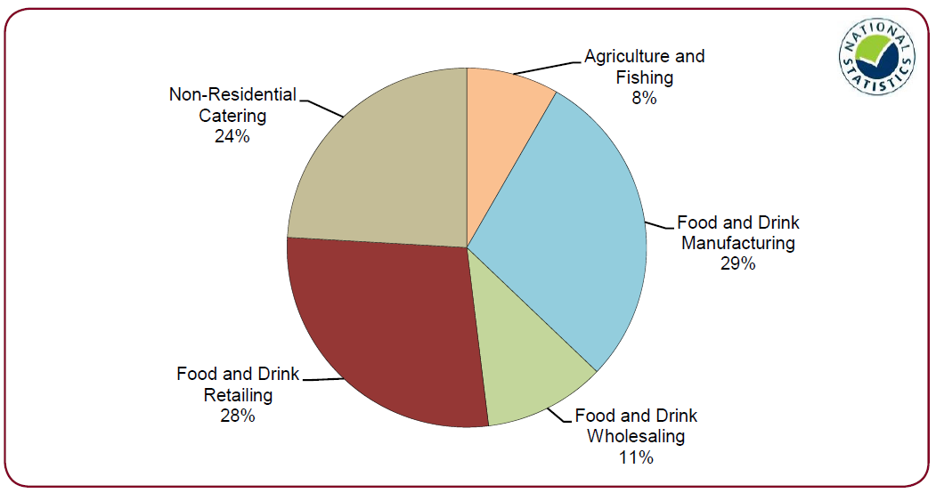

Source: Defra Food Statistics Pocketbook 2011, Figure 1.2 *Gross Value Added of the UK Agri-food Sector 2009*

For Defra (see Figure 3.1 above) the agri-food sector encompasses all of food and drink retailing and extends to non-residential catering, but not to hotels and other accommodation. At the UK level the links between the parts of a more broadly defined agri-food sector are likely to be quite strong: the majority of the UK’s primary food production and food manufacturing will be supplied to the UK food retailing and catering sectors. At sub-national level these links are likely to be much weaker. Modelled supply chain data[9] for the South West region suggests that 44% of primary production is supplied to the region; 38% to businesses and 6% direct to households. The great majority of the primary produce is supplied to food and drink manufacturers. The manufacturers themselves source 42% of their inputs from within the region although only 28% of their output is supplied to the region[10]. This progressive weakening of links at smaller geographies suggests a narrower definition of the agri-food industry is more appropriate at the Devon county level.

As Table 3.1 illustrates, the broad agri-food industry is made up of the core agri-food industry, secondary food sectors and food related sectors. All three sectors are considered to be an important part of the context for the whole of the agri-food economy in Devon. Both the Secondary food sectors and ‘Food related’ sectors may be key to strengthening local demand for core agri-food output and many businesses in these sectors would consider themselves to be a part of Devon’s agri-food landscape.

**Table 3.1 The components of the agri-food sector**

|  |  |
| --- | --- |
| Primary production | “**Core agri-food industry”** |
| Food and drink manufacturing |
| Food and drink wholesaling |
| Specialist food and drink retailing |
| Non-specialist predominantly food &  drink retailing | “**Secondary food sectors”** |
| Food and beverage services |
| Accommodation | “**Food related”** |

**3.3 Employment in the agri-food sector**

The overall employment ‘size’ of the agri-food industry is an important headline measure of the significance of the food economy. Using data from the Business Register and Employment Survey (BRES)[11] a headcount analysis shows that core agri-food activities provide employment for 31,900 people within a total employment of 79,100 in all food and drink *related* sectors (Table 3.2). In percentage terms 9% (4% in GB) of the county’s employment is in core agri-food activities, to which can be added consideration of a further 10% (9% in GB) in supermarkets, bars and restaurants[12] and 3% (1% in GB) in accommodation, giving a figure of 23% (15% in GB) in all food and drink related sectors.

**Table 3.2 Sector employment in Devon 2009-2010 average (headcount)**

|  |  |  |  |  |  |
| --- | --- | --- | --- | --- | --- |
|  | **Whole economy** | **Agri-food breakdown** | | | |
|  |  | Non-agri-food | Core agri-food | Secondary food | Food related |
| Agriculture, forestry & fishing | 21,400 | 400 | 21,000 |  |  |
| Mining, quarrying & utilities | 4,700 | 4,700 |  |  |  |
| Manufacturing | 27,200 | 23,200 | 4,000 |  |  |
| Construction | 24,600 | 24,600 |  |  |  |
| Motor trades | 7,700 | 7,700 |  |  |  |
| Wholesale | 15,100 | 10,700 | 4,400 |  |  |
| Retail | 41,000 | 23,800 | 2,500 | 14,700 |  |
| Transport & storage (inc postal) | 15,600 | 15,600 |  |  |  |
| Accommodation & food services | 32,500 | 0 |  | 21,500 | 11,000 |
| Information & communication | 9,000 | 9,000 |  |  |  |
| Financial & insurance | 5,800 | 5,800 |  |  |  |
| Property | 5,100 | 5,100 |  |  |  |
| Professional, scientific & technical | 20,400 | 20,400 |  |  |  |
| Business admin & support services | 15,900 | 15,900 |  |  |  |
| Public administration & defence | 17,800 | 17,800 |  |  |  |
| Education | 27,500 | 27,500 |  |  |  |
| Health | 41,000 | 41,000 |  |  |  |
| Arts, ents, recreation & services | 14,800 | 14,800 |  |  |  |
| **Total employment - Devon** | **347,100** | **268,000** | **31,900** | **36,200** | **11,000** |
| Percentage of whole economy | 100% | 77% | 9% | 10% | 3% |
| Total employment - GB (‘000s) | 27,893 | 23,730 | 1,236 | 2,545 | 381 |
| percentage of whole GB economy | 100% | 85% | 4% | 9% | 1% |
|  | 1.2% | 1.1% | 2.6% | 1.4% | 2.9% |
|  | 100.0 | 90.8 | 207.3 | 114.3 | 231.9 |

These are large differences in the industrial structure of employment compared with the rest of the nation and, even allowing for any uncertainties due to data qualities, it seems safe to say that the county is around one-and-a-half times as dependent on food and drink related sectors for employment as GB as a whole. However, as these sectors also tend to have relatively low levels of labour productivity the economic value of the food and drink share of the county’s economy will be significantly less.

The detailed structure of employment is presented in Appendix B. Key points include the following:

* Agriculture is responsible for about twice as much employment in Devon as it is generally in Great Britain
* 15% of Devon’s manufacturing employment is in food and drink processing which is about the same as in Great Britain’s manufacturing as a whole
* About a quarter of Devon’s food and drink manufacturing employment is in dairy products representing around 4% of the GB total in this sub-sector.
* 29% of the county’s wholesaling employment is food and drink related compared to only 20% in Great Britain as a whole
* Employment in supermarkets[13] outnumbers employment in specialist food retailing by a margin of 6 to 1 but this is actually a stronger specialist food presence than the GB equivalent figure of 6.9 to 1.
* Although not too much weight should be placed on year-on-year changes there was a notable fall in GB and in Devon in the specialist beverage retailer’s employment between 2009 and 2010. This fits with the closure of a number of high street chains of off licences.

Taken together these figures demonstrate that the agri-food sector in Devon is very important in terms of underpinning the employment base.

**3.4 Gross Value Added in Devon’s agri-food industry**

Official GVA data is published by the Office for National Statistic (ONS) but at lower geographies there is only a very limited breakdown by industry. In practice this means that for this study the ONS data available is limited to primary production[14]. Because better data is available it is possible to do much more detailed analysis on agriculture than any other part of the agri-food industry. It is clear that for many years the primary food production sectors have been on a completely different growth trajectory to the Devon economy as a whole. There has been no overall growth in nominal terms in the sector while the county’s economic output has largely grown steadily (See Figure 3.2).

**Figure 3.2 Agriculture’s nominal contribution to Devon’s GVA 1995-2009**

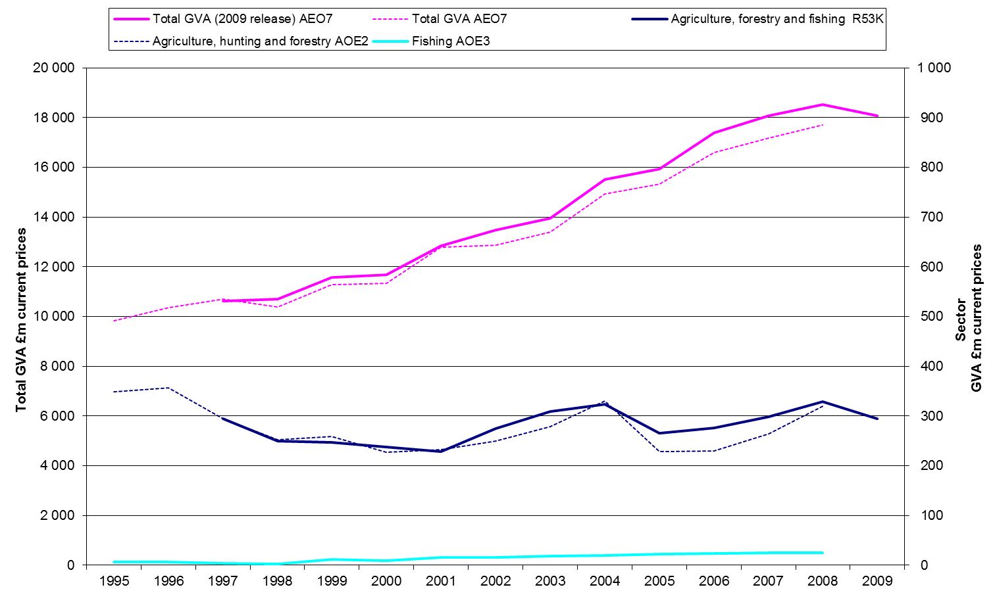

Source: ONS

The nominal value of the sector’s output actually fell between 1996 and 2001 but by 2008 had recovered to the same previous level before declining again. As a result, ‘agriculture’s’ share of the county’s GVA has fallen from 3.5% in 1995 to just under 2% in 2008 (Figure 3.3 below). This compares with a fall from 2% to less than 1% for the UK as whole.

This is not a very surprising result, except perhaps just how small the value of agriculture is, even in Devon. That said the value of agriculture’s primary production is only part of its total value which includes a range of other environmental and cultural services that are important but beyond the scope of this project. Meanwhile fishing has more or less held its own indicating some real growth in the value of output.

**Figure 3.3 The contribution of agricultural output: Devon and UK compared**

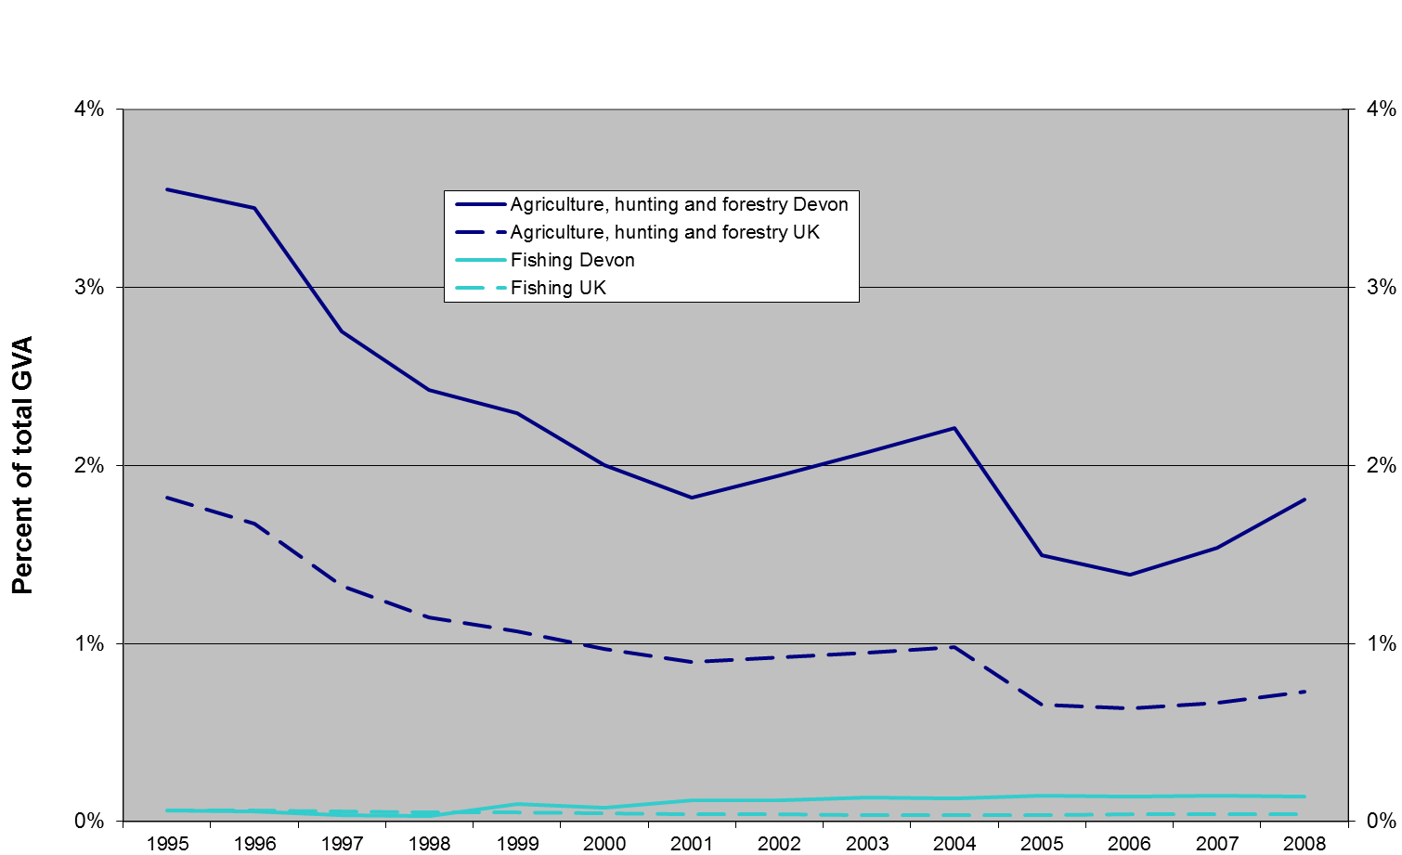

In 2005 the switch from production subsidies to ‘decoupled’ area-based payments meant agriculture’s nominal and relative contribution was lowered. Although this will in the longer run have influenced production decisions (see Lobley and Butler 2010[15] for a discussion of the impact of CAP reform on farms in the SW), the one-off change in GVA accounting in 2005 creates a discontinuity that does not reflect actual physical output.

However, there is no doubt that the value of agricultural production as a proportion of Devon’s economic output declined substantially between 1995 and 2005 even if this is exaggerated by the change in how farm payments are treated. While Devon’s contribution to UK agriculture during this period has been fairly constant at close to 3% since 2005 there is a slight upward trend. This could reflect a shift in relative values within agriculture in favour of livestock products or perhaps greater pressures in agriculture elsewhere in the UK from the competition for resources (land, labour).

In contrast to agriculture, the county’s fishing, although a very small contributor to GVA, has seen its share of UK sector economic output increase markedly from around 1% to around 5%.

At the 2008 levels primary food production (agriculture and fishing combined) is still only a very small part of the value of Devon’s economy. For a more up to date analysis of how Devon’s agricultural GVA may have fared it is necessary to look at national trends.

Both 2009 and 2010 saw a total fall of 8% in the underlyingvolume of output[16] from the broad agriculture sector across the two years compared to a net contraction nearer 3% for the whole UK economy. In value terms (Figure 3.4), the fall has been much more dramatic as commodity prices fell back from the 2008 highs as well, resulting in an 11.7% nominal fall in 2009 followed by another 5.7% fall in 2010.

**Figure 3.4 UK Nominal Output, indexed, 1997 to 2010**

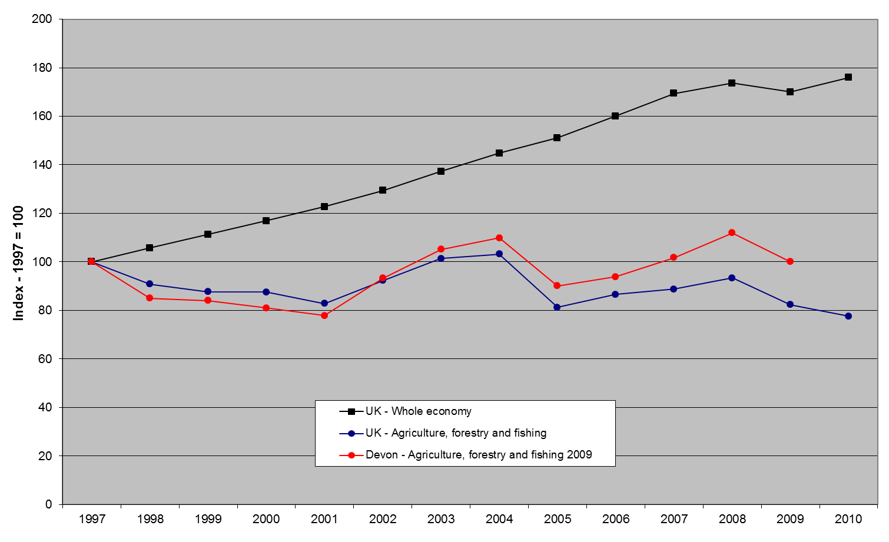

Such large likely falls in the volume and value of production since 2008 might be expected to have led to very visible signs of distress in farming. However, farm support payments are based in Euros and these have increased in value by around 20%. This is due to the devaluation of sterling against the euro. Consequently net farm incomes will have been substantially protected.

The limitations of official published data mean that for other parts of the agri-food sector we have to rely on modelled estimates[17]. This is shown in the time-series charted in Figure 3.5 below.

**Figure 3.5 The contribution of agriculture and food manufacturing to Devon’s GVA 1998 to 2008**



The modelled estimates indicate that food and drink manufacturing’s share of the economy has been falling over time, from at or above 2% up to 2001 to nearer 1.5% more recently. Allowing for year-on-year volatility, the two sectors combined have seen their share of the county’s economic output shrink to around 4% of the total[18]. The broad picture[19] seems to be that meat processing, baking and confectionary are the main contributors to Devon’s food and drink manufacturing output but the data also suggests that baking and confectionary may have become less important in recent years.

While not too much should be read into the exact numbers in 3.3[20], they do give some indication of the relative size, in output terms, of the different parts of the agri-food industry in Devon. The core agri-food industry in 2008 contributed around 5.6% of the county’s economic output, or around £612 million pounds. In its broadest sense, which includes restaurants, bars, supermarkets and accommodation, agri-food related industries account for approaching 13% of total GVA in Devon. The equivalent figures for Great Britain are 3.5% for the core agri-food industry and 7.6% for all agri-food related industries. Further detailed analysis of agricultural GVA is available in Appendix C.

These percentages are significantly different from the results for employment (core 9%, all 22% see Section 3.3), indicating large, but not surprising, variations in labour productivity. Agriculture accounts for five times the amount of head-count employment of food and drink manufacturing but only double the value of output, as measured in GVA. Some of this is likely to be accounted for by the levels of part-time working in different sectors.

**Table 3.3 Indicative GVA of agriculture and related food & drink sectors in Devon**

|  |  |  |  |
| --- | --- | --- | --- |
|  | **2008 GVA**  **£m** | **Sector share of total GVA** | |
|  | **Devon** | **Devon** | **GB** |
| Agriculture[21] | £302 | 2.8% | 0.6% |
| Fishing[22] | £11 | 0.1% | 0.0% |
| Food and Drink manufacturing[23] | £156 | 1.4% | 1.5% |
| F&D wholesale distribution[24] | £105 | 1.0% | 0.9% |
| Retail - Specialist food[25] | £39 | 0.4% | 0.4% |
| **Core agri-food industry** | **£612** | **5.6%** | **3.4%** |
| Food and beverage services[26] | £334 | 3.1% | 1.9% |
| Retail - non-specialists predominantly F&D[27] | £243 | 2.2% | 1.7% |
| **Secondary food industries** | **£577** | **5.3%** | **3.6%** |
|  |  |  |  |
| Accommodation[28] | £195 | 1.8% | 0.6% |
|  |  |  |  |
| All agri-food related industries | £1,384 | 12.8% | 7.6% |
|  |  |  |  |
| All industries[29] | £10,847 | 100.0% | 100.0% |

GVA output per full time equivalent has been calculated from the Regional Accounts which removes the potential part-time working distortions.

**Table 3.4 GVA per fte, 2007 to 2009 average**

|  |  |  |  |  |
| --- | --- | --- | --- | --- |
|  | **GB** | **SW** | **Devon** | |
|  | £ per FTE | | | |
| All industries | 49,000 | 41,000 | | 34,000 |
| Core agri-food industrial sectors: |  |  | |  |
| Agriculture | 16,000 | 16,000 | | 14,000 |
| Fishing | 49,000 | 54,000 | | 42,000 |
| Food and Drink manufacturing | 52,000 | 45,000 | | 35,000 |
| Food and drink Wholesale distribution | 51,000 | 40,000 | | NA |
| Retail of food in specialised stores (52.2) | 32,000 | 25,000 | | NA |
| Retail sale in non-specialised stores (52.1) | 32,000 | 20,000 | |  |
| Hotels and catering | 26,000 | 24,000 | | 20,000 |

Source SWRA[30]

The figures for output per full time equivalent in Table 3.4 above show quite wide variations, with extremely low productivity in agriculture and fairly high productivity in the much more capital intensive fishing industry. Productivity is also well below average in all of the service elements of the agri-food chain. Food and drink manufacturing productivity is at the all-industry average level for Devon but well below the sector level for the South West and Great Britain. This is probably due in part to the mix within the sector but more generally is likely to reflect the scale and capital intensity of the enterprises.

Although the detail is not complete, it appears consistent with the generally weak labour productivity in Devon. In sectors of significant employment, productivity is either weak relative to the GB sector equivalent, like food and drink manufacturing, or weak relative to Devon’s all-industry productivity, like Hotels and Catering or both like Agriculture. This suggests that further investment to increase the labour productivity of Devon’s agri-food sector could help improve Devon’s poor labour productivity when measured against other equivalent English (NUTS3[31]) areas (See e 3.5).

**Table 3.5 Measures of labour productivity in Devon, 2008**

|  |  |  |
| --- | --- | --- |
|  | **Index: England = 100** | **Rank out of 93 NUTS3 areas** |
| GVA per head of Population[32] | 75.5 | 60 |
| GVA per job filled[33]† | 79.6 | 81 |
| GVA per hour worked† | 83.4 | 77 |

(Although the index measure improves as the participation rate and part-time working are taken into account, the county’s rank actually falls from 60th to 77th in the per hour measure. This implies that in the NUTS3 areas which rank lower on the per head of population measures are more adversely affected than Devon by low participation rates and / or low hours worked per employee.)

**3.5 Value of farmgate production**

Turning now to the monetary value of Devon’s agriculture and its various sub-sectors, Table 3.6 presents an estimate of the farmgate values of the different agricultural commodities produced in Devon and represents the value of the home-grown raw ingredients available to the food industry. In the absence of local data on yields and prices this calculation is based on published data for the UK applied to the county’s crop areas, livestock numbers and milk quota.[34]

**Table 3.6 Farmgate values, 2009 and 2010**

|  |  |  |  |  |  |  |  |  |  |  |
| --- | --- | --- | --- | --- | --- | --- | --- | --- | --- | --- |
|  | ***Value to Devon*** | |  | ***Value to Devon*** | |  | | ***Value to Devon*** | | |
|  | **2009**  **All Holdings** | |  | **Commercial**  **holdings* only** | | |  | | **2010**  **Commercial**  **Holdings only** | |
|  | £ millions in current prices | | | | | | | | | |
| *Crops* |  | | | | | | | | | |
| Cereals not for stockfeed | £12.6 | 3% |  | £12.4 | 3% | |  | | £13.1 | 3% |
| Other arable crops | £3.7 | 1% |  | £3.6 | 1% | |  | | £4.6 | 1% |
| Potatoes | £6.7 | 1% |  | £6.2 | 1% | |  | | £5.9 | 1% |
| Horticulture | £24.0 | 5% |  | £20.0 | 4% | |  | | £21.2 | 4% |
|  | £47.0 | 10% |  | £42.2 | 9% | |  | | £44.8 | 9% |
| *Livestock* |  |  |  |  |  | |  | |  |  |
| Beef | £125.0 | 25% |  | £124.5 | 26% | |  | | £125.9 | 25% |
| Dairy (milk) | £226.8 | 46% |  | £226.5 | 47% | |  | | £242.6 | 48% |
| Sheep | £42.4 | 9% |  | £40.5 | 8% | |  | | £40.6 | 8% |
| Pigs | £20.2 | 4% |  | £17.7 | 4% | |  | | £19.2 | 4% |
| Poultry | £32.8 | 7% |  | £31.7 | 7% | |  | | £36.2 | 7% |
|  | £447.2 | 90% |  | £440.9 | 91% | |  | | £464.5 | 91% |
|  |  |  |  |  |  | |  | |  |  |
| Total Value of Farm Produce | £494.2 | 100% |  | £483.1 | 100% | |  | | £509.3 | 100% |

Source: Defra data and CRPR analysis

*See <http://www.defra.gov.uk/statistics/files/defra-stats-foodfarm-landuselivestock-june-results-methodology.pdf> for definitions of commercial holdings.

As well as putting a figure on this part of the food supply chain, the calculation reveals the relative contribution of the different commodities produced. The importance of milk cannot be overstated: liquid milk alone accounts for nearly half of the total value of output but there is also the contribution from the marketing of animals for meat from the dairy herd. This we estimate to account for maybe 60% of the total value of beef marketing, which would bring the total value of output from the dairy sector up to 65% of all output.

The level of confidence in this calculation is not such that it could provide a robust indication of year-on-year change in the value of farmgate output. In 2009 Defra published two sets of June Survey data, one of all holdings and a second with ‘non-commercial’ holdings excluded. This provided us with a one-off opportunity to look at the contribution from these very small farming enterprises. Table 3.7 looks at this in more detail.

Of Devon’s 17,392 registered agricultural holdings in 2009 7,765, or 45%, were not thought to be commercial. A very large proportion of these came under the heading of ‘other’ which included specialist horses and specialist grass (where the holder kept no livestock of their own). There were also significant numbers of non-commercial holdings classed as horticulture, pigs and poultry. Together the non-commercial holdings accounted for 21% of the recorded labour but, by our estimation, only 2% of the value of farmgate output.

**Table 3.7 Devon’s non-commercial farms**

|  |  |  |  |  |
| --- | --- | --- | --- | --- |
|  | **All**  **holdings** | **Commercial**  **Holdings** | **Non-commercial holdings** | **% NC** |
|  |  | | |  |
| Cereals | 774 | 691 | 83 | 11% |
| General Cropping | 192 | 164 | 28 | 15% |
| Horticulture | 691 | 363 | 328 | 47% |
| Specialist Pigs | 192 | 81 | 111 | 58% |
| Specialist Poultry | 597 | 252 | 345 | 58% |
| Dairy | 1,097 | 1,069 | 28 | 3% |
| Grazing Livestock (LFA) | 1,386 | 1,214 | 172 | 12% |
| Grazing Livestock (lowland) | 3,106 | 2,503 | 603 | 19% |
| Mixed | 917 | 758 | 159 | 17% |
| Other | 8,440 | 2,532 | 5,908 | 70% |
|  | 17,392 | 9,627 | 7,765 | 45% |
|  |  |  |  |  |
| Labour (headcount) | 23,622 | 18,629 | 4,993 | 21% |
|  |  |  |  |  |
| Value of farmgate output (£m) | £494.2 | £483.1 | £11.1 | 2% |

**3.6 Summary**

In summary, analysis of the employment and GVA data indicate the following key characteristics of Devon’s food economy:

* 44% of primary production is supplied to the region (38% to businesses and 6% to households);
* Manufacturers source 42% of their inputs from within the region. 28% of their output is supplied to the region;
* The employment headcount analysis shows that core agri-food activities provide employment for 31,900 people (9%) within a total employment of 79,100 (23%) in all food and drink related sectors. The county is around one and a half times as dependent on food and drink related sectors as GB as a whole though relatively low labour productivity means the value of the agri-food share of the county’s economy is less;
* Approximately a quarter of Devon’s food and drink manufacturing is in dairy products representing about 4% of the GB total in this sub-sector;
* Devon has a relatively higher employment rate in specialist food than GB as a whole;
* Agriculture’s nominal contribution to Devon’s GVA has fallen from 3.5% to 3% in 2008. Fishing has experienced real growth in the value of its output;
* Modelled estimates indicate that food and drink manufacturing’s share of the economy has been falling over time from around 2% in 2001 to 1.5% more recently.

**4 PRIMARY SECTOR ANALYSIS**

This chapter is informed by both published statistical data and interviews with key industry producers, processors and farmers in each of the major sectors of primary agricultural production.

**4.1 The dairy sector**

The dairy sector in Devon is by far the most significant sector of primary production accounting for 48% of the value of farm produce at the farmgate. At the same time farmgate milk price rises have accelerated and downstream consolidation in Devon has increased with some smaller processors being purchased by larger businesses.

***4.1.1 The size and structure of the dairy sector***

Devon’s dairy sector remains a highly dynamic area of food production with the long term trend of decreasing dairy numbers continuing. Figure 4.1 below illustrates a steady decline in dairy numbers over the past 30 years. Milk output in Devon has stayed fairly constant over time while the number of breeding animals in the herd has declined (see Figure 4.2). As a result yields have at least kept pace with the UK average. In the last few years there has been some increase in the county’s output against the UK trend, and a yield premium over the UK of about 3% to 5% is being maintained (Figure 4.3). As a result Devon’s share of UK milk deliveries has risen from 7.0% to 7.5% of the total.

**Figure 4.1 Total Devon dairy herd 1981 to 2010, indexed 1990 = 100**



Source: Defra Agricultural Survey / Census, CRPR analysis

**Figure 4.2 Dairy breeding herd and net milk quota, 1994/5 to 2010/11**



Source: Defra Agricultural Survey / Census and RPA

**Figure 4.3 Implied diary yield, Devon and UK, 1994/5 to 2010/11**



Source: Defra Agricultural Survey / Census and RPA, CRPR analysis

***4.1.2 Quota holders***

Between 1994/5 and 2010/11 the number of distinct net quota holders in Devon fell from 2,378 to 1,022 with virtually all of the fall occurring in the smaller quota size bands (up to half a million litres). At the same time the number of holders of over one million litres of net quota rose from 101 to 351, with this group now accounting for two-thirds of the total quota held. The average quota held in the 2 million plus group is 3.5 million litres, which at an average yield of, for example 7,500 litres, equates to herds of 470 milking cows. 2007 was the last year that herd size distribution data was released. Nevertheless, it can be seen that over a relatively short time period the proportion of dairy breeding animals in herds of 200 and over has increased from a little over 10% to well over 25% (see Figure 4.4). The implications are clear: small dairy herds are vanishing.

**Figure 4.4 Devon’s dairy herd size distribution: 1999, 2004 and 2007**

**

From 2010 the June Agricultural Survey published data excluded “non-commercial” holdings, which for dairy means herds of 10 or less. When this threshold was applied to the 2009 survey data the dairy breeding herd in Devon was reduced by just 153 animals or 0.1%.

The other way of looking at concentration in the dairy sector is to explore trends in the volume of milk output to see what is happening in terms of milk output. Table 4.1 below shows that between 2005/06 and 2009/10 the number of distinct quota holders in the county fell by 17% while the average production per holder increased by 19%. This is possibly an under-representation of the degree of change as, in recent years, quota value has become almost insignificant so that there has been a growing number of non-producing quota holders. (This will be resolved in the near future as this unused quota will be taken back into the national reserve.)

**Table 4.1 Changes in quota holders and average quota held, Devon, England and UK, 2005/06 and 2009/10**

|  |  |  |  |  |  |
| --- | --- | --- | --- | --- | --- |
|  |  | **2005/06 (Quota)** | **2009/10 (Delivered)** | **Change** | **% Change 05/06 to 09/10** |
| Devon | Distinct net quota holders | 1,279 | 1,063 | -216 | -17% |
|  | Average per holder ('000 lt) | 763 | 907 | +144 | +19% |
| England | Distinct per quota holder | 11,552 | 9,263 | -2,289 | -20% |
|  | Average per holder ('000 lt) | 822 | 909 | +86 | +10% |
| United Kingdom | Distinct net quota holders | 19643 | 16096 | -3547 | -18% |
| Average per holder ('000 lt) | 721 | 801 | +80 | +11% |

Source: RPA

Although the data indicates that Devon’s dairy herds have been getting steadily larger they still remain a little smaller than the average for England, both as measured by the average quota per holder and the percentage of the breeding herd in herds of 200 & over (27% vs. 29%). These largest herds are significantly more prevalent in the South East, although the total numbers are relatively small, and in Cheshire (43%), Dorset (41%) and Somerset (34%). This may indicate that there is still some scope for this trend to continue in Devon.

***4.1.3 Routes to market***

In contrast to years of depressed prices, recently average UK milk prices have seen dramatic changes in response to the strengthening market for milk commodities (see Table 4.2). In Devon the main three milk purchasing companies: Milk Link, Dairy Crest and Robert Wiseman continue to purchase the vast majority of milk produced in the county.

**Table 4.2 UK average milk prices**

|  |  |  |  |
| --- | --- | --- | --- |
| Year | 2006 | 2009 | 2012 |
| Average UK milk price (p/litre) | 17.95 | 23.73 | 24.68 |

Source: DairyCo

With 7.4% of the UK’s milk production and just 1.2% of the population, Devon is a big ‘exporter’ of milk. The calculation in Table 4.3 for Milk Supply and Use uses UK prices and per capita consumption to estimate the quality and value of the milk production that is surplus to the county’s own needs[35]. As can be seen, total milk production is over 600% in excess of that required for domestic, in-county, consumption meaning that Devon milk is a major export from the county. Some of the key trends and issues facing Devon’s diary sector are discussed in Box 4.1 below.

**Table 4.3 Milk supply and use[36]**

|  |  |
| --- | --- |
|  | Litres, millions |
| Total production | 984 |
| Total domestic use | 159 |
| Surplus (deficit) | 825 |
|  |  |
|  | £m |
| Value of production | £242.7 |
| Value of surplus ( deficit) | £203.4 |
|  |  |
| Devon’s production as % of UK production | 7.4% |
|  |  |
| UK production as % of UK domestic use | 103% |
| Devon’s production as % of Devon’s domestic use | 618% |

**Box 4.1 Devon’s dairy sector: Trends, developments and critical issues**

In the last few years there has been some increase in the county’s dairy output against the UK trend, and a yield premium over the UK of about 3% to 5% is being maintained. As a result Devon’s share of UK milk deliveries has risen from 7.0% to 7.5% of the total. This increase is happening at the same time as a concentration in the dairy sector with small dairy herds disappearing. While the price for milk has risen, it is still similar to the costs of production and there are significant investment requirements to modernise after years of poor profitability in the sector. Many ageing dairy farmers are facing significant investment requirements to modernise their production systems and this may lead to some leaving the market.

**Recent economic conditions:** In terms of the dairy processing sector Devon’s dairy processors produce a wide range of products and although there have been changes in consumer spending patterns and people are eating in more, businesses report good sales and consumers are still buying ‘treats’.

Those processors who have their own dairy herd report a considerable advantage in the food processing industry, being able to anticipate price rises in commodities in advance of those companies which are not farm based. Increases in diesel prices, resulting in higher costs of deliveries, have already caused price increases. Increases in diesel tend to be passed on immediately through delivery contracts which use current fuel prices. One company reported longer term contracts with utilities and those companies they supply as a way to generate price and cost stability.

**Future success:** Future success is likely to depend upon building sustainability into companies to reduce costs. New product development of highly differentiated products with clear points of difference is also seen as an important element for future success.

**Support requirements:** The Devon food brand is seen to have considerable potential although a significant perceived barrier in Devon is getting businesses to talk to each other.

Training and skills development across a whole range of skills from management to machine operators is also a significant area needing support. It was suggested that training needs to be seen as an investment rather than a cost to businesses.

**4.2 Horticulture and potatoes[37]**

Devon is not generally a notable grower of potatoes or a horticulture producer, accounting for only a very small percentage of the total crop areas in England (Table 4.4).

**Table 4.4 Horticulture and potatoes crop areas, 2010**

|  |  |  |  |
| --- | --- | --- | --- |
|  | **Devon(d) crop area (ha)** | **Devon area as % of SW region** | **Devon area as % of England** |
| Peas & beans | 25 | 3.6% | 0.1% |
| All other veg & salad | 943 | 17.0% | 1.2% |
| Total vegetables grown in open | 967 | 15.5% | 0.9% |
|  |  |  |  |
| Crops under glass/plastic(a) | 24 | 16.9% | 1.6% |
| Top fruit | 686 | 22.8% | 3.1% |
| Small fruit(b) | 90 | 11.8% | 1.1% |
| Hardy nursery stock(c) | 195 | 6.6% | 1.9% |
| Potatoes | 1,044 | 16.5% | 1.0% |
|  |  |  |  |
| Total farmed land | 504,598 | 27.9% | 5.6% |

Source: Defra June Survey

(a) Includes any fixed or mobile structure high enough to walk through which is glazed or clad with film, rigid plastics or other glass substitutes. It excludes lights, low plastic tunnels, French and Spanish tunnels.

(b) Includes crops grown in Spanish tunnels.

(c) Includes bulbs and flowers grown in the open.

(d) Devon CC, Torbay and Plymouth

The main trends and issues facing Devon’s horticulture sector are discussed Box 4.2 below.

**Box 4.2 Devon’s horticulture sector: Trends, developments and critical issues**

**Recent economic conditions**: according to key informants interviewed for this research approximately 70% of fruit and vegetables grown in Devon are sold to supermarkets; 15 – 20% is sold to wholesale markets or local wholesalers distributing to the holiday and catering industry; and the remaining 10% is sold through farm shops or other local markets. For a few very small producers who are not selling high volumes this is a good way of getting a higher margin for their produce but it is very time consuming. Farmgate prices attained by commercial growers have been largely static for the past 10 years and, although efficiencies have been made, the costs of production have still increased, thus reducing margins. Shop prices have risen although this reflects the increase in haulage and distribution costs rather than increases at the farmgate. The larger growers supplying multiple retailers are being squeezed and salad and tomato growers have declined in Devon, moving to other areas of England (including the eastern counties and the Midlands) where there are lower transport costs. Commercial horticulture in Devon has declined in recent years due to declining economic viability. The one success story is good quality swedes which need good soils and therefore Devon has a comparative advantage.

Before the recession affected spending patterns there was a growing change from basic fresh produce to prepared produce – consumers were, for example, buying bags of florets rather than the whole cauliflower. The recession has seen this change slow down again as consumers are more cautious and buying their vegetables whole rather than semi-prepared. Value and economy ranges have flourished more recently.

**Future external factors**: The growing awareness of food security makes many growers optimistic about the future although growers, and in particular nurseries and growers of tomatoes, need lower costs of water and electricity to remain competitive with European competitors. This sector is also recognised as high risk and very sensitive to annual variations in weather conditions. Availability of labour is also an issue. The majority of vegetable packers and fruit growers employ foreign workers and hope the exemptions for agricultural workers will continue in order to meet the UK’s shortage of supply of suitable workers.

**Future success:** Future success will depend on growers getting a slightly better return e.g. 2 – 3p/head more. Growers are only getting the minimum amount at the moment and they do not have a unified voice to exercise any power over the supermarket buyers. The industry has been doing effective ‘soft marketing’ with articles in magazines promoting their produce well and raising awareness. The future will also be affected by advances in research to address plant disease, insect tolerance and drought resistance as well as establishing mechanising methods to address labour shortages. Any increase in mechanisation has to be balanced against the increase in fuel costs.

**Support requirements:** Support to develop the Devon food brand and tap into the considerable potential for the Devon food economy would be very helpful.

**4.3 Cereals**

The proportion of farmed land devoted to cereal production gets progressively smaller the further west into the South West region with Devon using only 10% of its farmed area compared to 18% for the UK (and 28% for England). None-the-less this does still equate to 1.7% of the total cereal area in the UK, which is not insignificant. The key issue in terms of the food economy is the proportion of the county’s cereal crop that is for animal feed and for human consumption. Table 4.5 illustrates the value of Devon’s cereals using the UK crop values[38] and uses.

**Table 4.5 Devon’s main cereal production, 2010**

|  |  |  |  |  |  |
| --- | --- | --- | --- | --- | --- |
|  | **Crop area** | **UK crop value per ha** | **Estimated Devon total cereal crop value (£m)** | **UK percentage for food use** | **Estimated Devon food use value (£m)** |
| **Wheat** | 22,891 | £868 | £19.9 | 37% | £7.4 |
| **Barley** | 21,190 | £554 | £11.7 | 32% | £3.8 |
| **Oats** | 5,689 | £506 | £2.9 | 65% | £1.9 |
|  |  |  | £34.5 |  | £13.1 |

In addition to the main cereal types Devon also has 2,645 ha of ‘other cereals’ which are mainly rye and triticale. Although not a large area in itself this does represent 9% of the UK total area for these crops.

Demand for cereals has risen internationally. Devon cereals tend to be grown for animal feed and put into compounds or exported so is generally not the high quality food needed for human consumption (e.g. making bread or beer). Cereals prices are good at the moment but the input costs (fuel, fertiliser and labour) are all high which makes margins very slim. On farm cereal storage is increasingly expensive and is a large investment for individuals to take on. There may be public support required for shared grain storage facilities.

**4.4 Meat and poultry**

Table 4.6 gives an overview of the county’s livestock sectors and how they have been changing, in overall numbers, over the last five years. All are discussed in detail under individual livestock headings. In order to get a more accurate picture of the share of livestock accounted for by each type the numbers of animals has been converted into standard ‘livestock units’, which are based on feed requirements. This shows just how dominant the cattle sector is in Devon, accounting for 74% of all the livestock units. The equivalent figure for England is much lower at 61% and the difference is explained by a relative under-representation of both pigs and poultry in the county (Figure 4.5).

**Table 4.6 Livestock numbers 2005 to 2010**

|  |  |  |  |  |  |  |  |  |  |
| --- | --- | --- | --- | --- | --- | --- | --- | --- | --- |
|  | **All holdings** | | | | | **% change 2005 to 2009** | **Commercial only** | | **% change 2009 to 2010** |
|  | **2005** | **2006** | **2007** | **2008** | **2009** | **2009** | **2010** |
|  | thousands | | | | |  | thousands | |  |
| Beef herd | 70.3 | 69.1 | 73.0 | 72.4 | 71.7 | 2% | 71.2 | 72.9 | 2% |
| Dairy herd | 132.0 | 131.1 | 134.4 | 131.4 | 129.0 | -2% | 128.9 | 130.3 | 1% |
| Total pigs | 95.5 | 115.2 | 106.3 | 95.3 | 103.0 | 8% | 97.9 | 85.6 | -13% |
| Total sheep | 1,474 | 1,465 | 1,399 | 1,402 | 1,344 | -9% | 1,287 | 1,302 | 1% |
| Total fowl | 4,995 | 5,117 | 5,281 | 5,177 | 4,582 | -8% | 4,261 | 5,626 | +32% |

Source: Defra June Survey data.

**Figure 4.5 Share of Livestock Units, England and Devon, 2009**

|  |  |
| --- | --- |
|  |  |

Source: Defra June Survey, CRPR analysis

**4.5 Beef**

The history of the size of Devon’s beef herd (Figure 4.6) is markedly different from that of the dairy herd (Figure 4.1) on page 43. Without the limitation imposed in the case of milk quota, breeding beef cattle numbers increased very rapidly between 1987 and 1995, having been static or declining up to that point. The pace of growth lessened after 1995 but there was one further jump in numbers in 1998 taking the herd size to a peak. This was followed by two years of dramatic falls in 2000 and 2001. Since then numbers have been gradually recovering and in 2010 were within 5% of their previous peak. The factors behind these movements include: the changing subsidy regime under the CAP; disease outbreaks (most notably BSE, FMD, bTB); sterling exchange rate; and profitability (production costs, world food prices)

**Figure 4.6 Beef breeding herd in Devon 1981-2010 (indexed)**

Source: Defra June Survey data, CRPR analysis

Although the production of animals for their meat might be considered a by-product for the dairy sector, the ratio of prime marketings to herd numbers is not actually all that much lower than for the beef sector. This, combined with the larger dairy numbers overall, means that in the UK the dairy sector accounts for only a little under half of all prime cattle marketings. In Devon the dairy herd is a substantially greater proportion of all cattle and consequently well over half of the ‘beef’ meat supply is actually from dairy herds. As Table 4.7 indicates, Devon’s beef production is far in excess of the county’s domestic consumption requirements and consequently beef is a valuable export product.

**Table 4.7 Devon’s beef supply and use 2010**

|  |  |
| --- | --- |
|  | **Dressed carcass weight (tonnes)** |
| Total production | 50,800 |
| Total domestic use | -12,700 |
| Surplus (deficit) | 38,100 |
|  |  |
|  | £m |
| Value of production | £ 126 |
| Value of surplus ( deficit) | £ 94 |
|  |  |
| Devon’s production a % of UK production | 5.7% |
|  |  |
| UK production as % of UK domestic use | 85% |
| Devon’s production as % of Devon’s domestic use | 400% |

Additional detail on these calculations is available in Appendix D.

***4.5.1 Current economic conditions in the beef sector***

The beef market is doing well at the moment and enjoying good prices although the knock on effect is a significant increase in the price of stores. Those producers who rely on fattening stores now face very high working capital costs combined with high feed costs. It is therefore increasingly difficult for smaller producers (eg with 50 store cattle) to compete with larger-scale, more commercial producers elsewhere in England. The changes in Single Farm Payment (notably the shift to area based rather than a payment with an ‘historic’ element) will also affect beef producers, although at the moment the impact of these changes is unknown.

Despite these challenges a good, high value, export market for fifth quarter beef products (offals) is developing, which means processors will be able to increase their returns from carcasses. In addition, as noted above, Devon beef comes from both the suckler and dairy herds. Beef supplied from the dairy system is not generally of such high quality but it was argued that there is currently insufficient differentiation between the two supply chains. Increased differentiation could highlight the two different products from different systems and of different quality. The suckler system is an important grazing system for Devon for a range of non-agricultural reasons. For instance, continued grazing in marginal areas has a positive impact on both the environment and on tourism.

**4.6 Sheep production**

Sheep numbers in Devon rose steadily through the 1980s and then remained at these elevated levels, with some year-to-year fluctuation, until 1999 (see Figure 4.7). The year 2000 was made difficult by the strength of sterling which made both exports less competitive and reduced the value of the then sheep headage subsidies. The whole UK flock contracted by around 6% and this was also the case in Devon. From this already weakened position the sector was hit by FMD in 2001 which saw 13% of the national flock slaughtered. Devon was one of the worst hit areas and the county’s flock was cut by 19% in the single year, a fall only outstripped in Cumbria and County Durham.

As with the UK flock as a whole, there has been no subsequent recovery in sheep numbers since the disaster of 2001 and, indeed, since the ending of the headage payments in 2004 numbers have begun to decline again. This must be at least in part a reflection to a substantial fall in domestic consumption driven by higher prices. Sheep numbers in Devon are now below where they were 30 years ago although current numbers may be a better indicator of supply and demand than the subsidy distorted figures of the 1980s and 1990s. Nevertheless, lamb and mutton supply in Devon still generates a significant surplus valued at £27.5m (see Table 4.8).

**Figure 4.7 Devon’s sheep numbers (all sheep), 1981 to 2010 (indexed)**

Source: Defra data.

**Table 4.8 Devon’s lamb and mutton supply and use, 2010**

|  |  |
| --- | --- |
|  | **Dressed carcass weight (tonnes)** |
| Total production | 11800 |
| Total domestic uses | -3786 |
| Surplus (deficit) | 8014 |
|  |  |
|  | £m |
| Value of production | 40.4 |
| Value of surplus (deficit) | 27.5 |
|  |  |
| Devon’s production as % of UK production | 4.1% |
|  |  |
| UK production as % of UK domestic use | 92% |
| Devon’s production as % of Devon’s domestic use | 312% |

Additional detail on these calculations is available in Appendix D.

**Box 4.3 Trends and conditions in Devon’s sheep sector**

**Recent economic conditions**: In the last two years prices for lamb have risen so, although producers are experiencing increased costs of production (feed, fertiliser and fuel), they will have enjoyed some of the best prices for many years. The mutton market is also very strong and has a reliable and established consumer base.

Press coverage of the Schmallenberg virus was associated with depressed prices and sales. The organic sheep sector have seen their sales fall during the recession as consumers revert to cheaper products but this fall is balanced by an increase in exports.

**Future external factors:** The market for lamb mainly depends on the value of sterling relative to the euro and the resulting price of lamb for export. Changes in the Single Farm Payment will affect farmers production decisions. Although the gradual shift from historic based payments to flat rate payments under the Single Payment Scheme has had a different effect on various farm types, 2011 saw the historic element reduced to 10% and from 2012 it is a flat rate payment based on area. If it was the case that historic payments generally favoured the old Sheep Annual Premium claimants then this would have provided a diminishing cushion against marginal underlying enterprise profitability. That could suggest that a managed adjustment has been taking place but that it should now be more or less completed.

**Future success:** Lamb producers will have to focus on technical development and training and skills development to increase productivity. Unknown factors like disease will also affect future success.

**Support requirements**: Sheep farmers need public support to adopt new technologies to improve their productivity. Currently available basic training offering lambing techniques, soil analysis, etc but interviewees argued that Devon should be looking at more advanced technologies and developing the skills that go with them. There is international expertise – particularly from New Zealand – to draw upon.

### 

### 4.7 Pig production

The long term pattern for pig numbers in Devon is broadly similar to that of the UK. There is quite high year-on-year volatility but within this total pig numbers were in a broad range up to 1999 and then fell sharply over a period of three years to the current much lower range (see Figure 4.8). What is different for Devon is that the drop in 2001 was significantly larger in proportion and there has been no commensurate rebound. As a result the county’s share of the UK herd is now around 2.0% having been above 2.5% before 2000. Figure 4.9 charts the steady decline of the breeding herd although there is some evidence that the reduction has flattened out and that breeding herd numbers may even have risen slightly.

**Figure 4.8 Devon’s pig herd, 1981 to 2010 (indexed)**



Source: Defra data.

**Figure 4.9 Devon’s sows and gilts in pig, 1998 to 2010 (numbers)**



Source: Defra data.

Note that the impact of applying the new ‘commercial’ threshold means holders of fewer than 50 pigs in total or 10 breeding pigs are excluded. The numbers indicate that 1,400 breeding pigs, or 11% of the 2009 total, were in units of ten or less. These smaller producers may be supplying local markets and so although perhaps not economically significant at the county level they may be adding to local household choice and diversity at local markets. As Table 4.9 shows, despite the declining pig herd, Devon still produces a small surplus of pig meat worth £3.4m. See Box 4.4 for further details on trends and developments in Devon’s pig sector.

**Table 4.9 Devon’s pig meat supply and use, 2010**

|  |  |
| --- | --- |
|  | **Dressed carcass weight**  **(tonnes)** |
| Total production | 18900 |
| Total domestic uses | -16400 |
| Surplus / deficit | 2500 |
|  | £m |
| Value of production | 26.0 |
| Value of surplus / deficit | 3.4 |
| Devon’s production as % of UK production | 2.7% |
| UK production as % of UK domestic use | 53% |
| Devon’s production as % of Devon’s domestic use | 115% |

**Box 4.4 Trends and developments in Devon’s pig sector**

**Recent economic conditions**: Over the last 10 years pig production has declined in the UK. The UK imports the majority of its pig meat which may not be produced to the same UK welfare standards and may be imported at very competitive prices. The price pig suppliers receive is affected mainly by overall supply and what other producers in the EU are doing. At the moment European producers are receiving higher prices in Europe. As supply to the UK has decreased UK producers have seen some improvement in price and demand. Supply within the UK has also declined slightly with continuing blue ear problems in parts of the country. Pig producers in Devon are very few in number and benefit from reduced risk of disease. If finished pig prices continue to increase the price of weaners is also likely to increase.

The costs of production have risen considerably – particularly feed and diesel. While input prices have risen in line with the majority of sectors, producers are not passing on the increased costs but absorbing them into their margins. Rises in beef and lamb prices have resulted in some improvement in demand for pork. Although getting into pig production is relatively easier than getting into dairy (e.g. the production cycle is shorter at 6 months and the infrastructure costs are less) there have been fewer new entrants in recent years as economies of scale mean a producer requires at least 300-400 pigs to be viable.

**Future external factors:** Further improvements inthe DAPP (Deadweight Average Pig Price)[39] will be the main factor affecting future success of pig production in Devon. There is a notable price inequality with red meat pricing, e.g. lambs around £4.30/kg, beef cattle at £3.42, pork at £1.39–£1.42p. Beef and lamb both enjoy a strong export market unlike the import-dominated pig meat market. Future successes will be helped by the UK reclaiming a premium over lower welfare imported pork. Volatility in commodity prices and availability of skilled labour will also affect future production.

**Future success:** There may be scope for technical improvements in productivity but future success is mainly dependent on the prices received and the costs of inputs.

**4.8 Poultry: meat and eggs**

Poultry production in Great Britain has a quite distinct geography with one of the concentrations of production centred on Devon’s eastern border with Somerset (see Figure 4.10).

**Figure 4.10 GB Poultry Map**

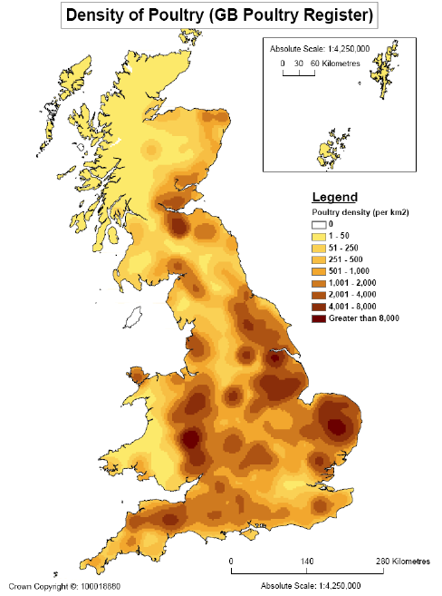

The data collected on poultry in the June Agricultural Survey is generally thought to be more problematic than for other mainstream livestock types. There are a number of reasons for this: ownership is often complex making responsibility for completing the return uncertain; the relatively small number of industrial-scale producers makes confidentiality a major issue; new entrants and departures can create large year-on-year distortions; and the nature of the production cycle can mean that a point in time ‘headcount’ may not reflect normal flock numbers.

That said, the poultry data for Devon presents a reasonably consistent picture. The county’s laying flock is generally around 5% of the UK total and table birds between 2.5% and 3%. Reported numbers in the breeding flock are very volatile indeed but these birds account for only a very small fraction of the total number of fowls (see Figure 4.11).

**Figure 4.11 Devon’s Poultry flock as a percentage of the UK total**



Source: Defra June Survey data

The data released for 2010 is less detailed than in earlier years and shows a 20% increase in layers / breeders and a 42% rise in table birds (broilers). There were significant increases in the UK flock but only 7% and 10% respectively. As the UK numbers are in line with egg and poultry meat production increases these seem to be credible. The county numbers equate to an additional 400,000 layers and 1,000,000 broilers. One interesting point made by an egg producer is that 3 million laying birds are estimated to be in people’s gardens which is close to 10% of the UK market. Further detail on trends and developments in the county’s poultry sector are discussed in Box 4.5.

**Box 4.5 Trends and developments in Devon’s poultry sector**

**Recent economic conditions**: The demise of cage production following the EU Directive on the 1st January 2012 has seen a considerable expansion of free range egg production which has opened up opportunities for many family farms in Devon. This expansion in free range production was fuelled by the expectation of a shortage in eggs. However, many of the large scale, commercial, egg producers switched from caged production to enriched cage production systems (designed to hold up to 90 birds and offers more freedom including the potential to nest, roost and stretch. Therefore the supply of eggs has been maintained. Also not all EU countries have yet managed to implement the directive so imported eggs from cheaper production systems are still available. An estimated 10% of imported eggs also come in liquid form for food manufacturing and it is difficult to know which production system liquid egg has come from.

**Future external factors:** Keeping expensive inputs (energy and feed) to a minimum will be important. The installation of Photovoltaic panels on the roofs of barns has cut energy costs but this system requires back up from the grid when insufficient power is available to heat sheds in order to maintain animal welfare in the winter. The costs of feed are reported by one egg producer to have risen by over 40% in the last three years. Producers have absorbed this increase in costs so far and the knock on effect has been little or no investment in their businesses as margins have been reduced.

**Future success:** Oneegg producer reported expecting markets to be strong as chicken meat and eggs are relatively cheap sources of protein. The main factors for success in the future will be the price of inputs to feed birds and market price for eggs. It was argued that ultimately egg prices will have to rise to reflect increased costs of production. Supermarkets compete heavily with each other and they put pressure on primary producers and processors to keep prices low and avoid price increases. One egg producer reported that future success would also depend on minimising the use of external inputs and possibly returning to feeding birds home grown cereals rather than selling the cereal. This same producer also indicated there may be scope for changing sales and marketing strategies. For instance, switching from supermarket contracts to more direct sales and wholesaling to retailers in order to enable egg producers to capture more of the margin.

**Support requirements**: Finance is a challenge for new start-ups and tenants. Primary producers also reported that, while owner occupiers are still more able to get finance for expansion, banks are paying more attention to a producer’s ability to service loans. One primary agricultural producer indicated that it is very important to find new innovative ways to get people into agriculture

## 5 PROCESSED AND MANUFACTURED FOODS

### 5.1 Introduction

This report does not include a statistical assessment of the processed food sector in Devon as availability of published data is limited. The following analysis is based on interviews with key industry informants (February 2012) and responses to the online survey (October 2012). The analysis serves to provide an overview of the key trends and issues affecting sectors as mentioned by producers and processors.

**5.2 Traditional cheese**

**5.2.1 *Recent economic conditions and external factors***

Unlike the market for most cheeses the traditional cheddar market is in long term decline. While there is a lot of interest in the local and special qualities of specialist traditional cheeses this is not being translated into spending patterns. Over the last 20 – 30 years there has been a clear move from mild to mature cheddar cheese and this is now a very large market. Traditional cheddar did benefit from this but it has now plateaued.

There has been an increase in commodity prices but those companies which rely on grazing for their milk production have continued to enjoy the comparative advantage of cheese production in Devon that means relatively lower input costs.

There have been a significant number of new cheese entrants – particularly exotic cheeses and the number of producers has expanded in recent years. For cheddar the main barrier to entry is that production has to be established on a large scale.

**5.2.2 *Factors for future success***

One cheese producing company reported that for future success they will be looking at refining tastes and finding those people who will pay more for more subtle flavours. It was reported that trade shows are good if there are not too many other cheese producers (not more than 3 or 4). Consumer awareness and understanding of the product is the all important factor in good sales. It will be important to continue with advertising and making sure marketing targets high end spenders and the South East.

The same producer reported that there is an established local market for traditional cheddar but that it is not very large. Approximately 20% of sales are in the SW and only 10% in Devon. A big decision will be whether or not to supply high end supermarkets like Waitrose or stick with the small, high-end delicatessens. There are also opportunities to export, mainly to the USA rather than continental Europe. It was felt that training and skills is getting easier as more educated people want to work in artisanal food production.

**5.2.3 *Support requirements***

Public support that makes doing business easier would be helpful such as access to finance and easing of planning restrictions. An interviewee suggested that banks should be encouraged to lend to more than just the usual owner/occupiers. Support for trade shows and marketing would be helpful.

**5.3 Alcoholic beverages**

**5.3.1 *Recent economic conditions and external factors***

The majority of ale brewed in Devon is cask ale supplied to the pub trade with a smaller amount being bottled for sale to farm shops, festivals, farmers markets and local supermarkets. In recent years changes in ownership of pubs in England has led to pubs being owned by large national companies and run by lessees or tenants tied to contracts to purchase their ale from their own pub company or brewer. Freehouse pubs are not under contract and therefore are able to purchase their ales from any supplier including the smaller breweries. The limited access to supply for many leased and tenanted pubs, which are supplied in volume by the larger national breweries, makes it difficult for the smaller Devon breweries to compete. However, as Devon brands grow and a greater volume is produced it is anticipated that this will improve. Increases in input prices including gas, electricity, water and malt have resulted in price rises this year. Prices are likely to rise further as the alcohol duty escalator rises 2% ahead of inflation. Spending patterns in pubs have already been affected with fewer visits and fewer drinks consumed per visit. Our interviewees argued that the combined effects of the recession, the smoking ban and more leisure alternatives have meant that fewer people are going to pubs and that pubs have to work hard to provide innovative services to maintain their customer base. However, overall the recession was not perceived to have affected sales in the strong cask ale market which is experiencing growth and enjoying good local demand.

**5.3.2 *Factors for future success***

The main focus for the alcohol beverage producers interviewed for this research will be to keep producing new products each year, consider the developing export market and, possibly, to increase bottling to develop wholesaling to retail outlets including supermarkets. Brewers also reported aiming to focus on supplying a few core products with a strong Devon brand within Devon and to expand sales through the South West more widely. Respondents also reported seeking to keep energy costs down by negotiating long fixed price contracts to keep prices stable as well as seeking cost effective waste disposal options.

**5.3.3 *Support requirements***

Access to finance could be a problem for relatively new businesses which are expanding quickly and, in this context, banks are seen to be unsupportive. Interviewees suggested that improved support from government to persuade banks to offer support to small businesses would be helpful. This should include making the loan guarantee system work as originally offered by government and ensuring that banks change their terms to be more supportive when required. However, for the more established businesses with good growth there were no difficulties reported in obtaining finance for expansion.

**5.4 Juices and water**

**5.4.1 *Recent economic conditions and external factors***

One interviewee reported that capital to finance expansion had not been available recently and that this had affected the success of a new product that was launched but had now been withdrawn.

Many consumers are visiting cafes or shopping centres on the high street and, although retail sales are down a bit as people are saving money, they are still enjoying a juice drink as a ‘treat’. Sales in January 2012 were reported as better than expected although, in recession when consumers are treating themselves, they tend to stick with the products they know.

It was reported that there has been definite growth in artisanal food production. However, prices of all inputs have increased including bottling, labelling and sugar so margins are squeezed and market prices of drinks products are not increasing to keep the prices competitive with the bigger brands.

**5.4.2 *Factors for future success***

The general confidence of wholesale buyers and any new entrant wholesale/distributer buyers is very important. It is important to have outlets supporting businesses in order to present their customers with a new choice when known brands are dominating the chiller. Also there are good experiences reported with some visitor attractions buying more from smaller suppliers in order to develop their ‘local’ links. Potential routes to success include focusing on niche market juices from the South West rather than competing with larger companies producing well known drinks. There are lots of small outlets and events to go to so there are good opportunities to sell – but businesses need to be very strategic about which events and fairs to attend.

**5.4.3 *Support requirements***

There is not much support available at the moment although it was reported that North Devon Plus has some small amounts available for technical development for new lines. There is limited technical expertise to drawn on in the niche markets and a fund to assist in developing technical skills would be helpful. It was also argued that membership of Food and Drink Devon/Love the Flavour is beneficial and that they are good at making the link between tourism and local food and providing a strategic overview.

One interviewee argued that the Farmers Market model is flawed because of the regulations which stipulate that producers can only sell what they make themselves which means a very inefficient time input. Public support to address this or explore other models for a number of small producers to sell together would be very interesting.

**5.5 Bakery products**

**5.5.1 *Recent economic conditions and external factors***

The smaller artisanal bakery businesses report positive sales at their retail outlets. Sales at Farmers Markets have been poor at the start of this year with traders generally agreeing on poor sales figures but this may be the expected dip following Christmas. As with many sectors there has been an increase in the costs of raw ingredients but labour costs are reported as the biggest cost when trying to expand. One bakery business which has moved its retail premises has increased sales as the footfall of consumers has increased, demonstrating a demand for quality products. During the recession the bakery business has seen people being more careful about where they spend their money with some consumers buying less quantity and spending a bit more on quality. Not all consumers have reduced incomes and Exeter in particular is perceived to have a good consumer base.

**5.5.2 *External factors***

Bakery products tend to be low cost and low margin. Competition from supermarkets is seen as the most significant threat to sales. In addition, significant increases in flour prices have affected profitability. The perception of our interviewees is that finance is not available from the private sector so accessing capital to expand has not been possible. The biggest hurdle to small bakery producers is where they choose to sell their products. People in Exeter want local food but many producers do not join together to come into the city to sell. Not everyone is willing or able to drive out to a farm shop or visit the once a week Farmers Market.

**5.5.3 *Factors for future success***

Businesses report focussing on locally produced, quality products with great taste. There is also a push to help the consumer understand that by spending on quality local products they are supporting the local economy. The feeling of provincial pride and belonging is also very important in this. There is also a desire to demonstrate that sustainable, low carbon projects can work, that they support local businesses and can benefit the appearance of the countryside.

**5.5.4 *Support requirements***

It was reported that the support and expertise of Devon Food and Drink is very useful. There is a need for good, affordable premises with a good footfall of customers perhaps also with support for small artisan food producers selling together; business rates and costs of employment are very high; there are available retail outlets in Exeter city centre which, with some support, producers could use together to sell their produce. Working co-operatively does not have to mean profit sharing.

**5.6 Preserves**

**5.6.1 *Recent economic conditions***

Whilst input costs for sugar, fruit and packaging have risen significantly the sector is generally doing well. One business reported rapid expansion and increasing their labour input alongside introducing a new confectionary line. This particular preserves business is positioning itself as local and environmentally sensitive and is self-financing.

**5.6.2 *External factors***

It was suggested that the availability of transport to get staff out to rural premises may be a factor affecting future business development. In terms of distribution, shared deliveries may offer businesses a means of keeping costs down. Alternative energy solutions are also important in reducing energy costs.

**5.6.3 *Public support***

The export market – particularly to continental Europe and the US - was highlighted as an area of considerable potential so public support to explore how to export was reported as something that would be very useful.

**5.7 Summary**

All producers and processors reported increased input costs but, despite this, all reported they would not increase prices, apart from one who intended increasing prices in March 2012. There is still a strong local market for high quality products such as cheese, bread, dairy products & juices. Export markets are thought to hold good opportunities for high quality, differentiated products and many processors thought public support to help businesses export would be very useful.

Producers and processors are not on the whole looking for new routes to market but would like to expand sales using their existing routes to market. However, high distribution and transport costs were reported by many businesses and a few indicated there may be scope for local producers undertaking shared deliveries.

**6 CONCLUSIONS**

As we have seen, Devon’s food economy is a significant source of employment in the county and, in its broadest sense, the agri-food sector of Devon makes a considerable contribution to GVA. Indeed, in a relative sense the agri-food sector is much more important to the county’s economy than it is nationally (i.e. it accounts for around 13% of GVA in Devon compared to 7.6% nationally). Given the size of the sector in these terms, changes in Devon’s food economy (either positive or negative) will have implications for the county’s economy as a whole.

Our analysis points to a highly diverse business structure with a large number of small businesses alongside some very large businesses. Many of the respondents to our survey are heavily orientated towards serving the local and regional market, although to an extent this is a reflection of the bias in the Survey towards smaller businesses and the difficulty of accessing data for the corporate sector. The future may see a greater polarisation in the sector. Our results indicate that in the processing and manufacturing sectors in particular, large businesses have experienced recent growth and plan to grow still further. Indeed, the findings reported here point to a degree of buoyancy and optimism in Devon’s food economy that is not matched by official figures. The interviews and online survey responses indicate a generally more positive outlook than would be expected from the published data. This could be a factor of the sampling and survey methodology in that willing participants tend to be more positive successful businesses. There may also be an upturn in business fortunes that is yet to work its way through into the published data. That is not to say, however, that the sector has been unaffected by the economic climate.

There is evidence of a lagged effect in terms of the impact of economic changes since 2008, with some business only experiencing changes in consumer behaviour relatively recently. That said, the picture is somewhat mixed, with evidence of declining discretionary spend (e.g. on alcohol) at the same time as a perception that consumers are still willing to ‘treat’ themselves. What is clearer, however, is that most sectors are experiencing a cost-price squeeze as the cost of inputs and distribution rise while end prices remain relatively unaffected. How long businesses can survive this situation is unknown. Certainly some expect to have to increase their prices, while others pointed to the impact that squeezed margins had on their ability to reinvest from their own funds. This was compounded by the widespread perception that banks are unwilling to lend. Given these difficult trading conditions it seems likely, despite the optimism noted above, that not all business will be able to survive.

Part of the optimism revealed through this research is linked to the perceived opportunity for expansion into other UK markets, notably in London, but also due to increasing opportunities for developing export markets. This raises a number of support needs around marketing, distribution and new product development which were voiced by a number of respondents. Indeed, it would be useful to establish just what export opportunities do exist and how Devon food businesses can be helped to take advantage of these.

A number of other support needs emerge from this analysis. Keeping costs down will be an important part of strategies for future success and many respondents pointed to the need to reduce energy costs, with some already installing alternative energy solutions. Independent advice and assistance is needed to help guide food businesses through the options for alternative energy systems. A number of businesses also identified difficulties associated with the cost and availability of product distribution systems and a number suggested that there was scope for shared, cooperative distribution services. There may also be other opportunities for cooperative working such as around storage and group purchasing schemes and even shared retail space. Such initiatives would benefit the smaller artisanal-type businesses that are unable to benefit from scale effects. Further work is needed to identify successful cooperative/group initiatives and to explore the potential for establishing similar initiatives in Devon.

The importance of improved and faster broadband was also mentioned numerous times during the course of this research, not just because of the direct benefits to producers, suppliers and retailers but also because it was seen as a means of attracting more businesses and entrepreneurs to Devon which, in turn, would help the development of a more vibrant economy.

Having conducted this exercise once, it is our recommendation that it is updated in the future as accurate information on the state of the food economy of Devon is useful for strategic decision making, particularly during turbulent economic times. However, as will be clear from the preceding chapters, this report has benefited from the availability of what is often very good evidence on primary production but rather poorer evidence on processing and distribution. Consequently it means that we have been unable to describe in detail the value being added to primary food production. Rather than attempt to describe and measure in detail the value being added to Devon’s primary food production, one option would be to develop some illustrative case studies around a range of different settlements. This is not a suggestion for research along the lines of ‘can X feed itself’ but rather for an attempt to map and quantify food chains, identify value added and opportunities for further development.

The changes to Defra’s June Agricultural Survey to focus on businesses over a certain commercial threshold provides useful food industry data but is likely to underplay other flows of social or environmental services coming from the large number of ‘non-commercial’ producers (i.e. those under Defra’s size thresholds). In 2009, of 17,392 registered agricultural holdings in Devon, 45% (7,765) were classed as non-commercial. These mostly very small holdings accounted for only 2% of the value of farmgate output but 21% of recorded labour and it is important not to lose sight of these in future work.

The agri-food sector represents a significant part of the county’s economy, both in terms of employment and GVA. Devon has a strong heritage in being seen as a ‘food’ county, with considerable consumer loyalty to Devon’s local and high quality products. This is reflected in the results of the online survey and evidence from the interviews which show a large amount of the produce of Devon businesses is sold within the county and direct to the public. The potential value to the Devon economy of further developing the food sector and the Devon food ‘brand’ should be investigated. As this report has demonstrated, Devon’s agri-food sector can play an important role within the emerging growth agenda. Given the significance of Devon’s agri-food sector in terms of its direct contribution to the economy of the county, the iconic status of certain products, and the range of environmental and cultural goods and services provided by the sector, a more strategic approach to facilitate the future development of the sector may be useful. This could probably be best achieved through partnership working between the public and private sectors.

**APPENDICES**

**APPENDIX A**

**SUMMARY RESULTS OF THE ONLINE SURVEY OF FOOD PRODUCERS IN DEVON**

## Introduction

This is a summary of the results of the online survey of food producers and processors which ran from 4 October 2011 to 27 October 2011. A total of 108 responses were received out of a total of 377 representing a response rate of 28%. Not all 108 respondents answered all questions therefore at times the number of responses will be reported from a total of less than 108.

The businesses invited to take part were sourced from various directories of Devon food producers and processors. It was difficult to get contact details for respondents of subsidiaries within the larger food companies Therefore there is likely to be a bias towards the smaller producers located within the county. However, overall there is a good mix of types of business and they range in size from just one employee to over 120. The analysis of the data from the Survey in this appendix is not designed to tell a particular analytical ‘story’, rather it is a simple description of the data and the breadth of responses received.

Many respondents were involved in a number of food economy activities. For the purposes of analysis, primary food production activities include: milk production/dairy, potato production, other vegetable production, fruit, beef, sheep, pigs, poultry (meat & eggs), marine fishing and game. Food processing activities include: first stage processed meat and meat products; traditional cheese; alcoholic beverages (wine and fruit wines, cider, beer); juices, presses, water and tea; sweet bakery products, savoury bakery products; dairy & ice cream; confectionery; preserves including spices, condiments, honey, fruit and vegetable processing and packing.

Overall the results of the Survey indicate a very positive outlook across the range of sectors and food producers and manufacturers. Even those respondents who reported negative growth were optimistic about their near future prospects. Particularly buoyant sectors include artisanal food producers supplying high quality products within the city or specialised rural outlets.

## The respondents

92% of respondents described themselves as Partners, Directors or Sole Traders with the remainder being Managers or ‘Other’.

Figure A1 illustrates the range of activities respondents were involved in, including primary food production (red meat and poultry, eggs, fruit and other vegetables) and food processing activities including preserves, bakery, beverages, fruit & vegetable processing, meat processing and milk processing for cheese and ice cream. In terms of the most important activity for generating turnover, 29% of respondents indicated primary food production and 71% some form of food processing.

**Figure A1 Most important business activity in terms of turnover**

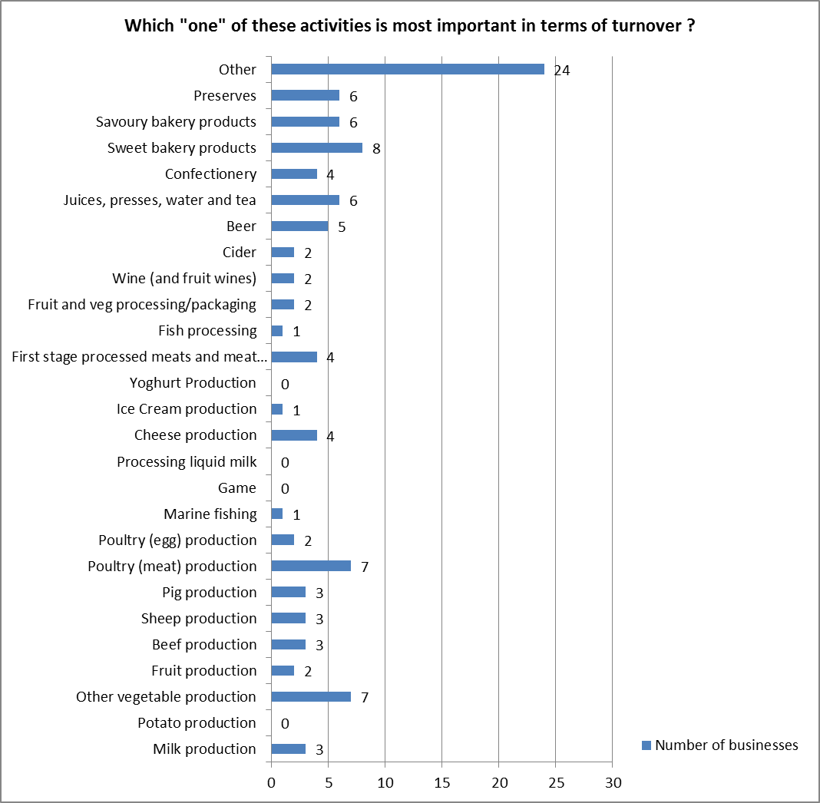

40% of respondents were engaged in a single business activity. 38% were engaged in two or three activities and 23% were engaged in four or more business activities. Of those engaged in a single activity only five were in primary food production including dairy, fruit, poultry meat, poultry eggs and marine fishing. The rest ranged across the whole food processing sector.

Those businesses engaged in the most activities tended to be the smaller scale food processing companies diversifying their activities through the “gate to plate” sales of their produce.

The Survey achieved a good mix of responses in terms of the age of the business (see Table A1). The main source of turnover for five out of 31 of the relatively new businesses (in business for less than five years) was primary food production. The other 26 relatively new businesses reflected a wide range of food processing activities, including seven in sweet and savoury bakery products, five in the beverage sector and two in honey production.

For the businesses which have been established for between 5–10 years there was a general spread of business activity with no obvious trends. For the older, more established businesses, 18 out of 48 had primary food production as their main source of turnover. Unsurprisingly, the majority of those involved in primary food production had been operating for more than 10 years.

**Table A1 Number of years business has been in operation**

|  |  |
| --- | --- |
| Less than 5 years | 31 (29%) |
| Between 5 and 10 years | 27 (25%) |
| Over 10 years | 48 (44%) |
| No answer | 2 (2%) |

39% of respondents had been in their current position in that business for more than 10 years; 29% had been in their current position for between 5 and 10 years and the remaining 32% had been in their current position for less than five years.

Almost half (48%) of respondents were aged between 45 and 54. 21% were under 35 and 31% were 55 or over. Therefore the majority of respondents were over 45 years of age. Nevertheless, the Survey has captured a good range of respondents in terms of their age.

Contrary to what might be expected of a survey of primary producers, our survey of producers, processors and manufacturers achieved a broadly even split in the number of female and male respondents with 51% being female and 49% male.

The vast majority (90%) of respondents had lived in Devon for more than 10 years. 92% of respondents described themselves as White British; 5% were White European; 1% described themselves as Mixed and 2% described themselves as ‘Other’ in terms of their ethnic origin.

## Markets

47% of respondents reported that 75% or more of their sales were within Devon; Just 4 businesses reported 75% or more of their sales in the South West region while 9 businesses reported 75% or more of their sales nationally. There were no companies reporting 75% or more of their sales outside the UK.

The primary producers in the Survey were more likely to be focused on the markets of Devon and the wider region. 17 businesses reported selling 50% or more of their produce to national markets. These businesses were involved in a wide range of products including milk, beef, poultry, fish, bakery, ice cream, and processing of meat & vegetables.

## Exports

Only 15% of respondents reported exporting *any* of their products to markets outside the UK. These businesses supplied a diverse spread of products including seafood, vegetables, cheese, processed meat, cordials, sauces and arable products. The one company exporting 70% of its produce was exporting condiments and spices. A fish processing company reported exporting 44% of its produce.

As Figure A2 indicates, the majority of respondents thought there would be no change in their market orientation in the short term, although 23 businesses expected sales to increase nationally and 11 expected sales to export markets to increase. Only three expected an increase in sales within Devon and two expected increased sales within the South West region.

**Figure A2**

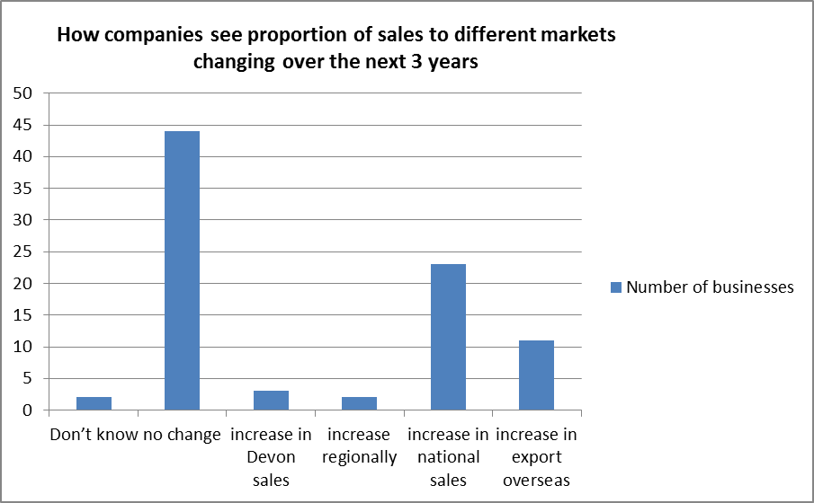

Businesses taking part in the Survey had multiple routes to market and there were a wide range of methods for selling their products (see Figure A3). Only eight businesses reported a contract with a supermarket or a processor while 70% reported selling direct to end consumers via their own shop, farmers markets or fairs. 45% of businesses sold via ecommerce – i.e. their own website; 63% used direct sales to independent retailers and 49% used direct sales to restaurants and private caterers.

**Figure A3 Routes to market**

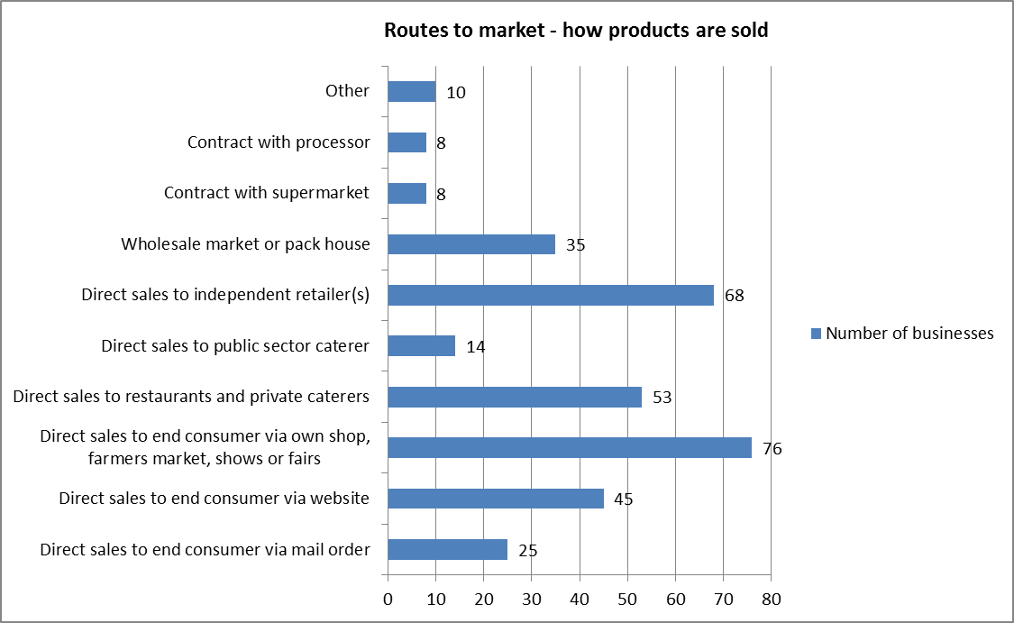

In contrast to the wide variety of routes to market employed by respondents, Figure A4 presents data on the most important route to market and illustrates that direct sales to consumers via own shop or farmers markets and fairs was the most important channel in terms of value for 37% of (107) respondents. For 22% wholesaling direct to independent retailers was the most important. Only six businesses reported direct sales to the end consumer via their website as the most valuable channel for sales. Those six businesses were selling poultry meat, sweet bakery products, preserves and other speciality food and only one had a turnover greater than £250,000. 60% of businesses mainly selling within Devon reported direct sales to consumers via own shop, farmers market, shows etc as the most valuable route to market. None of the respondents whose majority of sales were in Devon had a contract with a supermarket or processor.

**Figure A4**

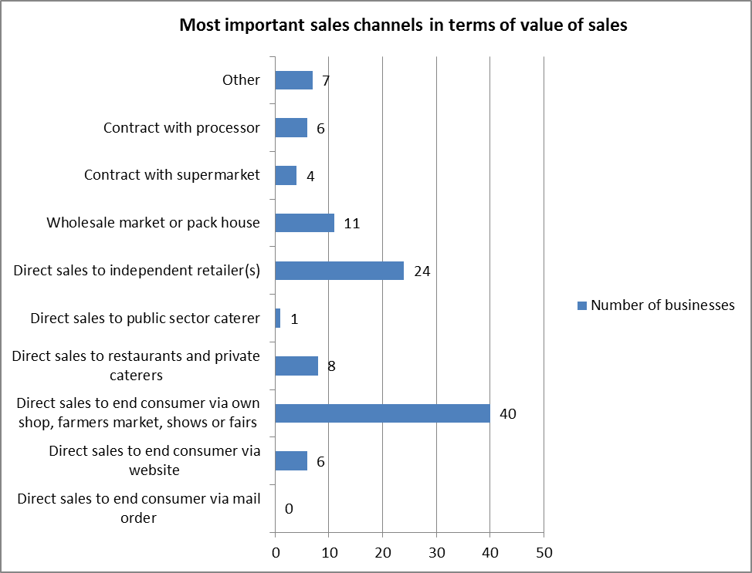

## Changes in routes to market over the next three years

46% of businesses reported that they would like to change the way they sell their products over the next three years. Businesses seeking to change the way they sell their products came from across the range of activities in primary food production and food processing. A similar proportion of primary food producers and food processors indicated they would like to change the way they sell their produce (42% of 31 primary food producers and 45% of food processors) and so there are no identifiable differences. Of these 39% indicated they would like to increase their direct retail via online and mail order. 35% indicated they would like to increase sales to wholesale and distributors. 18% hoped to increase their direct retail through farm shops and only one business was hoping to sell more to supermarkets.

## Barriers to changing the way businesses sell their products

42 respondents provided a range of qualitative responses regarding the barriers they face in making changes to the way the sell their products. Some businesses mentioned several barriers. For the purposes of analysis responses were grouped into eight broad categories illustrated in Figure A5 below. Very few (three) businesses reported few or no barriers. Ten companies referred to the costs and time constraints, nine reported shipping and transport costs as an issue, seven mentioned technical issues of posting perishable, chilled products, six referred to the necessary skills (marketing and knowledge required) and five mentioned consumer awareness issues. Interestingly, only one business mentioned slow internet as a problem.

**Figure A5**

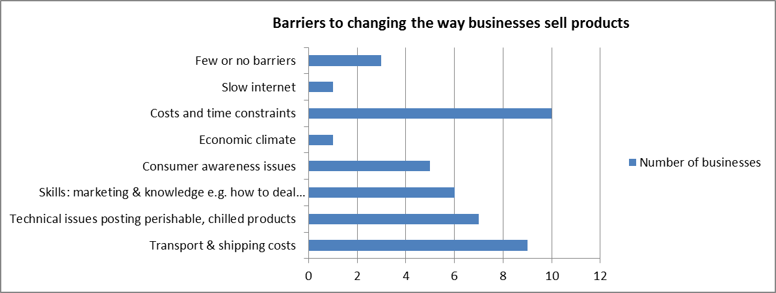

## Company finances and development prospects

Most respondents (90) provided a turnover figure. Of these 53% had a turnover of less than £100,000 while 13% had turnovers of more than £1m (see Figure A6). Of the 13% (12 businesses) with high turnover (greater than £1m) four were in primary food production, five were in meat, fish and vegetable processing, one business was producing savoury bakery products, one was in cheese production and one whole farm business was specialising in “gate to plate” sales. Of the 33% of businesses with turnovers between £100,000 to £1m, eight had primary food production as their main activity; 22 reported that food processing was their main activity.

**Figure A6**

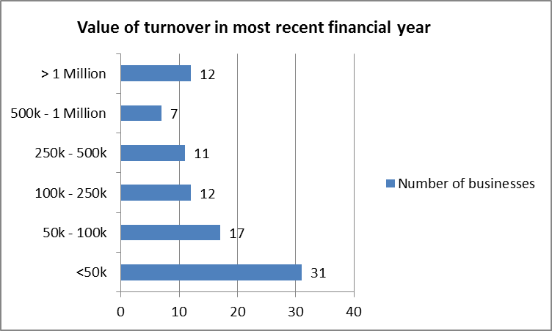

85 businesses responded to questions about changes in their turnover compared to recent years. Of these 18% (i.e. 15 businesses) reported a reduction in turnover compared to recent years (see Figure A7). On the other hand 61% reported an increase in turnover which indicates that most food economy respondents were experiencing growth which compares favourably with the overall UK economy.

92% of the businesses with a high turnover (greater than £1m) reported an increase in turnover. Four of these sold more than 50% of their products within Devon. The other eight were mainly selling to regional and national markets.

**Figure A7**

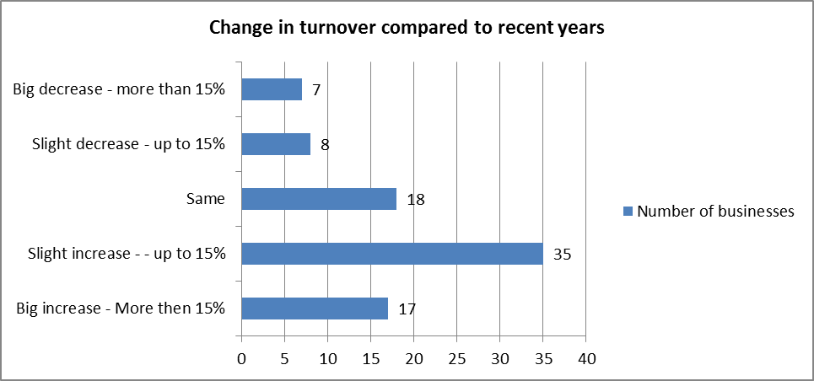

17 businesses reported growth of more than 15%. Of the 15 that also reported their turnover size, seven were companies with a small turnover (less than £100,000), five reported turnovers of between £100,000 and £1m and three had turnovers of over £1m. 12 businesses had been established for less than five years. This high growth associated with new businesses is not unexpected as some relatively new business may experience rapid growth during the establishment phase. These businesses were mainly in the food processing and manufacturing sectors.

Of the 14 businesses (from a range of food producing activities and a range of turnover sizes) reporting a reduction in turnover, most, not surprisingly, reported they would like to change the way they sell their products. Nine of these reporting a reduction in turnover reported selling over 50% of their products within Devon. Despite declining turnover nine of these businesses still described the current economic position of their business as ‘fair’ or ‘good’. Five reported it as ‘poor’ or ‘bad’.

## Business perceptions

Respondents were asked to describe the current economic position of their business. Of the 107 respondents 20% reported that they felt their economic position was ‘poor’ or ‘bad’ while 36% reported that their economic position was ‘good’ or ‘excellent’. The remaining 44% described their current economic position as ‘fair’.

Respondents were also asked how they would describe their economic prospects over the next three years. Interestingly, despite their current economic position, businesses were more positive about the future with 44% describing the economic prospects for their business over the next 3 years as ‘good’ or ‘excellent’. Just 13% described their economic prospects as ‘poor’ or ‘bad’ and 42% thought that their prospects were ‘fair’.

**Business plans for the next 3 years**

76% of businesses planned to marginally or significantly expand their businesses. 5% of businesses were planning to reduce the scale of their businesses and the remaining were seeking to maintain the scale of their businesses. Of the 28 businesses seeking to significantly expand their business most had food processing as their main source of income. 67% of companies with high turnover (greater than £1m) planned to significantly expand their business.

**Factors influencing businesses development plans**

When asked what factors influenced their plans to expand, maintain or reduce the scale of their businesses, respondents selected a range of factors as indicated in Figure A8. The main factors included: production costs, market prices, costs of labour, business profitability and input prices.

**Figure A8**

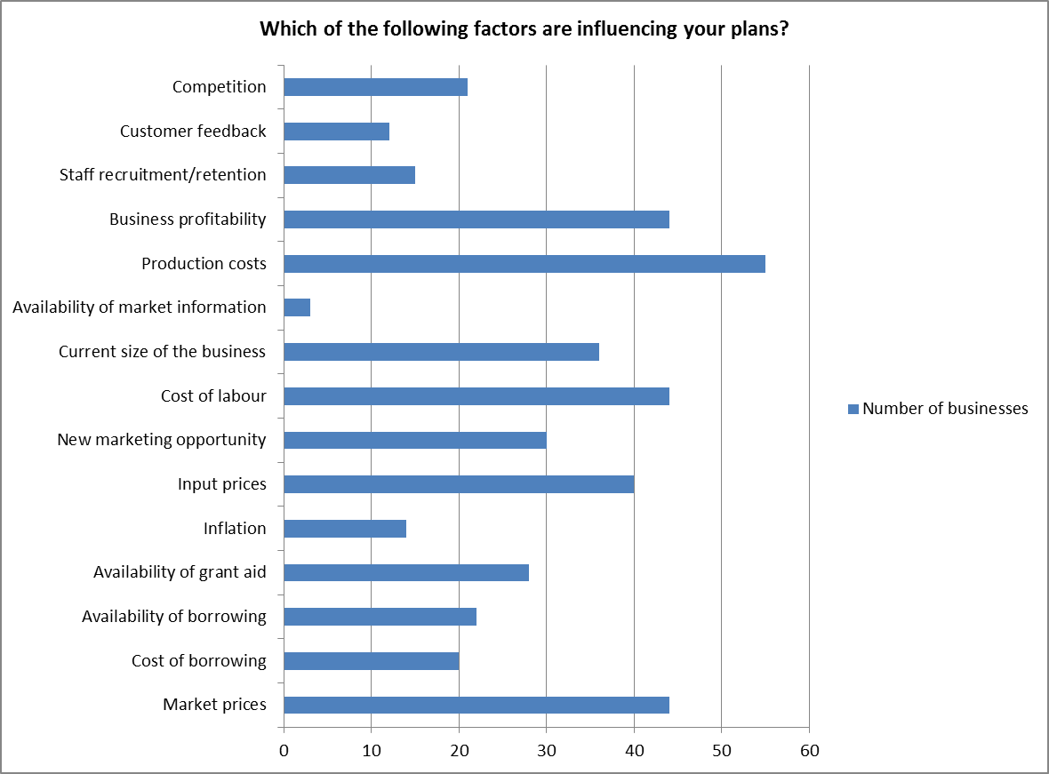

## Businesses with negative (poor or bad) perceptions

Of the 14 businesses with a negative economic outlook six were primary producers and the others produced a range of processed food products. This group represents a range of business sizes with turnovers ranging from less than £50,000 to up to £1m. Three of the businesses with a negative economic outlook reported that they still planned to marginally expand their businesses, with the rest seeking to either maintain their existing scale or reduce the scale of their business. The four main factors reported which influenced their plans were: production costs, labour costs, input prices and market prices. Other factors included the usual business issues such as competition, business profitability and inflation.

## Businesses with positive (excellent or good) perceptions

44% of businesses reported ‘good’ or ‘excellent’ perceptions regarding their future economic outlook. Of these the vast majority had food processing as their main source of income. Indeed, it appears that 50% of food processors believe their prospects to be ‘good’ or ‘excellent’ over the next three years compared with 29% of primary food producers.

94% of the businesses with a positive outlook planned to marginally or significantly expand their businesses. There were many factors reported which influenced their plans and there is no notable difference in the influencing factors between this group of companies with a positive outlook and the sample as a whole.

## Support from public or private sector

All respondents were asked which areas of their business would benefit from support over the next three years (see Figure A9). Sales and marketing was the most commonly cited area of required support. Other areas included capital investment, transport and distribution solutions and establishing routes to market. Other comments included weather mitigation, stopping supermarkets from driving down food prices and high level technical and scientific advice. Analysis of the data by sector and size of business turnover did not produce any obvious differences in the support required.

**Figure A9**

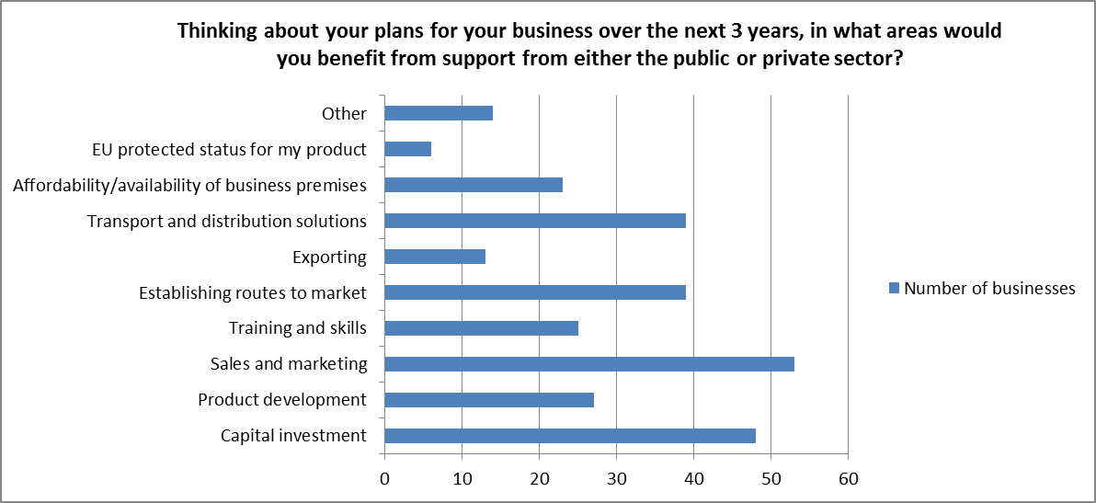

**Employment**

A total of 691 full-time employees, 322 part-time and 199 casual and seasonal employees were employed by the 108 businesses which took part in the Survey.

73% of businesses responding to the employment questions employed fewer than five full-time employees, while just one business employed more than 100 full-time employees. Clearly the vast majority of businesses employed less than five people. The distribution of numbers of part-time workers and seasonal/casual workers was similar with the majority of businesses employing less than five part-time or seasonal staff.

In 11% of businesses 80% of the workforce were graduates. Those businesses tended to be very small with fewer than five employees. Just over half (56%) of businesses had fewer than 20% of their workforce that were graduates. On the other hand, in 26% of businesses graduates made up 40% or more of the workforce. The majority of these (18 businesses) were involved in food processing with the remaining 10 citing primary food production as their main source of income. The majority of businesses with high graduate employment sold their products locally in Devon, and a smaller portion of their sales were to UK and export markets.

Most businesses either had not experienced any problems in recruiting or retaining staff or did not employ staff.

**APPENDIX B**

**DETAILED DATA ON EMPLOYMENT IN DEVON’S AGRI-FOOD INDUSTRIES**

It should be noted that the employment data shown includes full and part time employees and proprietors who were also full or part time. As such the figures are of numbers of employees rather than a true measure of labour input, e.g. Ftes or hours worked.

For each industrial sector Table B1 gives:

* GB employment
* Devon’s employment
* Devon’s employment as a percentage of the GB
* Devon’s location quotient
* % of employment within Devon’s Division
* % of employment within Devon’s narrow Food &Drink
* % of employment within Devon’s broad Food &Drink

The Location Quotient (LQ) is a measure of how strongly the sector is represented in the county, therefore for all industries the LQ is 100. Industries heavily represented, in employment terms, have an LQ well in excess of 100 and industries with little presence in the county well below.

**Data quality** is an issue, particularly when looking at smaller sectors at the county level. The employment element of BRES is survey-based and the samples will be quite small so that there are likely to be some anomalies; if the data does not fit well with other evidence then it may well be incorrect.

For reasons of confidentiality employee numbers are all rounded to the nearest 100 but the percentages and LQs are calculated from the un-rounded data. As a result some of the totals and subtotals may not be the exact summation of the relevant parts.

| **Table B1** |  |  |  |  | **% of employment within** | | | |
| --- | --- | --- | --- | --- | --- | --- | --- | --- |
|  | **GB** | **Devon** | **Devon as % of GB** | **Location Quotient** | **Devon Division** | **Devon Core agri food** | **Devon Core & Secondary agri-food** | **Devon broadest agri-food** |
| 010 : DEFRA farm labour | 442,700 | 20,300 | 4.6% | 369 | 97% | 64% | 30% | 26% |
| 016 : Support activities to agriculture and post-harvest crop activities | 19,500 | 500 | 2.3% | 187 | 2% | 1% | 1% | 1% |
| 031 : Fishing | 6,000 | 100 | 2.2% | 181 | 1% | 0% | 0% | 0% |
| 032 : Aquaculture | 3,200 | 100 | 3.0% | 240 | 0% | 0% | 0% | 0% |
| **Primary food producers** | **471,300** | **21,000** | **4.5%** | **358** | **100%** | **66%** | **31%** | **27%** |
|  |  |  |  |  |  |  |  |  |
| 101 : Processing and preserving of meat and production of meat products | 68,800 | 600 | 0.8% | 67 | 14% | 2% | 1% | 1% |
| 102 : Processing and preserving of fish, crustaceans and molluscs | 14,900 | 100 | 0.4% | 34 | 2% | 0% | 0% | 0% |
| 103 : Processing and preserving of fruit and vegetables | 30,900 | 200 | 0.5% | 41 | 4% | 0% | 0% | 0% |
| 104 : Manufacture of vegetable and animal oils and fats | 1,500 | 0 | 0.6% | 48 | 0% | 0% | 0% | 0% |
| 105 : Manufacture of dairy products | 22,800 | 900 | 4.0% | 325 | 23% | 3% | 1% | 1% |
| 106 : Manufacture of grain mill products, starches and starch products | 10,400 | 0 | 0.1% | 7 | 0% | 0% | 0% | 0% |
| 107 : Manufacture of bakery and farinaceous products | 95,000 | 1,000 | 1.0% | 82 | 24% | 3% | 1% | 1% |
| 108 : Manufacture of other food products | 78,500 | 500 | 0.7% | 56 | 14% | 2% | 1% | 1% |
| 109 : Manufacture of prepared animal feeds | 13,100 | 400 | 2.8% | 225 | 9% | 1% | 1% | 0% |
| 110 : Manufacture of beverages | 36,600 | 400 | 1.0% | 82 | 9% | 1% | 1% | 0% |
| **Food and drink processors** | **372,500** | **4,000** | **1.1%** | **86** | **100%** | **12%** | **6%** | **5%** |
|  |  |  |  |  |  |  |  |  |
| 2893 : Manufacture of machinery for food, beverage and tobacco processing | 7,000 | 0 | 0.7% | 55 | 0% | 0% | 0% | 0% |

|  |  |  |  |  |  |  |  |  |
| --- | --- | --- | --- | --- | --- | --- | --- | --- |
|  |  |  |  |  | **% of employment within** | | | |
|  | **GB** | **Devon** | **Devon as % of GB** | **Location Quotient** | **Devon Division** | **Devon Core agri food** | **Devon Core & Secondary agri-food** | **Devon broadest agri-food** |
| C : Manufacturing | 2,406,400 | 27,200 | 1.1% | 91 | 100% |  |  |  |
| 4611 : Agents involved in the sale of agricultural raw materials, live animals, textile raw materials and semi-finished goods | 2,900 | 100 | 3.3% | 263 | 1% | 0% | 0% | 0% |
| 4617 : Agents involved in the sale of food, beverages and tobacco | 4,000 | 0 | 1.2% | 95 | 0% | 0% | 0% | 0% |
| 4620 : Wholesale of agricultural raw materials and live animals | 28,200 | 800 | 2.8% | 228 | 5% | 3% | 1% | 1% |
| 4630 : Wholesale of food, beverages and tobacco (minus 4635 tobacco) | 195,700 | 3,400 | 1.7% | 140 | 23% | 11% | 5% | 4% |
| **Food and drink wholesalers** | **230,800** | **4,400** | **1.9%** | **152** | **29%** | **14%** | **6%** | **6%** |
|  |  |  |  |  |  |  |  |  |
| 46 : Wholesale trade, except of motor vehicles and motorcycles | 1,135,300 | 15,100 | 1.3% | 107 | 100% |  |  |  |
| 4711 : Retail sale in **non-specialised** stores with food, beverages or tobacco predominating | 1,060,300 | 14,700 | 1.4% | 112 | 36% |  | 22% | 19% |
| 4721 : Retail sale of fruit and vegetables in specialised stores | 14,000 | 400 | 2.6% | 208 | 1% | 1% | 1% | 0% |
| 4722 : Retail sale of meat and meat products in specialised stores | 32,000 | 600 | 2.0% | 159 | 2% | 2% | 1% | 1% |
| 4723 : Retail sale of fish, crustaceans and molluscs in specialised stores | 2,800 | 100 | 2.8% | 228 | 0% | 0% | 0% | 0% |
| 4724 : Retail sale of bread, cakes, flour & sugar confectionery in spec. stores | 54,300 | 700 | 1.3% | 101 | 2% | 2% | 1% | 1% |
| 4725 : Retail sale of beverages in specialised stores | 25,400 | 200 | 0.6% | 50 | 0% | 0% | 0% | 0% |
| 4729 : Other retail sale of food in specialised stores | 23,600 | 500 | 2.1% | 169 | 1% | 2% | 1% | 1% |
| 4781 : Retail sale via stalls and markets of food, beverages & tobacco products | 2,600 | 0 | 1.7% | 139 | 0% | 0% | 0% | 0% |
| **Specialised food and drink retailers** | **154,700** | **2,500** | **1.6%** | **128** | **6%** | **8%** | **4%** | **3%** |
|  |  |  |  |  | **% of employment within** | | | |
|  | **GB** | **Devon** | **Devon as % of GB** | **Location Quotient** | **Devon Division** | **Devon Core agri food** | **Devon Core & Secondary agri-food** | **Devon broadest agri-food** |
| 47 : Retail trade, except of motor vehicles and motorcycles | 2,896,900 | 41,000 | 1.4% | 114 | 100% |  |  |  |
| 5610 : Restaurants and mobile food service activities | 705,500 | 9,000 | 1.3% | 103 | 42% |  | 13% | 11% |
| 5620 : Event catering and other food service activities | 230,700 | 1,700 | 0.7% | 60 | 8% |  | 3% | 2% |
| 5630 : Beverage serving activities | 548,900 | 10,800 | 2.0% | 158 | 50% |  | 16% | 14% |
| **56 : Food and beverage service activities** | **1,485,000** | **21,500** | **1.4%** | **116** | **100%** |  | **32%** | **27%** |
|  |  |  |  |  |  |  |  |  |
| **55 : Accommodation** | **381,100** | **11,000** | **2.9%** | **231** |  |  |  | **14%** |
| I : Accommodation and food service activities | 1,866,100 | 32,500 | 1.7% | 140 |  |  |  | 41% |
|  |  |  |  |  |  |  |  |  |
| **All employment** | **27,892,900** | **347,100** | **1.2%** | **100** |  |  |  |  |
|  |  |  |  |  |  |  |  |  |
| **Core agri-food** | **1,236,400** | **31,900** | **2.6%** | **207** |  | **100%** | **47%** | **40%** |
| Secondary food | 2,545,300 | 36,200 | 1.4% | 114 |  |  | 53% | 46% |
| **Core agri-food and secondary food** | **3,781,600** | **68,100** | **1.8%** | **145** |  |  | **100%** | **86%** |
|  |  |  |  |  |  |  |  |  |
| Accommodation | 381,100 | 11,000 | 2.9% | 231 |  |  |  | 14% |
| **Broadest agri-food** | **4,162,700** | **79,100** | **1.9%** | **153** |  |  |  | **100%** |

**Interpreting the table**

Structural differences between the county’s employment and employment across Great Britain can be seen in the **Devon as % of GB** and **Location Quotient** columns. Devon accounted for 1.2% of all employment in Great Britain but specialisation means that this percentage varied across different sectors. For example, the county’s employment in accommodation accounted for 2.9% of all accommodation sector employment in Great Britain. The level of over or under representation can be seen in the LQ where a value of 100 means that the sector share of employment exactly matched the county total share of GB employment. A high value, such as 231 for accommodation, means that the sector is over-represented.

The percentage of employment **within division** gives an indication of the degree of concentration on particular sub-sectors, for example manufacture of dairy products accounted for 23% of employment across all food and drink processing or food and drink wholesalers accounted for 29% of employment across all wholesalers.

The final three columns look at how much individual industrial sectors contributed to total agri-food employment. Here we present three measures: the **core** which is producers, processors, wholesalers and specialist retailers, the **core plus secondary** which adds in non-specialist retailers and food and drink services and, lastly, the **broadest** version which adds in accommodation as well. So, for example, the primary producers accounted for 66% of core agri-food employment, 31% of core and secondary employment and 27% of agri-food employment under the broadest definition.

**APPENDIX C**

**FURTHER ANALYSIS OF AGRICULTURAL GVA**

As can be seen from Figure C1, national level GVA data is not deflated. That is, it is presented in the prices that were prevailing at the time with no adjustment for inflation. This is part of a wider difficulty with following agricultural output changes over time, where the value of output fluctuates far more due to changes in *prices* than changes in *output volumes*. At the UK level ONS calculate sector ‘chained volume measures’ which estimate changes in output volumes rather than values. The Figure shows these for all UK industries compared with ‘agriculture’.

**Figure C1 Chained volume measures: agriculture and all industries compared**



By comparing the chained volume measures with the current price values of output we can derive sector implied deflators – that is the adjustments needed to get from value to volume (Figure C2).

The Figure illustrates the degree to which price adjustments in ‘agriculture’ differ from those in the general economy. Rather than a fairly smooth pattern of general price inflation (the black line) we see an extended period of declining prices in ‘agriculture’ (blue line) between 1996 and 2000, price increases close to general inflation for the next couple of years before a spike in 2004. This is followed by a huge fall in 2005 – in effect the element of ‘price’ paid through subsidies to farmers is removed. This is followed by the very real world commodity price acceleration in 2007 and 2008.

**Figure C2 Implied deflator for agriculture**



So what does all this mean for agricultural output in Devon? Figure C3 below shows the county’s nominal agricultural (blue line) and output deflated by the national implied sector deflator (red line). This gives some indication what the path of underlying changes in the **volume** of output may have been BUT there will be some level of distortion due to differences in the county’s commodity mix compared to the national commodity mix.

Looking at indexed prices in Figure C4 (which include the value of subsidies), the effect of the lack of cereal production in the county would have been substantially offset by the higher proportion of meat production which followed a similar price path up to 2006. The more muted path of milk prices, which would have had a greater influence in the county, would mean that the UK deflator over-deflates the county’s sector output, i.e. the pre and post 2006 parts of the curve should be higher than shown. That would result in a fairly flat chained volume output up to 2006 but a steeper increase thereafter. This profile would fit with the known facts that marketings of adult cattle resumed in 2006 having been suspended from 1995/96.

**Figure C3 Changes in agricultural output - Devon**



**Figure C4 Price changes in key agricultural sectors**



We therefore estimate that the changes in total *nominal* value up to 2005 were very largely due to price changes rather than decline or growth in the underlying volume of output. Since 2005 there has been a significant pick up in the nominal value of agricultural output accompanied by a smaller recovery in the share of agriculture in the whole economy and, we estimate, some increase in the underlying volume of agricultural output.

**Notes on modelled estimates of GVA**

There are some other published sources of sector GVA estimates, e.g. those produced by Experian and Oxford Economics, which are modelled using unpublished ONS data. However, these only get us a little further in terms of coverage by adding Food and Drink manufacturing at the county level. As well as the additional ONS data these use unofficial data sources and complex estimations with the result that different models give different estimates. Because the methodologies are not fully disclosed these differences cannot easily be explained. For this reason we have only presented data derived from the South West Regional Accounts (SWRA) model, where the data is most detailed and the methodology is most transparent, but we do recognise that it is only one of a number of estimations of how Devon’s economy functions. This further emphasises that, with the absence of any local supply chain that is sufficiently robust to be classified as ‘national statistics’, there is no definitive model of the Devon’s economy.

**The South West Regional Accounts**

The SWRA are an integrated economic information system for the South West. The Accounts were compiled as part of the Business & Economy Module of the South West Regional Observatory to bring together information on all aspects of the region’s economy in a single, consistent, and integrated resource. The SWRA were sponsored by the South West Regional Development Agency.

The core of the input-output accounts is the ‘transactions’ matrix, which records the values of purchases and sales between industry groups taking place within the economy during the relevant time period - in essence, a map of the supply chains linking local industries. The input-output matrix also specifies the inputs which each industry buys in the region, the value of local labour utilised, the value of imports brought in from other regions, taxes and gross profits. A typical transactions table divides the economy into production sectors (industry groupings such as ‘agriculture’ and ‘business services’ which are organised according to their principal commodity outputs), final demand categories (consumption, investment, government expenditure and exports), and factor incomes (typically employment, profits and taxes). The transactions matrix in the SWRA can be mapped to the UK national input-output tables.

At county level only agriculture and food and drink manufacturing are directly available in the SWRA datasets. For the remaining sectors we have to move further still from the hard evidence and use regional data from the SWRA model to split broad sectors into detailed sector shares:

|  |  |  |  |  |  |  |
| --- | --- | --- | --- | --- | --- | --- |
| C part sector emp | ⁄ | C whole sector emp | **X** | SW part sector GVA | **X** | C whole sector GVA |
| SW part sector emp | ⁄ | SW whole sector emp | SW whole sector GVA |

For example, to calculate Devon’s F&D Wholesaling output what we know is Devon’s output for the whole wholesaling sector and the employment in both the whole sector and the part we are looking for. We can’t just use this to apportion the GVA because labour productivity may be different. So we take the relative labour productivity for the SW Region to adjust the allocation.

## APPENDIX D

## NOTES FOR SUPPLY AND USE TABLES CALCULATIONS RELATING TO THE PRIMARY SECTOR ANALYSIS

## (DAIRY, HORTICULTURE AND POTATOES, MEAT AND POULTRY, BEEF, SHEEP, PIG)

This appendix also offers background data to Devon’s food economy and household consumption.

**General notes on the Supply and Use calculations**

The Supply & Use tables in the main report translate livestock numbers and crop areas into quantities of food commodities. This is a purely theoretical exercise intending only to give an indication of how the county’s agricultural commodity production compares with its consumption of the same product. The reality of food supply chains means that the volume of both ‘exports’ and ‘imports’ will be far in excess of the notional net surplus or deficit in the product.Note that we have used the population of Devon CC but not the two UAs of Torbay and Plymouth to estimate Devon’s use.

**Dairy**

Milk quotas were introduced by the EU in 1984 in order to place an artificial ceiling on the volume of production and rein in the surpluses of milk and milk products that were accumulating in the EU (EC) intervention stores. After their introduction (at 1981 deliveries plus 1%) the quotas were progressively cut over the next few years to reach about 90% of the initial volume.

Up to 1994 prices were also controlled largely by the Milk Marketing Board creating a situation in which competition was largely played out through the value of milk quotas, see Figure D1. Since 2006 all quota holders have had their quotas progressively increased and the plan is for the system to be abolished altogether by 2015.

**Figure D1 UK milk quota and production 1980/81 to 2010/11**



The liberalisation of the milk market after 1994 created an interesting experiment in market economics. One the one hand a regulated monopoly, the Milk Marketing Board (MMB), was replaced by a small number of agents (processors) who could have created an oligopolistic market, where there is little real competition between sellers to drive down price. On the other hand, milk product buyers were becoming increasingly dominated by the supermarkets, potentially creating an oligopsonistic market, where a small number of buyers have power over the sellers. The outcome is clearly revealed in the milk price which dropped from 25 ppl to 17 ppl, a drop of one third in nominal terms and far more if inflation is taken into account (see Figure D2).

**Figure D2 UK average annual milk price 1980 to 2010**



Even at this lower milk price the UK continued to produce up to the national quota limit and milk quota continued to have a significant value until 2004/05. From this point onwards the market equilibrium appears to have been progressively below the old quota ceiling, while at the same time the ceiling was being raised to achieve a soft landing for the eventual abolition of restrictions in 2015.

Net supply to the UK home market started to fall after 2003, reaching a low in 2009 before recovering in 2010 (Figure D3). To date imports and exports have played only a very small role but there is some expectation that some EU producers, like France and Ireland, will see milk products as a major export market within the EU post 2015.

**Figure D3 UK production and net supply 1995 to 2010**



Looking at the uses of milk in the UK (Figure D4), liquid milk shows virtually no change at all over time indicating that population growth is being balanced by falls in per capita consumption. The recent fall in supply to the domestic market seems to be largely reflected in the decline of milk powder production and the growth in 2010 appears to be attributed to cheese.

**Figure D4 UK milk uses 1995 to 2010**



**All livestock**

Average dressed carcass weights (DCWs) have been calculated for prime and cull marketings from Agriculture in the UK, published annualy by Defra. These were then applied to estimates of Devon marketings (using the Meat & Livestock Commission calculation) to generate Devon’s DCWs. AUK also provides DCW £/kg which then gives Devon’s value of output. The use side is calculated as UK total supply (home production plus imports) divided by UK population to give a kg per head use which is applied to Devon’s population number. Note that use is not adjusted for any local difference in consumption although household consumption data suggests that the SW region generally consumes more than average. The problem is that only part of the meat intake is in carcass form, the rest being processed. Therefore we cannot get back from commodity consumption to a DCW equivalent.

**Horticulture & potatoes**

**Figure D5 UK vegetable supply and use, 1988-2010**



Source: Defra data.

**Figure D6 UK cauliflower and spring cabbage prices, 1995-2010**



Basic Horticultural Statistics, Defra

**Figure D7 UK potato supply and use, 1985-2010**



**Figure D8 UK weekly potato prices, 1995-2010**



**Fruit**

**Figure D9 Fruit – tonnes marketed, 1985 to 2010**



Source: Basic Horticultural Statistics, Defra

**Figure D10 UK fruit prices, 1995-2010**



Source: Basic Horticultural Statistics, Defra, CRPR analysis

**Vegetables**

**Figure D11 UK vegetable supply and use, 1988-2010**



Source: Defra data.

**Figure D12 UK cauliflower and spring cabbage prices, 1995-2010**



Basic Horticultural Statistics, Defra

**Beef**

**Figure D13 UK beef supply and use**



Source: Defra data.

**Figure D14 UK beef market prices, 1998-2010**



Source: Defra data.

**Notes on the Beef calculation**

The MLC marketing calculation includes calf sales so these need to be combined with prime sales in the AUK data. Although MLC marketings are used rather than combined beef and dairy breeding herd numbers the results are close – the MLC-based figure is lower reflecting the lower marketing rates for dairy.

Household consumption data gives a figure of kg 0.116 carcass beef and veal per person per week for the UK with the SW 8% higher, compared to an equivalent of kg 0.218 calculated from total supply, i.e. about half of UK supply goes into processed products (which includes raw products like sausages and burgers).

The chief thing to be aware of is that in 2005 older animals could not be marketed and this change explains most of the uplift in production. The average price per kilo for production has risen from £1.81/kg CDW to £2.47 (+37%) but this includes the lowering effect of the older cattle. Prices for prime finished cattle (liveweight) have risen from £1.02 to £1.47 (+55%). These increases compare with general price inflation, RPI(Y) – excluding mortgage interest and indirect taxes – going up by 18%.

It is clearly important, therefore, to look at trends in both dairy and beef numbers to understand the context for beef supply (see Figure D15).

**Figure D15 Devon’s Beef and Dairy numbers 1998-2010**



**Mutton and Lamb**

**Figure D16 UK Lamb and mutton supply and use, 1985-2005**



Source: Defra data.

**Figure D17 UK finished lamb market prices 1998-2011**



Source: Defra data.

**Notes on Lamb calculation**

Marketings are based on Devon’s percentage of the UK breeding herd in the previous year. The GB price for lamb per kg is used because AUK does not show one. Household consumption data gives a figure of kg 0.049 carcass mutton and lamb per person per week for the UK with the SW the same, compared to an equivalent of kg 0.069 calculated from total supply, i.e. about 30% of UK supply goes into processed products.

UK domestic use of lamb and mutton has fallen by 17% since 2005 – having been higher in 2007 it has plummeted in the last couple of years. Clearly related to supply, the price had gone up by 56% since 2005 but there must be a sterling devaluation effect as well – 35% of domestic production is being exported to the EU up from 28%.

**Pigmeat**

**Figure D18 UK pig meat supply and use, prices 1985-2010**



Source: Defra data.

**Figure D19 UK weekly pig prices (all pigs), 1998-2010**



Source: Defra data

**Background data to Devon’s Food Economy**

**Table D1 Household consumption SW and UK (Three year average 2007 to 2009)**

|  |  |  |  |  |
| --- | --- | --- | --- | --- |
| **Description** | **Units** | **UK** | **South West** | **SW vs UK** |
| Milk and milk products excluding cheese and butter | ml | 1,981 | 2,111 | +7% |
| Cheese | g | 115 | 138 | +20% |
| Carcass meat | g | 219 | 235 | +7% |
| *Of which* Beef and veal | g | 116 | 126 | +8% |
| *Of which* Mutton and lamb | g | 49 | 49 | +0% |
| *Of which* Pork | g | 54 | 61 | +11% |
| Non-carcass meat and meat products | g | 790 | 778 | -1% |
| Fish | g | 161 | 163 | +1% |
| Eggs | no. | 2 | 2 | +9% |
| Fats | g | 182 | 190 | +4% |
| *Of which* Butter | g | 40 | 44 | +9% |
| Sugar and preserves | g | 126 | 143 | +14% |
| Fresh and processed potatoes | g | 773 | 827 | +7% |
| Fresh and processed fruit and vegetables, excl potatoes | g | 2,328 | 2,604 | +12% |
| Fresh and processed vegetables, excl potatoes | g | 1,120 | 1,259 | +12% |
| Fresh and processed fruit | g | 1,208 | 1,345 | +11% |
| Bread | g | 664 | 668 | +1% |
| Flour | g | 58 | 55 | -6% |
| Cakes, buns and pastries | g | 157 | 173 | +10% |
| Biscuits and crispbreads | g | 167 | 196 | +17% |
| Other cereals and cereal products | g | 540 | 545 | +1% |
| Beverages | g | 55 | 61 | +11% |
| Other food and drink | g | 700 | 726 | +4% |
| Soft drinks | ml | 1,682 | 1,632 | -3% |
| Confectionery | g | 131 | 130 | -1% |
| Alcoholic drinks | ml | 741 | 746 | +1% |

Generally the standard error increases dramatically with extra levels of detail. For the headline categories it is less than 2.5% but is wider for eggs, fish, flour and alcoholic drinks. The breakdown of carcass meat is included but the standard error is 10-20% for mutton and lamb and for pork. Somehow the region seems to consume more of just about everything and indeed it has the highest daily calorie intake from food at 2315 vs. 2215 for England.

**Data issues**

Livestock numbers and crop areas are taken from published **June** **Agricultural Census/Survey** data. There are a number of issues of data quality and continuity which apply to the June Census/Survey generally:

Periodically there have been adjustments to the treatment of the smallest holdings, the most important of these being:

The exclusion of ‘minor holdings’ after the 2000 census

The exclusion of ‘non-commercial’ holdings after 2009

Over time what started as a census has become a survey with an ever decreasing sample size. This means that confidence intervals for detailed data at county level have increased. Even before it became a survey, ‘census’ non-responses were dealt with by rolling forward the data for the most recent response for the holding, building in a lag effect in the data.

However 2010 was a census year so the most recent data should also be the most accurate.

Since 2006 data for cattle has not been collected through the June Survey because the information was provided for the Cattle Tracing System (CTS). Although this is likely to be more accurate than the preceding survey data it is less detailed in the breakdowns of age and purpose.

For Devon in particular there is an additional issue arsing from the separation of the two Unitary Authorities, Plymouth and Torbay. Between 2000 and 2009 data for the County Council and the two UAs was published separately without a total for the old whole Devon area. Because of their small size much of the detailed data for the UAs was suppressed to maintain confidentiality so it is not possible to assemble a complete Devon dataset consistent with earlier and 2010 data. However, where there is data available for all three the difference amounts to less than 0.5%.



1. Throughout this report the use of the term ‘recession’ is not intended to imply the technical definition of two consecutive quarters of negative growth but rather the prolonged economic downturn since 2008 which, for many businesses, has all the characteristics of a recession in terms of impact of trading conditions, confidence, etc. That said, at the time of writing (April and May 2012) the latest figures released indicate that the UK is indeed in recession again following negative growth in the last quarter of 2011 and the first quarter of 2012.
2. Gross Value Added (GVA) is a measure of the value of goods and services produced in an area, industry or sector of an economy.
3. Further information, methods and sources can be found in subsequent chapters.
4. All the results from the online survey are available in Appendix A.
5. Lobley, M. et al (2012) A Review of Cornwall's Agri-Food Industry. CRPR Research Report 32.
6. Beglin, N., Duff, C. and Parkin, E. 2010 Exeter Community Food Enterprises (CFE’s): An area based study of CFE’s in the south west of England
7. Membership of the group comes from local projects and activists who aim to help connect different agencies and projects in Devon concerned with promoting food policies and practices which are more sustainable, fair and local. They also seek to influence other organisations in positions of decision-making on such food issues; and encourage and share good practice on new sustainable food initiatives
8. <http://sd.defra.gov.uk/2010/01/food-2030/>
9. ECONi – the South West Regional Accounts
10. The division between the region and the rest of the UK is based on data that is only rated as ‘poor to fair’ in quality and so should be taken only as a starting point for discussion.
11. BRES does not collect data on agricultural employment but this is provided by Defra. However, Defra do not provide county level employment data to BRES so the June Survey has been used to produce an estimate.
12. ‘supermarkets, bars and restaurants’ in SIC terminology are ‘non-specialist predominantly food and drink retailers’ and ‘food and beverage services’
13. 4,711 non-specialist predominantly food and drink retailers.
14. And even this is slightly contaminated by the inclusion of some non-farming elements such as hunting, forestry and landscape services and of course farming itself includes some non-food output.
15. Lobley, M. and Butler, A. (2010). The impact of CAP reform on farmers’ plans for the future: Some evidence from South West England. *Food Policy* 35, (2010) 341–348
16. Chained volume measure.
17. The modelled data shown is from the South West Regional Accounts (SWRA), and is based on current price data and so corresponds with the ONS data above. Even with SWRA it is not possible to get directly to this study’s definition of the core agri-food industry because at county level both retailing and wholesales are not split into component parts. So in the first instance we can only generate a partial picture of the core-agri-food industry comprising agriculture and food manufacturing only.
18. This may exaggerate the decline as it includes the one-off accounting adjustment taking farm subsidies out of GVA in 2005 (see discussion above).
19. The Regional Accounts break down Food and Drink manufacturing into sub-sectors is based mainly on the relevant ONS employment data. At county level this data does show the sort of volatility you would expect from the ONS sample sizes so one should not read too much into the exact data for a single year.
20. Regional relative productivity data has been broken down from broad sectors, like retailing, into the smaller parts that we are interested in. This adds a further layer of estimation and so these results should be treated with caution.
21. SWRA
22. SWRA
23. SWRA
24. modelled from SWRA
25. modelled from SWRA
26. modelled from SWRA
27. modelled from SWRA
28. modelled from SWRA
29. SWRA
30. Based on 2007-09 average to smooth out year-on-year variation.
31. Upper tier authorities or groups of lower tier authorities (unitary authorities or districts).
32. [Dec 2010 sub-regional GVA release](http://www.ons.gov.uk/ons/rel/regional-accounts/regional-economic-activity--gva-/december-2010/nuts3-excel-tables--published-december-2010-.xls)
33. [Sub-Regional Productivity, September 2011, October 2011](http://www.ons.gov.uk/ons/publications/re-reference-tables.html?edition=tcm:77-233135)
34. As we are looking at primary agricultural production in the context of the wider agri-food industry it is important to note that the following farming outputs are not included: (1) Cereals sold as animal feed as these become an input into primary production; (2) The value added through on-farm processing and retailing of primary commodities; (3) Other farm products (e.g. fuel crops, flowers) and services (farm tourism, contracting)
35. According to household consumption data, people in the South West region do consume more milk and milk products than the UK average so this ‘surplus’ may be a little less if Devonians follow the regional trend.
36. Further information on calculations for the supply and use tables are included in Appendix D.
37. Note that the Potato Council does not produce separate county data for Devon.
38. The lower prices for feed cereals are balanced by higher yields so end value per hectare is not much different.
39. DAPP is the current industry average calculated by the Meat and Livestock Commission and updated weekly.