Procedure for dealing with trainee(s) in schools that are graded ofsted inadequate
The University of Exeter, Graduate School of Education, does not routinely place trainees in schools that are graded Ofsted Inadequate. However, there may be situations such as a school being inspected just prior to or during a trainee placement and graded inadequate or where a school has made significant progress since the inadequate grading. In all cases, the decision as to whether the trainee stays/is placed at the school will be made by the Partnership Director (PD) in consultation with the Partnership Relations Manager, school, trainee and academic as appropriate.

FLow chart
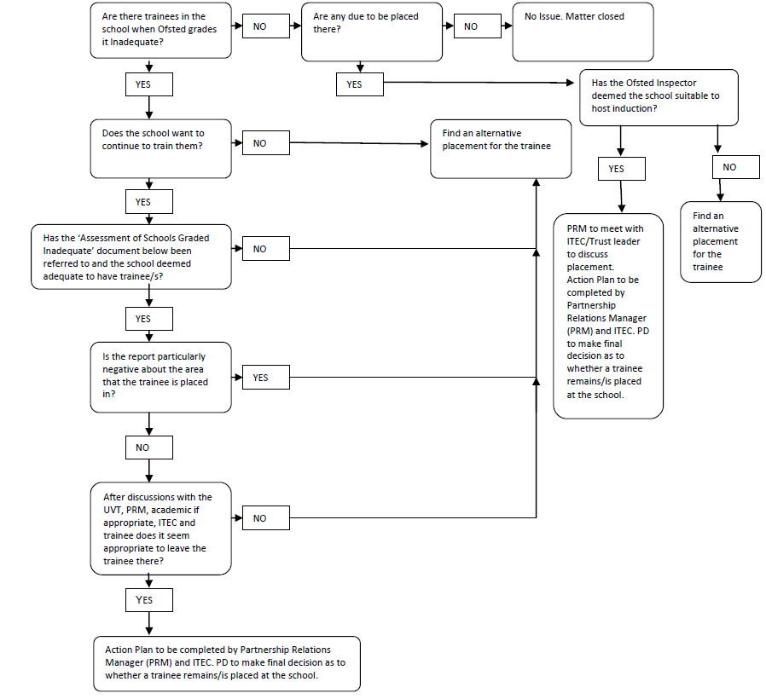

ITe partnership – assessment of schools graded inadequate
If a school is assessed as Inadequate (4) following an Ofsted Inspection, the following factors should be taken into consideration when deciding whether current trainees should remain on placement there or trainees should be placed there during future placements. If a decision is made for the trainee/s to remain on placement or to be placed there, an action plan must be completed and the factors reviewed regularly.
- Ofsted inspection - has the Ofsted inspector judged the school/or part of the school to be suitable to host induction? If not trainees will only be placed there in exceptional circumstances, where the Partnership Director is confident that the school can provide the training entitlement of a high quality and where the trainees would not be disadvantaged by the placement.

- The amount of time remaining on the placement

- Subject Department – The quality, experience, capacity, support and best practice available in the department

- The Trainee – Does the trainee want to be on placement at the school, do they feel the environment will support their training needs?

- Whole School Support – Is the school able to support trainees at this time, including ensuring the Professional Studies Programme will be in place?

- School’s Progress – How will progress be monitored?

- Additional support – what extra support might be required, including additional UVTs visits

ITe partnership – guidance for supporting the process
What happens if Ofsted judges a school to be inadequate?
If inspectors judge a school to be inadequate, it will be placed in one of the following two categories of concern.
- Special measures – This means the school is both:
- failing to provide its pupils with an acceptable standard of education
- not showing the capacity to make the improvements needed.

- Serious weaknesses – This means that the school’s performance requires:
- significant improvement but meets only one, or neither, of the conditions for special measures. A school with serious weaknesses will have one or more of the key judgements graded inadequate (grade 4) and/or have important weaknesses in the provision for pupils’ spiritual, moral, social and cultural development.
For Local Authority schools
A maintained school judged as inadequate and placed in a category of concern will be issued with an academy order by the Secretary of State for Education, to require it to become a new sponsored academy.2 Inspectors will not normally monitor the school unless there are concerns or there is a delay in the school becoming a sponsored academy.
For academies
For academies, maintained nursery schools and non-maintained special schools that have been judged as inadequate and placed in a category of concern, inspectors will visit these schools to check on their progress until they can be removed from the category (unless, for academies, they are re-brokered with a new sponsor to become a new sponsored academy). Ofsted will normally re-inspect these schools within 30 months of the publication of the inspection report that placed them in a category of concern.
ITT criteria info
ITT providers should satisfy themselves that partner schools have the capacity to undertake their responsibilities. Where a school has serious weakness or is in special measures, it may still be possible for providers to use the school, especially if the improvements to be made do not affect the subject or age range of the training. The partnership needs to be confident that the trainee will not be disadvantaged by the school experience and the situation should be kept under close review.

CRITERIA FOR ECTs
Induction cannot be completed in:
• a school requiring special measures (i.e. one which is eligible for intervention under section 62 of the Education and Inspections Act 2006), except in cases where Ofsted have judged a school, or part of a school, to be suitable to host induction.
Generally, once a setting has entered special measures it is not permitted to recruit any new ECTs. However, an Ofsted Inspector may make a judgement on whether the setting is suitable for the purposes of induction. In some cases, particularly with larger schools, Ofsted may give permission for ECT appointments within specific departments or subject departments of the school.

action plan

Action plan for Schools with trainees being graded Inadequate
Trainee name/s and subject/s:
School:
Reason for Action Plan:
Key issues identified by Ofsted Inspection:
Action plan agreed by and date:
Action | By who and when will this be reviewed
Review notes and date:

