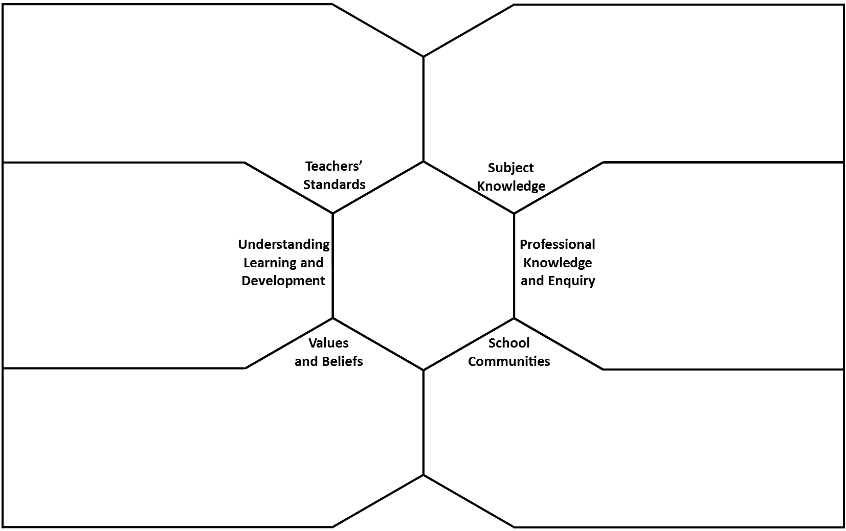
The Purpose of Education During Lockdown
In response to the theories of Freire’s banking model of education, he commented that students are not containers and that they should work collaboratively, co-learning and engaging creatively. In the modern school, OFSTED have now commented that some schools are preparing students too early for KS4 exams and jeopardising the creative arts/active approaches to learning. For example, the three year GCSE and cutting KS3 short in order to start exams early.

The purpose of a school is to provide a safe, structured and well-managed environment which sets students up for working life. The purpose of education is to provide the actual knowledge and skills which is needed to progress. Education is a well-rounded topic and students can be educated practically, creatively, remotely and in lots of other ways.

The purpose of education may change in the event of extended school closure because it will perhaps make sure other commitments/struggles at home/home life issues are taken more into account. Furthermore, we might see the content of education change and what is expected, National Curriculums may alter.

Schools will reflect their ethos in their expectations towards teachers and students – having faith in them.

The Teaching Standards that will be more difficult to adhere to are TS7, TS6 and TS2.
- TS7 relies on students ensuring they follow the normal behavioural standards which they would be expected to at school. Parents exercise different authority over their children and therefore, teachers are unable to exercise discipline as effective as it would be at school.
- TS6 and TS2 involves ensuring accurate and productive assessment use whilst making progress – most schools use formative and summative assessment to track progress and be accountable for their attainment. It is harder to track progress whilst in lockdown and to ensure students are being assessed correctly.
The Standards that are more relevant whilst working at a distance are:
- TS8 – Teachers need to establish good working relationships with the rest of the department and with teachers. They need to communicate any issues/developments with the subject.
- TS4 and TS5 – Teachers need to plan detailed, well-structured and engaging lessons as well as having lots of variated content. They need to ensure the curriculum is kept dynamic and resources are well thought out. Teachers all need to ensure that lessons are differentiated with extra support and resources for different abilities (Stretch and Challenge/EAL/SEN)
Teachers’ responsibilities for their vulnerable children will change during lockdown –
- They must ensure vulnerable students are given extra support and establish a safe environment for them.

The Purpose of Education During Lockdown
Discuss your answers to the prompt questions and summarise these discussions on this framework sheet. Ensure that you summarise areas of agreement and are clear about areas of conflict and whether you were able to resolve them.

The active reading of novels and texts may find it hard for students to work independently at home – quite often, by using collaborative or whole class reading, students will connect with the texts more and have the opportunity to talk through and discuss ideas. For example, Shakespeare – students might not understand the language and are unable to discuss their misunderstandings. Poetry – a lot of students will not be able to grasp the deeper meanings behind texts.

Students might find it hard to focus and write extended pieces of writing without the assistance of the teacher within the context of a lesson, this is especially prominent if the child doesn’t have a place at home to concentrate (noisy house, siblings).

Teachers can make it more accessible by providing summaries and overviews for students. Help sheets and prompt questions will allow students to consider potential meanings and interpretations. Teachers might also provide models for students to read and magpie before writing their own.
The Education Endowment Foundation considers that pupils can learn via remote learning but there are 5 key aspects to ensure quality remote learning:
- Teaching quality is more important than delivery of lessons – hence teachers should ensure they give clear explanations, scaffold and feedback.
- Ensuring students have access to technology – especially PP.
- Peer interactions can provide motivation and improve learning outcomes – collaborative approaches like peer marking, live discussions, sharing good work can encourage better remote learning.
- Supporting pupils to work independently and monitoring progress – prompting/reflection/providing daily checklists/plans.
- Different approaches to remote learning – using various resources will keep remote learning dynamic.

There is not a lot of literature on teaching English online but there are lots of online resources available to students which can be distributed by teachers easily.

The move to online learning may impact pupils’ learning and progress positively for those students who thrive using laptops/technology – especially as we move into an increasingly, more online world. It will also advance different resources available – videos/Bitesize/Youtube.
However, it might hinder students’ being proactive and getting involved during actual ‘teaching time’ because online learning is more flexible.

Disadvantaged pupils need more support to learn currently because some may not have access to resources (online) at home. They may also have difficult home lives – it is these students who should be able to come into schools.

‘Progression’ may be viewed differently by some parents – for example, some parents may use this time for students to learn more practical skills such as cooking, cleaning, fixing things etc. Students may also get involved with work for their parents such as farming. Some parents may place more of a focus on quality family time etc.
Progression for teachers may be that they know the students are logging on to learn as much as they can and producing work for them.
However, lockdown does change the nature of ‘progression…’
Teachers can support students at home by ensuring there are well-planned and well-structured lessons with varied tasks. They should have an easily accessible point of call like an email address or discussion forum where students can ask questions; this will also help other pupils support their peers.
Teachers should provide praise to those who are really excelling and pushing themselves as a way to encourage other students and should offer feedback throughout the school day.

Teachers should support parents by giving them their contact details and showing them what is expected of their children but also considering that these are unprecedented times and there is much room for mitigation.

Pupils can support each other through group work/chats and discussion forums like Teams which will allow students to discuss work and encouragement.

Schools can support parents and pupils by offering emotional and open support – providing a holistic view of education. Making links available.

