**Welfare**

How are the concepts of mental health and wellbeing relevant to the

Teachers’ Standards?

S1 – aware of different student dispositions

S2 – encouraging them to reflect on progress, being aware of

S3 – subject knowledge of RSE

S4 – build in opportunities to reflect, fail or experiment

S5 – clear understanding of needs of SEN students, understand how a range of factors can inhibit pupils’ ability to learn, and how best to overcome these

S6 – include low-stakes assessment to help manage anxiety, build up resilience

S7- use graduated behaviour responses for SEN and students with challenging behaviour

S8 – communicate effectively with parents. Know when to communicate with others re.safeguarding

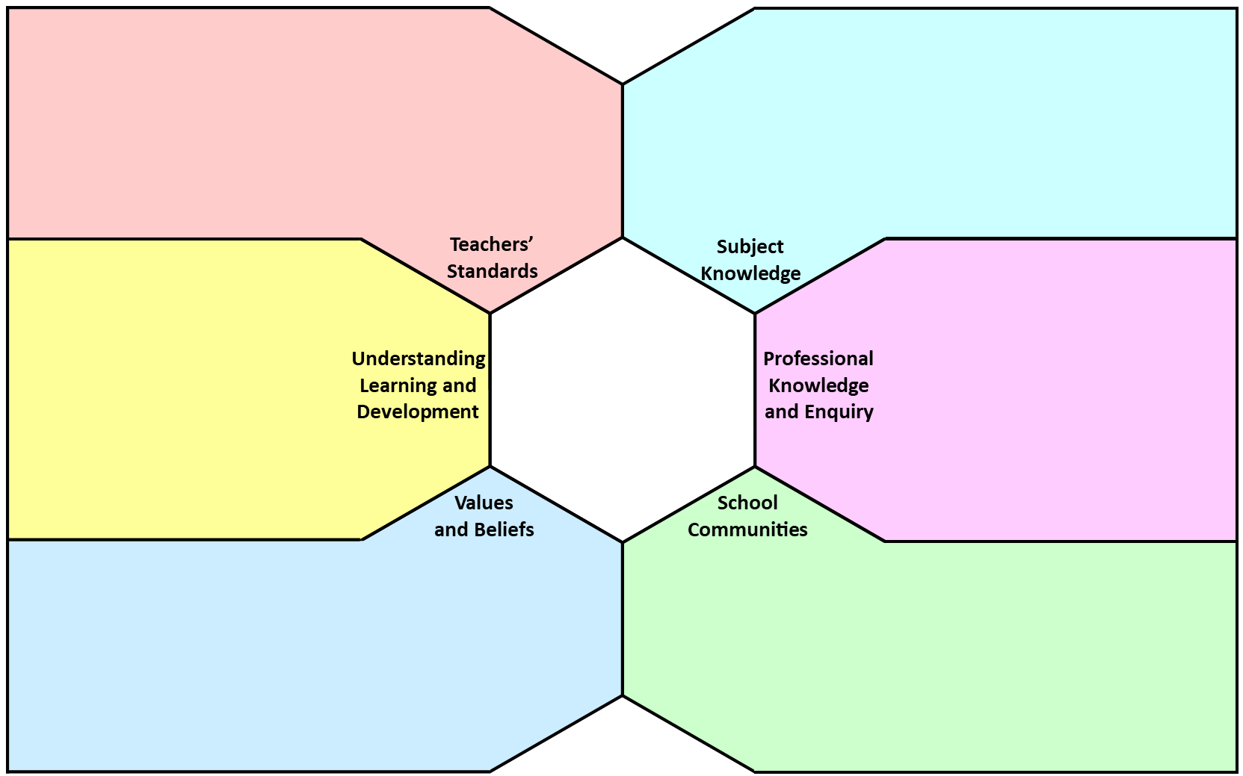

**Welfare**

Contributing factors that affect pupil wellbeing and mental health include: relationships between teachers and pupils, a sense of belonging to school, relationships with other students, bullying, family support, physical activity and fitness

A teacher’s wellbeing and mental health can greatly affect pupil learning as teachers’ attitudes and moods effect students. The teacher’s confidence might suffer due to poor mental health which may affect pupil behaviour.

Pupils’ behaviour is affected by their own mental health and wellbeing. We encountered very few resilience strategies in our placement schools so believe more needs to be done. One example, an assembly on resilience we were unsure of its effectiveness and believe there needs to be more than just words or theory but actions.

My placement school addressed teacher and pupil mental health and wellbeing through an LGBT society and assemblies addressing issues related to mental health. There is an Initiative of mentoring for students with behavioural issues.

Teachers/schools should be having conversations with parents and carers about the mental health and wellbeing of pupils in order to make them aware of support systems available. Phone calls home to parents for concerns about changing behaviour. We discussed how to know when it is a safeguarding issue or not, if in doubt speak to a safeguarding officer.

Issues that might arise relating to different ways of understanding teacher mental health and wellbeing include a lower regard for teacher’s wellbeing, parents consider more important the wellbeing of the children. How schools deal with long-term sickness of teachers is important for parent/teacher relationships.

Looking at the curriculum for Relationship and Sex Education (RSE) and Health Education, what are the implications for your subject knowledge as you prepare for your tutor group (secondary) as an NQT?

Will need to ensure that I have an understanding of the correct presentation of the information, the terminology, being up-to-date on social media and legal aspects.

Can you think of particular areas of your subject which require some kind of ‘resilience training’ in strategies to overcome challenges?

Reacting positively and being proactive to feedback; reading challenging texts, particularly Shakespeare; exam strategies.

My personal definition of teacher/pupil mental health and wellbeing is feeling stable and able to cope with day to day life. Others in my group considered: feeling safe, with opportunities to discuss any issues, an ability to manage and cope, be aware of your own needs and prioritise when necessary

My definition has been shaped by your own experiences as a learner and as a teacher, particularly during the PGCE as it has emphasized the importance of looking after yourself and how challenging teaching is.

Mental health is such an issue now partly because it is not such a taboo, people feel more able to talk about mental health difficulties and take time off if necessary. We felt there was also higher expectations on teachers in particular more difficult GCSE’s. The behaviour of students could also be a factor in mental health for teachers but also for students. There are increased peer pressures on students due to cyber bullying and the pressures of social media.

* Practical strategies that I have developed during my training to manage mental health include: planning blocks of time, lists and prioritizing, asking for advice and talking about challenging experiences, perseverance, switching off after a certain time of day
* School leaders should be encouraged to give time to teachers and be there to answer any questions or support them. There should be continued support for all teachers and regular check-ins with HoD. There could be CPD on strategies for managing workload and/or SLT can implement strategies.