ENCHANTED OBJECTS AND MYTHICAL BEASTS
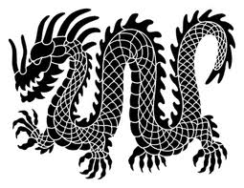
Enchanted Object | What are its special powers? | Who enchanted it?
Mythical Beast | What are its special powers? | What does it look like?

Make a quick sketch of your enchanted object or mythical beast and annotate the sketch with noun phrases which describe it and help your reader visualise and understand it.

